DLA Piper LLP (US)

555 Mission Street, Suite 2400

San Francisco, California 94105-2933

www.dlapiper.com

Jeffrey C. Selman

jeffrey.selman@us.dlapiper.com

T 415.615.6095

F 415.659.7465

October 15, 2021

Securities and Exchange Commission

Division of Corporation Finance

Office of Technology

100 F Street, NE

Washington, DC 20549

Attn: Anna Abramson

Jan Woo

Re: GigCapital4, Inc.

Revised Preliminary Proxy Statement on Schedule 14A

Filed September 17, 2021

File No. 001-40031

Ladies and Gentlemen:

This letter responds to the comment letter (the “Comment Letter”) of the staff (the “Staff”) of the Division of Corporation Finance of the United States Securities and Exchange Commission (the “Commission”), dated September 29, 2021, to Raluca Dinu, Chief Executive Officer of GigCapital3, Inc. (“GigCapital4” or the “Company”) regarding Amendment No. 1 to the Preliminary Proxy Statement on Schedule 14A filed September 17, 2021 (the “Revised Preliminary Proxy Statement”). Simultaneously with the submission of this letter, the Company is filing Amendment No. 2 to the Preliminary Proxy Statement in response to the Staff’s comments.

This letter sets forth each comment of the Staff in the Comment Letter and, following the comment, sets forth the Company’s response.

Revised Preliminary Proxy Statement on Schedule 14A

Risk Factors

Historically, existing customers have expanded their relationships with us..., page 50

- We note your disclosure on page F-74 that you had four customers contributing in excess of 10% of consolidated revenues for the Successor 2020 Period, and two significant customers in the Predecessor 2020 Period. Disclose any material risks associated with this concentration of revenue. In addition, describe any material contracts with these significant customers, including term and termination provisions.

The Company acknowledges the Staff’s comment and has revised the disclosure on page 52 of Amendment No. 2.
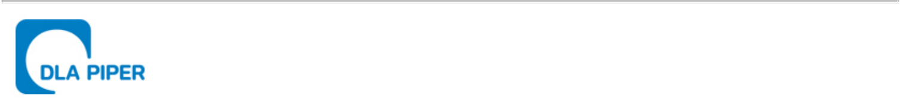
October 15, 2021

Page Two

New BigBear may redeem the unexpired warrants..., page 109

- We note the disclosure added in response to prior comment 21. Please also clarify whether recent common stock trading prices exceed the threshold that would allow the company to redeem public warrants..

The Company acknowledges the Staff’s comment and has revised the disclosure on page 112 of Amendment No. 2.

Unaudited Prospective Financial Information, page 172

- We note the disclosure added in response to prior comment 11. Please explain why it is a reasonable assumption that all unexercised options on existing backlog will be awarded and no contracts will be terminated for convenience. In addition, please disclose in the filing the assumptions related to your projected revenue and expenses that you described in your comment letter response.

The Company acknowledges the Staff’s comment and has revised the disclosure on pages 174 to 176 of Amendment No. 2.

Information About New BigBear, page 265

- We note your response to prior comment 16. Please reconcile your revised disclosure on page 271 that historical revenue CAGR exceeds 25% for 2017-2020 (a four year period) with your disclosure on page 272 that “[a]s mentioned previously, BigBear has grown at nearly 30% CAGR over the last five years” and on page 266 that CAGR was “more than 25% over the last three years.”

The Company acknowledges the Staff’s comment and has revised the disclosure on pages 272, 278, and 279 of Amendment No. 2.

Beneficial Ownership of Securities, page 328

- We note your response to prior comment 22. In addition to the tabular disclosure that omits shares of common stock underlying warrants that are not exercisable within 60 days pursuant to Item 403 of Regulation S-K and Rule 13d-3 of the Exchange Act, please separately disclose the Sponsor and its affiliates’ total potential ownership interest in the combined company, assuming exercise and conversion of all securities.

The Company acknowledges the Staff’s comment and has revised the disclosure on pages 335 to 337 of Amendment No. 2.
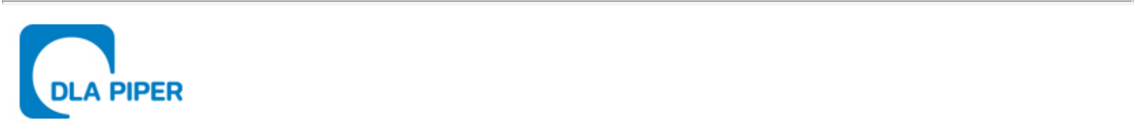
October 15, 2021

Page Three

Notes to Combined Financial Statements

Note P - Revenues, page F-73

- We repeat the second part of prior comment 24 to confirm that all revenue from external customers is attributed to the United States. Refer to ASC 280-10-50-41(a).

The Company acknowledges the Staff’s comment and has revised the disclosure on pages F-74 and F-94 of Amendment No. 2.

The Company and its management acknowledge they are responsible for the accuracy and adequacy of their disclosures, notwithstanding any review, comments, action or absence of action by the Staff.

We and the Company very much appreciate the Staff’s attention to the review of the Revised Preliminary Proxy Statement. Please do not hesitate to contact me at (415) 615-6095 if you have any questions regarding this letter or the Amended Registration Statement.

Very truly yours,

/s/ DLA Piper LLP (US)

DLA Piper LLP (US)

Jeffrey C. Selman

Partner

