DLA Piper LLP (US)
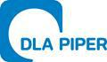

555 Mission Street, Suite 2400 San Francisco,

California 94105-2933

www.dlapiper.com

Jeffrey C. Selman

jeffrey.selman@us.dlapiper.com

T 415.615.6095

F 415.659.7465

October 27, 2021

Securities and Exchange Commission

Division of Corporation Finance

Office of Technology

100 F Street, NE

Washington, DC 20549

Attn: Anna Abramson

Re: GigCapital4, Inc.

Revised Preliminary Proxy Statement on Schedule 14A

Filed October 15, 2021

File No. 001-40031

Ladies and Gentlemen:

This letter responds to the comment letter (the “Comment Letter”) of the staff (the “Staff”) of the Division of Corporation Finance of the United States

Securities and Exchange Commission (the “Commission”), dated October 26, 2021, to Dr. Raluca Dinu, Chief Executive Officer of GigCapital4, Inc.

(“GigCapital4” or the “Company”) regarding Amendment No. 2 to the Preliminary Proxy Statement on Schedule 14A filed October 15, 2021 (the

“Revised Preliminary Proxy Statement”). Simultaneously with the submission of this letter, the Company is filing Amendment No. 3 to the Preliminary

Proxy Statement in response to the Staff’s comments.

This letter sets forth each comment of the Staff in the Comment Letter and, following the comment, sets forth the Company’s response.

Revised Preliminary Proxy Statement on Schedule 14A

Risk Factors

Historically, existing customers have expanded their relationships with us..., page 51

- We note the disclosure provided in response to prior comment 1. Please clarify whether all of the significant customers referenced in this risk factor have contracts that “permit them to unilaterally terminate our arrangement at any time (subject to notice and certain other provisions).”

The Company acknowledges the Staff’s comment and has revised the disclosure on page 52 of Amendment No. 3.

The Company and its management acknowledge they are responsible for the accuracy and adequacy of their disclosures, notwithstanding any review, comments, action or absence of action by the Staff.
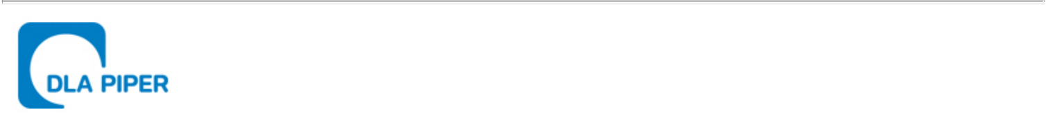
October 27, 2021

Page Two

We and the Company very much appreciate the Staff’s attention to the review of the Revised Preliminary Proxy Statement. Please do not hesitate to contact me at (415) 615-6095 if you have any questions regarding this letter or the Amended Proxy Statement.

Very truly yours,

/s/ DLA Piper LLP (US)

DLA Piper LLP (US)

Jeffrey C. Selman

Partner

