SEC Form 3
FORM 3 | UNITED STATES SECURITIES AND EXCHANGE
 | COMMISSION
 | COMMISSION |  | OMB APPROVAL
 | Washington, D.C. 20549
 | Washington, D.C. 20549 |  | OMB Number: | 3235-
 | INITIAL STATEMENT OF BENEFICIAL OWNERSHIP OF |  | OMB Number: | 0104
 | INITIAL STATEMENT OF BENEFICIAL OWNERSHIP OF |  | Estimated average burden
 | SECURITIES |  |  | 0.5

hours per
response:

Filed pursuant to Section 16(a) of the Securities Exchange Act of 1934
or Section 30(h) of the Investment Company Act of 1940
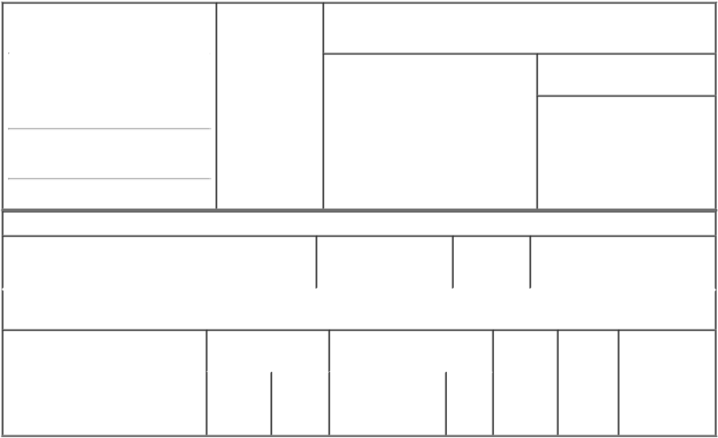

1. Name and Address of Reporting Person |  |  | * | 2. Date of Event
 |  |  |  | Requiring Statement
 | Cannito Peter Anthony Jr |  |  | Requiring Statement
 |  |  |  | (Month/Day/Year)
 |  |  |  | 12/07/2021

3. Issuer Name and Ticker or Trading Symbol

BigBear.ai Holdings, Inc. [ BBAI ]

(Last) (First) (Middle)

6811 BENJAMIN FRANKLIN

DRIVE

(Street)
COLUMBIA MD | 21046

- Relationship of Reporting Person(s) to Issuer
(Check all applicable)
X Director 10% Owner

Officer (give Other (specify
title below) below)

- If Amendment, Date of Original Filed (Month/Day/Year)

- Individual or Joint/Group Filing (Check Applicable Line)

- Form filed by One Reporting Person

Form filed by More than One Reporting Person

(City) (State) (Zip)

Table I - Non-Derivative Securities Beneficially Owned

 | 1. Title of Security (Instr. 4) | 2. Amount of Securities | 3. Ownership | 4. Nature of Indirect Beneficial
 |  | Beneficially Owned (Instr. | Form: Direct | Ownership (Instr. 5)
 |  | 4) | (D) or Indirect
 |  |  | (I) (Instr. 5)

Table II - Derivative Securities Beneficially Owned

(e.g., puts, calls, warrants, options, convertible securities)

1. Title of Derivative Security (Instr. 4) | 2. Date Exercisable and |  | 3. Title and Amount of Securities |  | 4. | 5. | 6. Nature of
 | Expiration Date |  | Underlying Derivative Security |  | Conversion | Ownership | Indirect Beneficial
 | (Month/Day/Year) |  | (Instr. 4) |  | or Exercise | Form: | Ownership (Instr.
 |  |  |  |  | Price of | Direct (D) | 5)
 |  |  |  | Amount | Price of | Direct (D) | 5)
 |  |  |  | Amount | Derivative | or Indirect
 |  |  |  | or | Security | (I) (Instr. 5)
 |  |  |  | Number
 | Date | Expiration |  | of
 | Exercisable | Date | Title | Shares

Explanation of Responses:

Remarks:

Exhibit 24: Power of Attorney.

No securities are beneficially owned.

 | /s/ Joshua Kinley, as
 | Attorney-in-Fact for Peter 12/07/2021
 | Cannito
 | ** Signature of Reporting |  |  |  | Date
 | Person |  |  |  | Date
Reminder: Report on a separate line for each class of securities beneficially owned directly or indirectly.
* If the form is filed by more than one reporting person, see Instruction 5 (b)(v).

- Intentional misstatements or omissions of facts constitute Federal Criminal Violations See 18 U.S.C. 1001 and 15 U.S.C. 78ff(a). Note: File three copies of this Form, one of which must be manually signed. If space is insufficient, see Instruction 6 for procedure.
Persons who respond to the collection of information contained in this form are not required to respond unless the form displays a currently valid OMB Number.

POWER OF ATTORNEY

KNOW ALL BY THESE PRESENTS, that the undersigned hereby makes, constitutes and appoints Dr. Louis R. Brothers, Joshua Kinley and Sean Ricker, signing singly, the undersigned's true and lawful attorneys-in-fact, with full power and authority as hereinafter described on behalf of and in the name, place and stead of the undersigned to:

- execute for and on behalf of the undersigned, in the undersigned's capacity as a director, director nominee, officer or beneficial owner of shares of common stock (the "Shares") of BigBear.ai Holdings, Inc., a Delaware corporation (the "Company"), any Schedule 13D or Schedule 13G, and any amendments, supplements or exhibits thereto (including any joint filing agreements) required to be filed by the undersigned under Section 13 of the Securities Exchange Act of 1934, as amended, and the rules and regulations promulgated thereunder (the "Exchange Act"), and any Forms 3, 4, and 5 and any amendments, supplements or exhibits thereto required to be filed by the undersigned under Section 16(a) of the Exchange Act;

- do and perform any and all acts for and on behalf of the undersigned which may be necessary or desirable to complete and execute any such Schedule 13D, Schedule 13G, Form 3, 4, or 5 and timely file such forms with the United States Securities and Exchange Commission and any stock exchange on which the Shares are then listed; and

- take any other action of any type whatsoever in connection with the foregoing which, in the opinion of such attorneys-in-fact, may be of benefit to, in the best interest of, or legally required by, the undersigned, it being understood that the documents executed by such attorneys-in-fact on behalf of the undersigned pursuant to this Power of Attorney shall be in such form and shall contain such terms and conditions as such attorneys-in-fact may approve in such attorneys-in-fact's discretion.

The undersigned hereby grants to such attorneys-in-fact full power and authority to do and perform any and every act and thing whatsoever requisite, necessary, or proper to be done in the exercise of any of the rights and powers herein granted, as fully to all intents and purposes as the undersigned might or could do if personally present, with full power of substitution or revocation, hereby ratifying and confirming all that such attorneys-in-fact's substitute or substitutes, shall lawfully do or cause to be done by virtue of this Power of Attorney and the rights and powers herein granted. The undersigned acknowledges that the foregoing attorneys-in-fact, in serving in such capacity at the request of the undersigned, are not assuming, nor is the Company assuming, any of the undersigned's responsibilities to comply with Section 13 and Section 16 of the Exchange Act.

This Power of Attorney shall remain in full force and effect until the undersigned is no longer required to file reports or schedules under Section 13 or Section 16 of the Exchange Act with respect to the undersigned's holdings of and transactions in securities issued by the Company, unless earlier revoked by the undersigned in a signed writing delivered to the foregoing attorneys-in-fact.

* * * * *

IN WITNESS WHEREOF, the undersigned has caused this Power of Attorney to be executed as of this 7th day of December, 2021.

/s/ Peter Cannito
-------------------------------
Name: Peter Cannito

