SEC Form 4

FORM 4

Check this box if no longer subject to Section 16. Form 4 or Form 5 obligations may continue. See Instruction 1(b).

UNITED STATES SECURITIES AND EXCHANGE COMMISSION
Washington, D.C. 20549
Washington, D.C. 20549 |  | OMB APPROVAL
STATEMENT OF CHANGES IN BENEFICIAL OWNERSHIP
STATEMENT OF CHANGES IN BENEFICIAL OWNERSHIP |  | OMB Number: | 3235-0287
STATEMENT OF CHANGES IN BENEFICIAL OWNERSHIP |  | Estimated average burden
Filed pursuant to Section 16(a) of the Securities Exchange Act of 1934 |  | hours per response: | 0.5
or Section 30(h) of the Investment Company Act of 1940
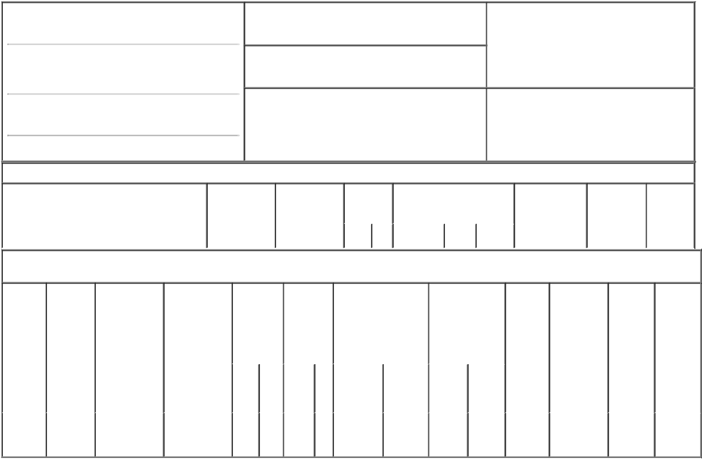

1. Name and Address of Reporting Person*
Ricker Sean Raymond

(Last) (First) (Middle)

6811 BENJAMIN FRANKLIN DRIVE

2. Issuer Name and Ticker or Trading Symbol

BigBear.ai Holdings, Inc. [ BBAI ]

3. Date of Earliest Transaction (Month/Day/Year)

12/07/2021

- Relationship of Reporting Person(s) to Issuer (Check all applicable)

 | Director | 10% Owner
X | Officer (give title | Other (specify
X | below) | below)

Corporate Controller

(Street)

COLUMBIA 21046

(City) (State) (Zip)

4. If Amendment, Date of Original Filed (Month/Day/Year) 6. Individual or Joint/Group Filing (Check Applicable
Line)
X Form filed by One Reporting Person

Form filed by More than One Reporting
Person

Table I - Non-Derivative Securities Acquired, Disposed of, or Beneficially Owned

1. Title of Security (Instr. 3) | 2. Transaction | 2A. Deemed | 3. | 4. Securities Acquired (A) or |  |  | 5. Amount of | 6. Ownership | 7. Nature
 | Date | Execution Date, | Transaction | Disposed Of (D) (Instr. 3, 4 and |  |  | Securities | Form: Direct | of Indirect
 | (Month/Day/Year) | if any | Code (Instr. | 5) |  |  | Beneficially | (D) or Indirect | Beneficial
 |  | (Month/Day/Year) | 8) |  |  |  | Owned Following | (I) (Instr. 4) | Ownership
 |  |  |  |  |  |  | Reported |  | (Instr. 4)
 |  |  | Code V | Amount | (A) or | Price | Transaction(s)
 |  |  | Code V | Amount | (D) | Price | (Instr. 3 and 4)

Table II - Derivative Securities Acquired, Disposed of, or Beneficially Owned

(e.g., puts, calls, warrants, options, convertible securities)

1. Title of | 2. | 3. Transaction | 3A. Deemed | 4. | 5. Number |  | 6. Date Exercisable and |  | 7. Title and Amount |  | 8. Price of | 9. Number of | 10. | 11. Nature
Derivative | Conversion | Date | Execution Date, | Transaction | of |  | Expiration Date |  | of Securities |  | Derivative | derivative | Ownership | of Indirect
Security | or Exercise | (Month/Day/Year) | if any | Code (Instr. | Derivative |  | (Month/Day/Year) |  | Underlying |  | Security | Securities | Form: | Beneficial
(Instr. 3) | Price of |  | (Month/Day/Year) | 8) | Securities |  |  |  | Derivative Security |  | (Instr. 5) | Beneficially | Direct (D) | Ownership
 | Derivative |  |  |  | Acquired |  |  |  | (Instr. 3 and 4) |  |  | Owned | or Indirect | (Instr. 4)
 | Security |  |  |  | (A) or |  |  |  |  |  |  | Following | (I) (Instr. 4)
 |  |  |  |  | Disposed |  |  |  |  |  |  | Reported
 |  |  |  |  | of (D) (Instr. |  |  |  |  |  |  | Transaction(s)
 |  |  |  |  | 3, 4 and 5) |  |  |  |  |  |  | (Instr. 4)
 |  |  |  |  |  |  |  |  |  | Amount
 |  |  |  |  |  |  |  |  |  | or
 |  |  |  |  |  |  |  |  |  | Number
 |  |  |  |  |  |  | Date | Expiration |  | of
 |  |  |  | Code V | (A) | (D) | Exercisable | Date | Title | Shares
Stock
Option | $9.99 | 12/07/2021 |  | A | 25,000 |  | (1) | 12/07/2031 | Common | 25,000 | $0.00 | 25,000 | D
(Right to |  |  |  |  |  |  |  |  | Stock
Buy)

Explanation of Responses:

1. The options were granted on December 7, 2021, and vest ratably on each of December 7, 2022, December 7, 2023, December 7, 2024 and December 7, 2025.

Remarks:

/s/ Joshua Kinley, as Attorney-

in-Fact for Sean Ricker

** Signature of Reporting Person

12/07/2021

Date

Reminder: Report on a separate line for each class of securities beneficially owned directly or indirectly.

* If the form is filed by more than one reporting person, see Instruction 4 (b)(v).

- Intentional misstatements or omissions of facts constitute Federal Criminal Violations See 18 U.S.C. 1001 and 15 U.S.C. 78ff(a). Note: File three copies of this Form, one of which must be manually signed. If space is insufficient, see Instruction 6 for procedure.
Persons who respond to the collection of information contained in this form are not required to respond unless the form displays a currently valid OMB Number.

