SEC Form 4

FORM 4

Check this box if no longer subject to Section 16. Form 4 or Form 5 obligations may continue. See Instruction 1(b).

UNITED STATES SECURITIES AND EXCHANGE COMMISSION
Washington, D.C. 20549
Washington, D.C. 20549 |  | OMB APPROVAL
STATEMENT OF CHANGES IN BENEFICIAL OWNERSHIP
STATEMENT OF CHANGES IN BENEFICIAL OWNERSHIP |  | OMB Number: | 3235-0287
 |  | Estimated average burden
Filed pursuant to Section 16(a) of the Securities Exchange Act of 1934 |  | hours per response: | 0.5
or Section 30(h) of the Investment Company Act of 1940
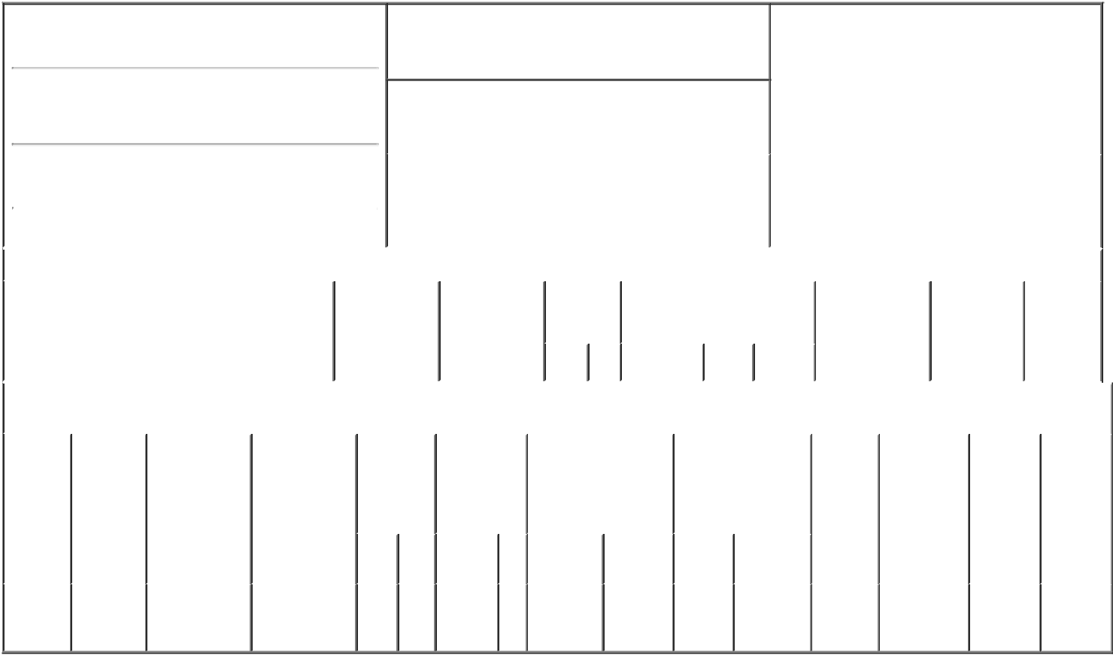

1. Name and Address of Reporting Person*
Frutchey Brian Douglas

(Last) (First) (Middle)

6811 BENJAMIN FRANKLIN DRIVE

2. Issuer Name and Ticker or Trading Symbol

BigBear.ai Holdings, Inc. [ BBAI ]

3. Date of Earliest Transaction (Month/Day/Year)

12/07/2021

- Relationship of Reporting Person(s) to Issuer (Check all applicable)

 | Director | 10% Owner
X | Officer (give title | Other (specify
X | below) | below)

Chief Technology Officer

 | (Street) |  |  |  |  |  |  |  | 4. If Amendment, Date of Original Filed (Month/Day/Year) |  |  |  |  |  |  | 6. Individual or Joint/Group Filing (Check Applicable Line)
 |  | COLUMBIA |  | MD |  | 21046
 |  |  |  |  |  | 21046 |  |  |  |  |  |  |  |  |  | X |  | Form filed by One Reporting Person
 |  |  |  |  |  |  |  |  |  |  |  |  |  |  |  |  |  | Form filed by More than One Reporting Person
 |  | (City) |  | (State) |  | (Zip)
 |  |  |  |  | Table I - Non-Derivative Securities Acquired, Disposed of, or Beneficially Owned
 | 1. Title of Security (Instr. 3) |  |  |  |  | 2. Transaction |  |  |  | 2A. Deemed |  | 3. |  | 4. Securities Acquired (A) or |  |  |  | 5. Amount of |  | 6. Ownership |  | 7. Nature of
 |  |  |  |  |  | Date |  |  |  | Execution Date, |  |  | Transaction Disposed Of (D) (Instr. 3, 4 and 5) |  |  |  |  | Securities |  | Form: Direct |  | Indirect
 |  |  |  |  |  | (Month/Day/Year) |  |  |  | if any |  |  | Code (Instr. |  |  |  |  | Beneficially |  | (D) or Indirect |  | Beneficial
 |  |  |  |  |  |  |  |  |  | (Month/Day/Year) 8) |  |  |  |  |  |  |  | Owned Following |  | (I) (Instr. 4) |  | Ownership
 |  |  |  |  |  |  |  |  |  |  |  |  |  |  |  |  |  | Reported |  |  |  | (Instr. 4)
 |  |  |  |  |  |  |  |  |  |  |  |  | Code V | Amount | (A) or | Price |  | Transaction(s)
 |  |  |  |  |  |  |  |  |  |  |  |  | Code V | Amount | (D) |  |  | (Instr. 3 and 4)
 |  |  |  |  |  | Table II - Derivative Securities Acquired, Disposed of, or Beneficially Owned
 |  |  |  |  |  | (e.g., puts, calls, warrants, options, convertible securities)
 | 1. Title of |  | 2. |  | 3. Transaction | 3A. Deemed | 4. |  |  | 5. Number of |  | 6. Date Exercisable and |  |  | 7. Title and Amount of |  |  | 8. Price of | 9. Number of |  | 10. | 11. Nature
 | Derivative |  | Conversion |  | Date | Execution Date, | Transaction |  |  | Derivative |  | Expiration Date |  |  | Securities Underlying |  |  | Derivative | derivative |  | Ownership of Indirect
 | Security |  | or Exercise |  | (Month/Day/Year) | if any | Code (Instr. |  |  | Securities |  | (Month/Day/Year) |  |  | Derivative Security |  |  | Security | Securities |  | Form: | Beneficial
 | (Instr. 3) |  | Price of |  |  | (Month/Day/Year) | 8) |  |  | Acquired (A) |  |  |  |  | (Instr. 3 and 4) |  |  | (Instr. 5) | Beneficially |  | Direct (D) | Ownership
 |  |  | Derivative |  |  |  |  |  |  | or Disposed of |  |  |  |  |  |  |  |  | Owned |  | or Indirect | (Instr. 4)
 |  |  | Security |  |  |  |  |  |  | (D) (Instr. 3, 4 |  |  |  |  |  |  |  |  | Following |  | (I) (Instr. 4)
 |  |  |  |  |  |  |  |  |  | and 5) |  |  |  |  |  |  |  |  | Reported
 |  |  |  |  |  |  |  |  |  |  |  |  |  |  |  |  |  |  | Transaction(s)
 |  |  |  |  |  |  |  |  |  |  |  |  |  |  |  | Amount or |  |  | (Instr. 4)
 |  |  |  |  |  |  |  |  |  |  |  | Date |  | Expiration |  | Number of
 |  |  |  |  |  |  | Code V |  |  | (A) | (D) | Exercisable |  | Date | Title | Shares
 | Stock
 | Option |  | $9.99 |  | 12/07/2021 |  | A |  |  | 30,468.75 |  | (1) |  | 12/07/2031 | Common | 30,468.75 |  | $0.00 | 30,468.75 |  | D
 | (Right to |  |  |  |  |  |  |  |  |  |  |  |  |  | Stock
Buy)

Explanation of Responses:

1. The options were granted on December 7, 2021, and vest ratably on each of December 7, 2022, December 7, 2023, December 7, 2024 and December 7, 2025.

Remarks:

/s/ Joshua Kinley, as Attorney-

in-Fact for Brian Frutchey

** Signature of Reporting Person

12/07/2021

Date

Reminder: Report on a separate line for each class of securities beneficially owned directly or indirectly.

* If the form is filed by more than one reporting person, see Instruction 4 (b)(v).

- Intentional misstatements or omissions of facts constitute Federal Criminal Violations See 18 U.S.C. 1001 and 15 U.S.C. 78ff(a). Note: File three copies of this Form, one of which must be manually signed. If space is insufficient, see Instruction 6 for procedure.
Persons who respond to the collection of information contained in this form are not required to respond unless the form displays a currently valid OMB Number.

