UNITED STATES

SECURITIES AND EXCHANGE COMMISSION

Washington, D.C. 20549

SCHEDULE 13G

Under the Securities Exchange Act of 1934

GIGCAPITAL5, INC.

(Name of Issuer)

COMMON STOCK, PAR VALUE $0.0001 PER SHARE

(Title of Class of Securities)

37519U109

(CUSIP Number)

JUNE 27, 2022

(Date of event which requires filing of this statement)

Check the appropriate box to designate the rule pursuant to which this Schedule is filed:

o Rule 13d-1(b)

- Rule 13d-1(c) o Rule 13d-1(d)

The remainder of this cover page shall be filled out for a reporting person’s initial filing on this form with respect to the subject class of securities, and for any subsequent amendment containing information which would alter the disclosures provided in a prior cover page.

The information required in the remainder of this cover page shall not be deemed to be "filed" for the purpose of Section 18 of the Securities Exchange Act of 1934 ("Act") or otherwise subject to the liabilities of that section of the Act but shall be subject to all other provisions of the Act (however, see the notes).
CUSIP No. | 37519U109 | SCHEDULE 13G | Page | 2 | of | 10
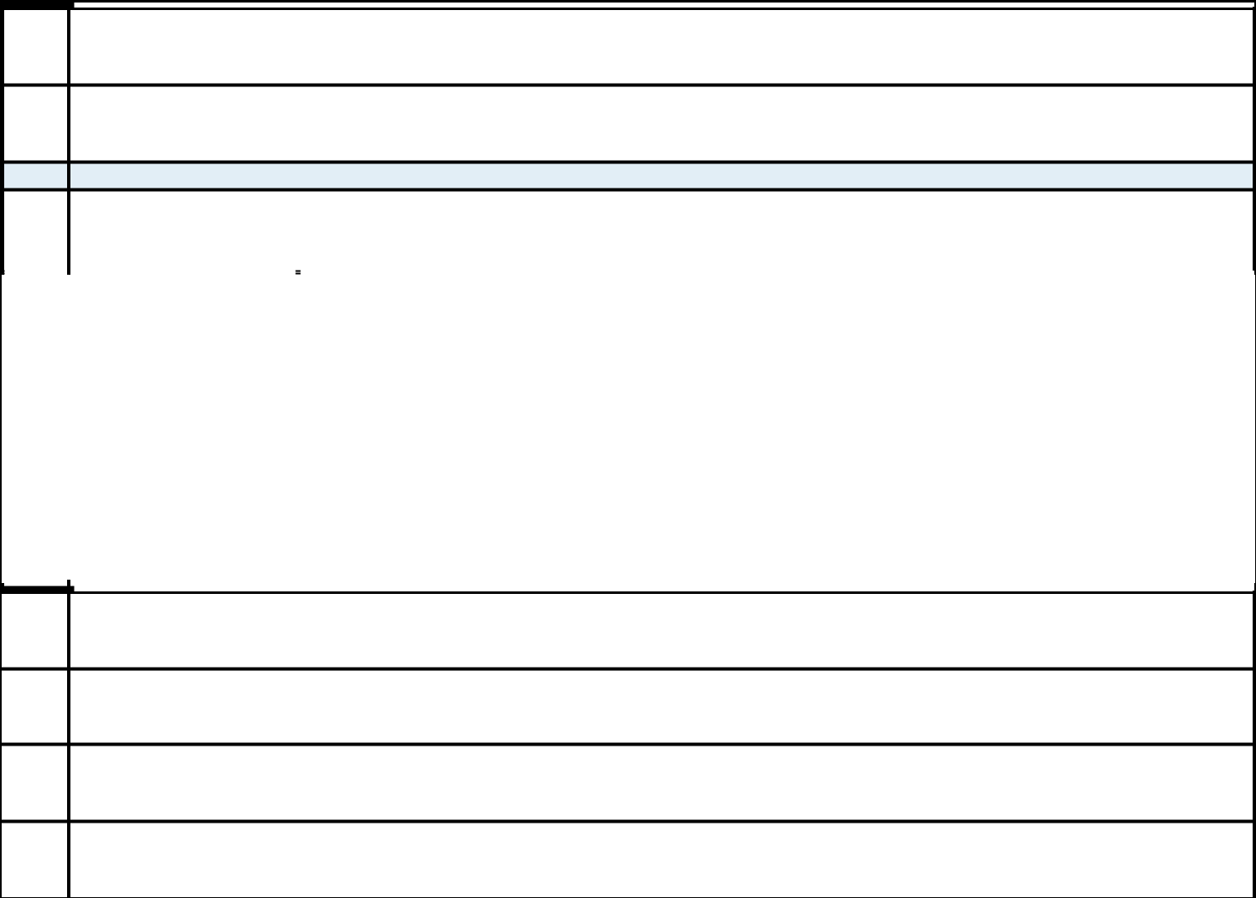

NAMES OF REPORTING PERSONS

1

Millennium Management LLC

CHECK THE APPROPRIATE BOX IF A MEMBER OF A GROUP

- (a) o

  - o

- SEC USE ONLY

CITIZENSHIP OR PLACE OF ORGANIZATION

4

Delaware

 | 5 | SOLE VOTING POWER
NUMBER OF |  | -0-
NUMBER OF |  | SHARED VOTING POWER
SHARES | 6 | SHARED VOTING POWER
BENEFICIALLY | 6
BENEFICIALLY |  | 1,483,470
OWNED BY |  | 1,483,470
OWNED BY |  | SOLE DISPOSITIVE POWER
EACH | 7 | SOLE DISPOSITIVE POWER
REPORTING | 7
REPORTING |  | -0-
PERSON WITH |  | -0-
PERSON WITH | 8 | SHARED DISPOSITIVE POWER
 |  | 1,483,470

AGGREGATE AMOUNT BENEFICIALLY OWNED BY EACH REPORTING PERSON

9

1,483,470

CHECK BOX IF THE AGGREGATE AMOUNT IN ROW (9) EXCLUDES CERTAIN SHARES

10

o

PERCENT OF CLASS REPRESENTED BY AMOUNT IN ROW (9)

11

5.0%

TYPE OF REPORTING PERSON

12

OO

CUSIP No. | 37519U109 | SCHEDULE 13G | Page | 3 | of | 10
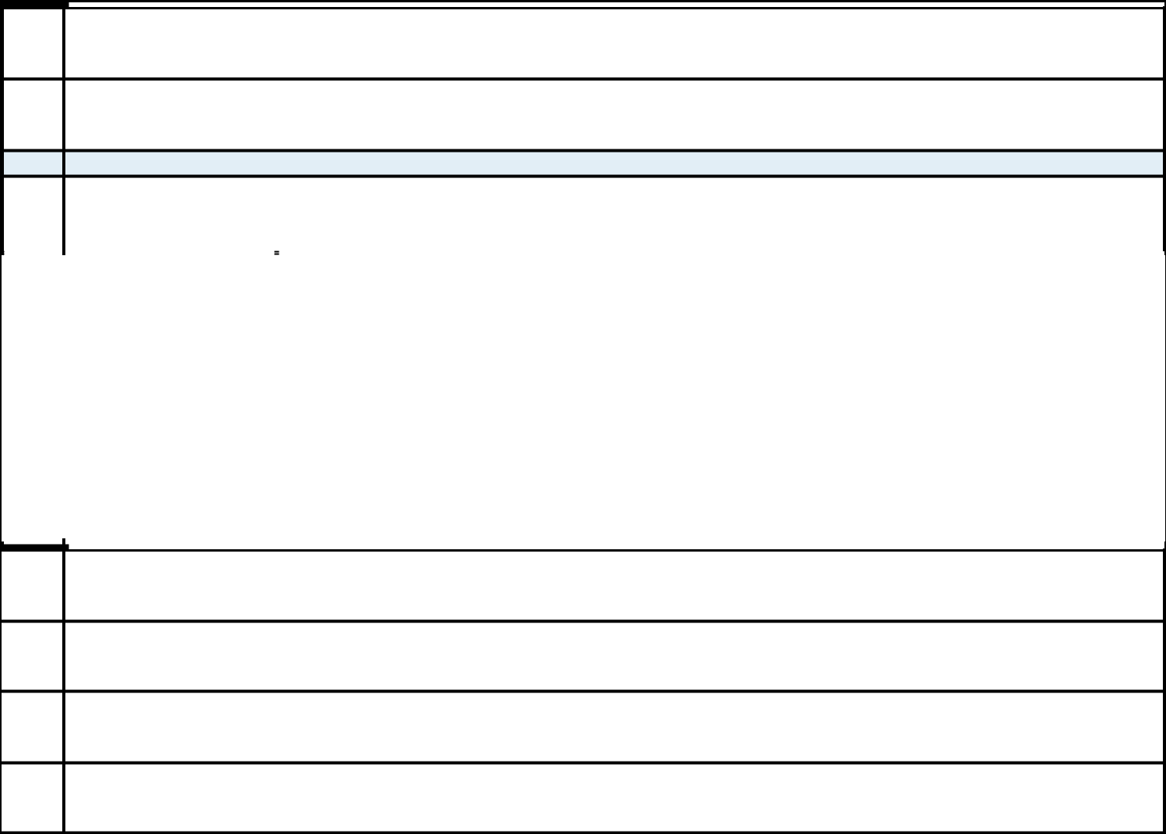

NAMES OF REPORTING PERSONS

1

Millennium Group Management LLC

CHECK THE APPROPRIATE BOX IF A MEMBER OF A GROUP

- (a) o

  - o

- SEC USE ONLY

CITIZENSHIP OR PLACE OF ORGANIZATION

4

Delaware

 | 5 | SOLE VOTING POWER
 | 5 | -0-
NUMBER OF |  | -0-
NUMBER OF |  | SHARED VOTING POWER
SHARES | 6 | SHARED VOTING POWER
BENEFICIALLY | 6 | 1,483,470
OWNED BY |  | 1,483,470
OWNED BY |  | SOLE DISPOSITIVE POWER
EACH | 7 | SOLE DISPOSITIVE POWER
REPORTING | 7 | -0-
PERSON WITH |  | -0-
 | 8 | SHARED DISPOSITIVE POWER
 | 8 | 1,483,470

AGGREGATE AMOUNT BENEFICIALLY OWNED BY EACH REPORTING PERSON

9

1,483,470

CHECK BOX IF THE AGGREGATE AMOUNT IN ROW (9) EXCLUDES CERTAIN SHARES

10

o

PERCENT OF CLASS REPRESENTED BY AMOUNT IN ROW (9)

11

5.0%

TYPE OF REPORTING PERSON

12

OO

CUSIP No. | 37519U109 | SCHEDULE 13G | Page | 4 | of | 10
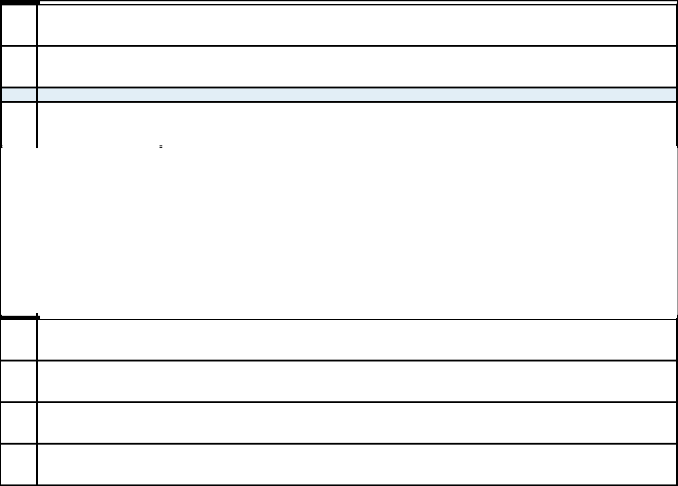

NAMES OF REPORTING PERSONS

1

Israel A. Englander

CHECK THE APPROPRIATE BOX IF A MEMBER OF A GROUP

- (a) o

  - o

- SEC USE ONLY

CITIZENSHIP OR PLACE OF ORGANIZATION

4

United States

 | 5 | SOLE VOTING POWER
 | 5 | -0-
NUMBER OF |  | -0-
NUMBER OF |  | SHARED VOTING POWER
SHARES | 6 | SHARED VOTING POWER
BENEFICIALLY | 6 | 1,483,470
OWNED BY |  | 1,483,470
OWNED BY |  | SOLE DISPOSITIVE POWER
EACH | 7 | SOLE DISPOSITIVE POWER
REPORTING | 7 | -0-
PERSON WITH |  | -0-
 | 8 | SHARED DISPOSITIVE POWER
 | 8 | 1,483,470

AGGREGATE AMOUNT BENEFICIALLY OWNED BY EACH REPORTING PERSON

9

1,483,470

CHECK BOX IF THE AGGREGATE AMOUNT IN ROW (9) EXCLUDES CERTAIN SHARES

10

o

PERCENT OF CLASS REPRESENTED BY AMOUNT IN ROW (9)

11

5.0%

TYPE OF REPORTING PERSON

12

IN

CUSIP No. | 37519U109 | SCHEDULE 13G | Page | 5 | of | 10

Item 1.

- Name of Issuer: GigCapital5, Inc.
- Address of Issuer’s Principal Executive Offices:

1731 Embarcadero Road, Suite 200

Palo Alto, California 94303

Item 2. (a) Name of Person Filing:

- Address of Principal Business Office:

- Citizenship:

Millennium Management LLC 399 Park Avenue

New York, New York 10022 Citizenship: Delaware

Millennium Group Management LLC 399 Park Avenue

New York, New York 10022 Citizenship: Delaware

Israel A. Englander

c/o Millennium Management LLC 399 Park Avenue
New York, New York 10022 Citizenship: United States

- Title of Class of Securities:

common stock, par value $0.0001 per share ("Common Stock")

- CUSIP Number: 37519U109

Item 3. If this statement is filed pursuant to Rule 13d-1(b), or 13d-2(b), check whether the person filing is a:

- oBroker or dealer registered under section 15 of the Act (15 U.S.C. 78o);

- oBank as defined in section 3(a)(6) of the Act (15 U.S.C. 78c);

- oInsurance company as defined in section 3(a)(19) of the Act (15 U.S.C. 78c);

- oInvestment company registered under section 8 of the Investment Company Act of 1940 (15 U.S.C. 80a-8);

- oAn investment adviser in accordance with §240.13d-1(b)(1)(ii)(E);

- oAn employee benefit plan or endowment fund in accordance with §240.13d-1(b)(1)(ii)(F);

CUSIP No. | 37519U109 | SCHEDULE 13G | Page | 6 | of | 10

- oA parent holding company or control person in accordance with §240.13d-1(b)(1)(ii)(G);

- oA savings association as defined in Section 3(b) of the Federal Deposit Insurance Act (12 U.S.C. 1813);

- oA church plan that is excluded from the definition of an investment company under section 3(c)(14) of the Investment Company Act of 1940 (15 U.S.C. 80a-3);

- oGroup, in accordance with §240.13d-1(b)(1)(ii)(J).

Provide the following information regarding the aggregate number and percentage of the class of securities of the issuer identified in Item 1.

See response to Item 9 on each cover page.

See response to Item 11 on each cover page.

- Number of shares as to which such person has:

  - Sole power to vote or to direct the vote See response to Item 5 on each cover page.

CUSIP No. | 37519U109 | SCHEDULE 13G | Page | 7 | of | 10

- Shared power to vote or to direct the vote See response to Item 6 on each cover page.
- Sole power to dispose or to direct the disposition of See response to Item 7 on each cover page.

- Shared power to dispose or to direct the disposition of See response to Item 8 on each cover page.

The securities disclosed herein as potentially beneficially owned by Millennium Management LLC, Millennium Group Management LLC and Mr. Englander are held by entities subject to voting control and investment discretion by Millennium Management LLC and/or other investment managers that may be controlled by Millennium Group Management LLC (the managing member of Millennium Management LLC) and Mr. Englander (the sole voting trustee of the managing member of Millennium Group Management LLC). The foregoing should not be construed in and of itself as an admission by Millennium Management LLC, Millennium Group Management LLC or Mr. Englander as to beneficial ownership of the securities held by such entities.

Item 5. Ownership of Five Percent or Less of a Class

If this statement is being filed to report the fact that as of the date hereof the reporting person has ceased to be the beneficial owner of more than five percent of the class of securities, check the following o.

Item 6. Ownership of More than Five Percent on Behalf of Another Person.

Not applicable.

Item 7. Identification and Classification of the Subsidiary Which Acquired the Security Being Reported on By the Parent Holding Company.

Not applicable.

Item 8. Identification and Classification of Members of the Group

See Exhibit I.

Item 9. Notice of Dissolution of Group

Not applicable.

Item 10. Certification

By signing below each of the undersigned certifies that, to the best of its knowledge and belief, the securities referred to above were not acquired and are not held for the purpose of or with the effect of changing or influencing the control of the issuer of the securities and were not acquired and are not held in connection with or as a participant in any transaction having that purpose or effect.

CUSIP No. | 37519U109 | SCHEDULE 13G | Page | 8 | of | 10

Exhibits:

Exhibit I: Joint Filing Agreement, dated as of July 5, 2022, by and among Millennium Management LLC, Millennium Group Management LLC and Israel A.

Englander.

CUSIP No. | 37519U109 | SCHEDULE 13G | Page | 9 | of | 10

SIGNATURE

After reasonable inquiry and to the best of its knowledge and belief, each of the undersigned certifies that the information with respect to it set forth in this statement is true, complete, and correct.

Dated: July 5, 2022

MILLENNIUM MANAGEMENT LLC

By: /s/Gil Raviv

Name: Gil Raviv

Title: Global General Counsel

MILLENNIUM GROUP MANAGEMENT LLC

By: /s/Gil Raviv

Name: Gil Raviv

Title: Global General Counsel

/s/ Israel A. Englander

Israel A. Englander

CUSIP No. | 37519U109 | SCHEDULE 13G | Page | 10 | of | 10

EXHIBIT I

JOINT FILING AGREEMENT

This will confirm the agreement by and among the undersigned that the Schedule 13G filed with the Securities and Exchange Commission on or about the date hereof with respect to the beneficial ownership by the undersigned of the Common Stock, par value $0.0001 per share, of GigCapital5, Inc. will be filed on behalf of each of the persons and entities named below in accordance with Rule 13d-1(k) under the Securities Exchange Act of 1934, as amended. This Agreement may be executed in two or more counterparts, each of which shall be deemed an original, but all of which together shall constitute one and the same instrument.

Dated: July 5, 2022

MILLENNIUM MANAGEMENT LLC

By: /s/Gil Raviv

Name: Gil Raviv

Title: Global General Counsel

MILLENNIUM GROUP MANAGEMENT LLC

By: /s/Gil Raviv

Name: Gil Raviv

Title: Global General Counsel

/s/ Israel A. Englander

Israel A. Englander

