SEC Form 3
FORM 3 | UNITED STATES SECURITIES AND EXCHANGE
 | COMMISSION
 | COMMISSION |  | OMB APPROVAL
 | Washington, D.C. 20549
 | Washington, D.C. 20549 |  | OMB Number: | 3235-
 |  |  | OMB Number: | 0104
 | INITIAL STATEMENT OF BENEFICIAL OWNERSHIP OF |  |  | 0104
 | INITIAL STATEMENT OF BENEFICIAL OWNERSHIP OF |  | Estimated average burden
 | SECURITIES |  | response: | 0.5
 |  |  | hours per


Filed pursuant to Section 16(a) of the Securities Exchange Act of 1934

or Section 30(h) of the Investment Company Act of 1940
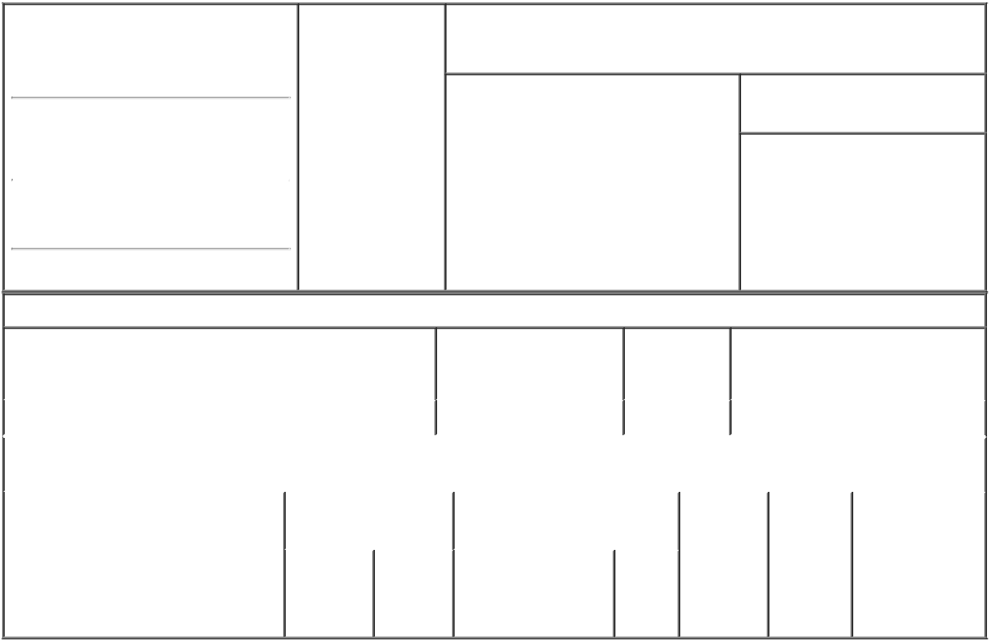

1. Name and Address of Reporting Person* |  |  |  | 2. Date of Event
 | Polar Asset Management |  |  | Requiring Statement
 |  |  |  | (Month/Day/Year)
 | Partners Inc. |  |  | 09/23/2022

3. Issuer Name and Ticker or Trading Symbol

GigCapital5, Inc. [ GIA ]

(Last) | (First) | (Middle)
16 YORK STREET SUITE 2900
(Street)
TORONTO A6 |  | M5J 0E6

- Relationship of Reporting Person(s) to Issuer
(Check all applicable)

Director X 10% Owner

Officer (give Other (specify

title below) below)

- If Amendment, Date of Original Filed (Month/Day/Year)

- Individual or Joint/Group Filing (Check Applicable Line)

- Form filed by One Reporting Person

Form filed by More than One Reporting Person

(City) (State) (Zip)

Table I - Non-Derivative Securities Beneficially Owned

1. Title of Security (Instr. 4) | 2. Amount of Securities | 3. Ownership | 4. Nature of Indirect Beneficial
 | Beneficially Owned (Instr. | Form: Direct | Ownership (Instr. 5)
 | 4) | (D) or Indirect
 |  | (I) (Instr. 5)

 | Common Stock, par value $0.0001 per share |  |  |  | 1,547,620 |  | I |  | See footnote (1)⁽¹⁾
 |  |  | Table II - Derivative Securities Beneficially Owned
 |  | (e.g., puts, calls, warrants, options, convertible securities)
 | 1. Title of Derivative Security (Instr. 4) |  | 2. Date Exercisable and |  | 3. Title and Amount of Securities |  |  |  | 4. | 5. | 6. Nature of
 |  |  | Expiration Date |  | Underlying Derivative Security |  |  |  | Conversion | Ownership | Indirect Beneficial
 |  |  | (Month/Day/Year) |  | (Instr. 4) |  |  |  | or Exercise | Form: | Ownership (Instr.
 |  |  |  |  |  |  |  |  | Price of | Direct (D) | 5)
 |  |  |  |  |  | Amount |  |  | Price of | Direct (D) | 5)
 |  |  |  |  |  | Amount |  |  | Derivative | or Indirect
 |  |  |  |  |  | or |  |  | Security | (I) (Instr. 5)
 |  |  |  |  |  | Number
 |  |  | Date | Expiration |  | of
 |  |  | Exercisable | Date | Title | Shares

Explanation of Responses:

- Polar Asset Management Partners Inc., a company incorporated under the laws of Ontario, Canada (the "Reporting Person"), serves as investment advisor to Polar Multi-Strategy Master Fund, a Cayman Islands exempted company ("PMSMF") and has sole voting and investment discretion with respect to the securities reported herein which are held by PMSMF. The Reporting Person disclaims beneficial ownership of these securities, and this report shall not be deemed an admission that Reporting Person is the beneficial owner of the securities reported herein for the purpose of Section 16 of the Securities Exchange Act of 1934, as amended, or for any other purpose, except to the extent of Reporting Person's pecuniary interest therein. This Form 3 is being filed due to the redemption of 18,985,950 shares of common stock (as announced by the Company in a Form 8-K filed on September 23, 2022) by Company shareholders, after which the Reporting Person's aggregate beneficial ownership was above 10%.

Andrew Ma, Chief
Compliance Officer, on _{10/03/2022}
behalf of Polar Asset
Management Partners Inc.

** Signature of Reporting | Date
Person | Date
Reminder: Report on a separate line for each class of securities beneficially owned directly or indirectly.
* If the form is filed by more than one reporting person, see Instruction 5 (b)(v).

- Intentional misstatements or omissions of facts constitute Federal Criminal Violations See 18 U.S.C. 1001 and 15 U.S.C. 78ff(a). Note: File three copies of this Form, one of which must be manually signed. If space is insufficient, see Instruction 6 for procedure.

Persons who respond to the collection of information contained in this form are not required to respond unless the form displays a currently valid OMB Number.

