SEC Form 4

FORM 4

Check this box if no longer subject to Section 16. Form 4 or Form 5 obligations may continue. See Instruction 1(b).

UNITED STATES SECURITIES AND EXCHANGE COMMISSION
Washington, D.C. 20549
Washington, D.C. 20549 |  | OMB APPROVAL
STATEMENT OF CHANGES IN BENEFICIAL OWNERSHIP
STATEMENT OF CHANGES IN BENEFICIAL OWNERSHIP |  | OMB Number: | 3235-0287
STATEMENT OF CHANGES IN BENEFICIAL OWNERSHIP |  | Estimated average burden
Filed pursuant to Section 16(a) of the Securities Exchange Act of 1934 |  | hours per response: | 0.5
or Section 30(h) of the Investment Company Act of 1940
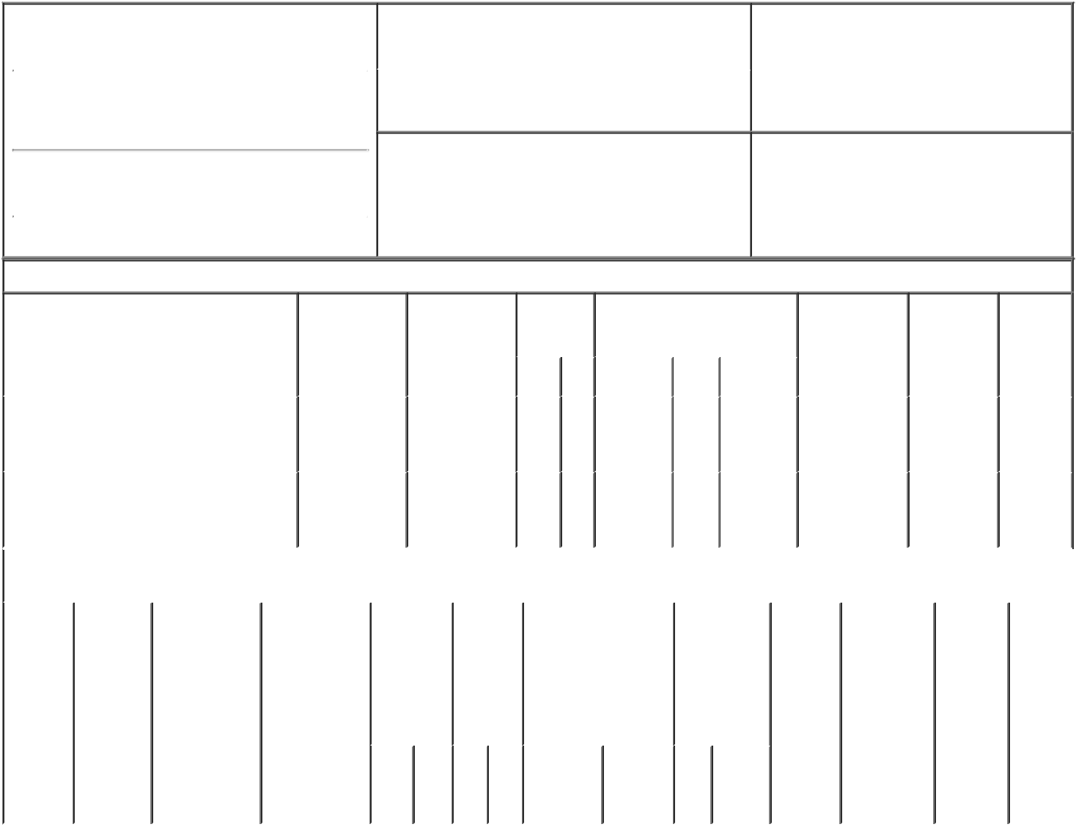

1. Name and Address of Reporting Person* |  |  |  |  | 2. |  |  | Issuer Name and Ticker or Trading Symbol
 | Polar Asset Management Partners Inc. |  |  |  |  |  | GigCapital5, Inc. [ GIA ]
 | (Last) | (First) | (Middle) |  | 3. |  |  | Date of Earliest Transaction (Month/Day/Year)
 | (Last) | (First) |  |  | 02/28/2023
16 YORK STREET SUITE 2900

- Relationship of Reporting Person(s) to Issuer (Check all applicable)

Director X 10% Owner

Officer (give title Other (specify

below) below)

(Street)
 | TORONTO | A6 | M5J 0E6
 | (City) | (State) | (Zip)

4. If Amendment, Date of Original Filed (Month/Day/Year) 6. Individual or Joint/Group Filing (Check Applicable

Line)

X Form filed by One Reporting Person

Form filed by More than One Reporting

Person

Table I - Non-Derivative Securities Acquired, Disposed of, or Beneficially Owned

1. Title of Security (Instr. 3) | 2. Transaction | 2A. Deemed | 3. | 4. Securities Acquired (A) or |  |  | 5. Amount of | 6. Ownership | 7. Nature
 | Date | Execution Date, | Transaction | Disposed Of (D) (Instr. 3, 4 and 5) |  |  | Securities | Form: Direct | of Indirect
 | (Month/Day/Year) | if any | Code (Instr. |  |  |  | Beneficially | (D) or Indirect | Beneficial
 |  | (Month/Day/Year) | 8) |  |  |  | Owned Following | (I) (Instr. 4) | Ownership
 |  |  |  |  |  |  | Reported |  | (Instr. 4)
 |  |  | Code V | Amount | (A) or | Price | Transaction(s)
 |  |  | Code V | Amount | (D) | Price | (Instr. 3 and 4)

 | Common Stock, par value $0.0001 per |  |  |  |  |  |  |  |  |  |  |  |  |  |  |  | See
 |  |  |  |  | 02/28/2023 |  |  | S | 80,000 | D | $10.45 |  |  | 1,467,620 |  | I | footnote
 | share
 | share |  |  |  |  |  |  |  |  |  |  |  |  |  |  |  | ₁(1)
 | Common Stock, par value $0.0001 per |  |  |  |  |  |  |  |  |  |  |  |  |  |  |  | See
 |  |  |  |  | 02/28/2023 |  |  | S | 15,400 | D | $10.4014 |  |  | 1,452,220 |  | I | Footnote
 | share
 | share |  |  |  |  |  |  |  |  |  |  |  |  |  |  |  | ₁(1)
 |  |  | Table II - Derivative Securities Acquired, Disposed of, or Beneficially Owned
 |  |  |  |  | (e.g., puts, calls, warrants, options, convertible securities)
 | 1. Title of | 2. | 3. Transaction | 3A. Deemed |  | 4. | 5. Number | 6. Date Exercisable and |  | 7. Title and |  |  | 8. Price of |  | 9. Number of | 10. | 11. Nature
 | Derivative | Conversion | Date | Execution Date, |  | Transaction | of | Expiration Date |  | Amount of |  |  | Derivative |  | derivative | Ownership | of Indirect
 | Security | or Exercise | (Month/Day/Year) | if any |  | Code (Instr. | Derivative | (Month/Day/Year) |  | Securities |  |  | Security |  | Securities | Form: | Beneficial
 | (Instr. 3) | Price of |  | (Month/Day/Year) |  | 8) | Securities |  |  | Underlying |  |  | (Instr. 5) |  | Beneficially | Direct (D) | Ownership
 |  | Derivative |  |  |  |  | Acquired |  |  | Derivative |  |  |  |  | Owned | or Indirect | (Instr. 4)
 |  | Security |  |  |  |  | (A) or |  |  | Security (Instr. |  |  |  |  | Following | (I) (Instr. 4)
 |  |  |  |  |  |  | Disposed |  |  | 3 and 4) |  |  |  |  | Reported
 |  |  |  |  |  |  | of (D) |  |  |  |  |  |  |  | Transaction(s)
 |  |  |  |  |  |  | (Instr. 3, 4 |  |  |  |  |  |  |  | (Instr. 4)
 |  |  |  |  |  |  | and 5)
 |  |  |  |  |  |  |  |  |  |  | Amount
 |  |  |  |  |  |  |  |  |  |  | or
 |  |  |  |  |  |  |  |  |  |  | Number
 |  |  |  |  |  |  |  | Date | Expiration |  | of
 |  |  |  |  |  | Code V | (A) (D) | Exercisable | Date | Title | Shares

Explanation of Responses:

- Polar Asset Management Partners Inc., a company incorporated under the laws of Ontario, Canada (the "Reporting Person"), serves as investment advisor to Polar Multi-Strategy Master Fund, a Cayman Islands exempted company ("PMSMF") and has sole voting and investment discretion with respect to the securities reported herein which are held by PMSMF. The Reporting Person disclaims beneficial ownership of the securities reported herein, and this report shall not be deemed an admission that Reporting Person is the beneficial owner of the securities reported herein for the purpose of Section 16 of the Securities Exchange Act of 1934, as amended, or for any other purpose, except to the extent of Reporting Person's pecuniary interest therein.

/s/ Andrew Ma, Chief

Compliance Officer, on behalf
of Polar Asset Management
Partners Inc.

** Signature of Reporting Person

03/02/2023

Date

Reminder: Report on a separate line for each class of securities beneficially owned directly or indirectly.

* If the form is filed by more than one reporting person, see Instruction 4 (b)(v).

- Intentional misstatements or omissions of facts constitute Federal Criminal Violations See 18 U.S.C. 1001 and 15 U.S.C. 78ff(a). Note: File three copies of this Form, one of which must be manually signed. If space is insufficient, see Instruction 6 for procedure.

Persons who respond to the collection of information contained in this form are not required to respond unless the form displays a currently valid OMB Number.

