SEC Form 4

FORM 4

Check this box if no longer subject
- to Section 16. Form 4 or Form 5 obligations may continue. See Instruction 1(b).

UNITED STATES SECURITIES AND EXCHANGE COMMISSION
Washington, D.C. 20549
Washington, D.C. 20549 |  | OMB APPROVAL
STATEMENT OF CHANGES IN BENEFICIAL OWNERSHIP
STATEMENT OF CHANGES IN BENEFICIAL OWNERSHIP |  | OMB Number: | 3235-0287
STATEMENT OF CHANGES IN BENEFICIAL OWNERSHIP |  | Estimated average burden
Filed pursuant to Section 16(a) of the Securities Exchange Act of 1934 |  | hours per response: | 0.5
or Section 30(h) of the Investment Company Act of 1940
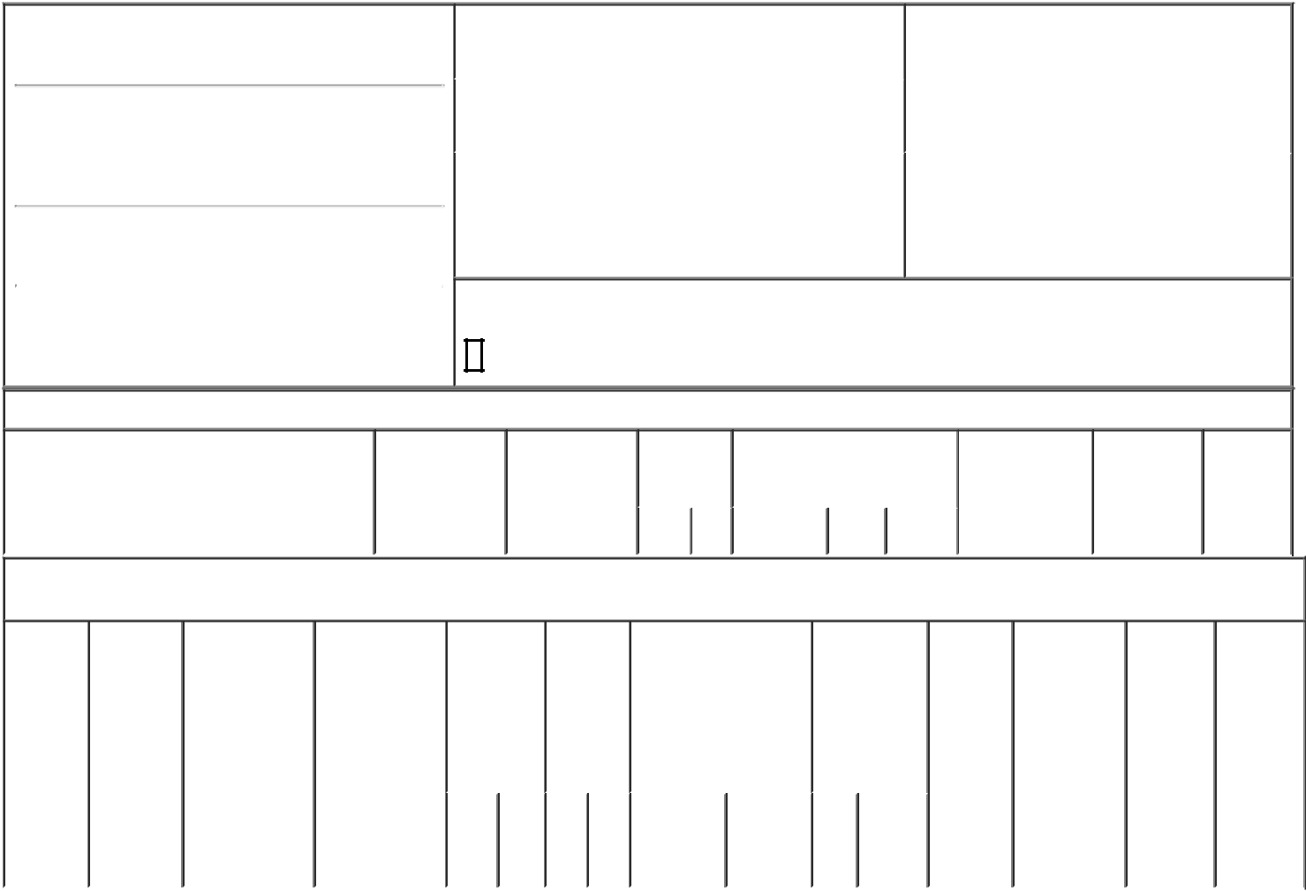

1. Name and Address of Reporting Person*
Weightman Walter Bradford

(Last) (First) (Middle)

C/O QT IMAGING HOLDINGS, INC.

3 HAMILTON LANDING SUITE 160

(Street)
 | NOVATO | CA | 94949
 | (City) | (State) | (Zip)

2. |  | Issuer Name and Ticker or Trading Symbol |  | 5. | Relationship of Reporting Person(s) to Issuer
 | QT IMAGING HOLDINGS, INC. [ QTI ] |  |  | (Check all applicable)
 |  |  |  |  |  | Director | 10% Owner
 |  |  |  |  | X | Officer (give title | Other (specify
3. |  | Date of Earliest Transaction (Month/Day/Year) |  |  | X | Officer (give title | Other (specify
 |  |  |  |  | X | below) | below)
03/04/2024 |  |  |  |  |  | Chief Financial Officer
4. |  | If Amendment, Date of Original Filed (Month/Day/Year) |  | 6. | Individual or Joint/Group Filing (Check Applicable
Line)

X Form filed by One Reporting Person

Form filed by More than One Reporting

Person

Rule 10b5-1(c) Transaction Indication

Check this box to indicate that a transaction was made pursuant to a contract, instruction or written plan that is intended to satisfy the affirmative defense conditions of Rule 10b5-1(c). See Instruction 10.

Table I - Non-Derivative Securities Acquired, Disposed of, or Beneficially Owned

1. Title of Security (Instr. 3) | 2. Transaction | 2A. Deemed | 3. | 4. Securities Acquired (A) or |  |  | 5. Amount of | 6. Ownership | 7. Nature
 | Date | Execution Date, | Transaction | Disposed Of (D) (Instr. 3, 4 and |  |  | Securities | Form: Direct | of Indirect
 | (Month/Day/Year) | if any | Code (Instr. | 5) |  |  | Beneficially | (D) or Indirect | Beneficial
 |  | (Month/Day/Year) | 8) |  |  |  | Owned Following | (I) (Instr. 4) | Ownership
 |  |  |  |  |  |  | Reported |  | (Instr. 4)
 |  |  | Code V | Amount | (A) or | Price | Transaction(s)
 |  |  | Code V | Amount | (D) | Price | (Instr. 3 and 4)

Table II - Derivative Securities Acquired, Disposed of, or Beneficially Owned

(e.g., puts, calls, warrants, options, convertible securities)

1. Title of | 2. | 3. Transaction | 3A. Deemed | 4. | 5. Number | 6. Date Exercisable and |  |  | 7. Title and |  |  | 8. Price of | 9. Number of |  |  | 10. | 11. Nature
Derivative | Conversion | Date | Execution Date, | Transaction | of | Expiration Date |  |  | Amount of |  |  | Derivative | derivative |  |  | Ownership | of Indirect
Security | or Exercise | (Month/Day/Year) | if any | Code (Instr. | Derivative | (Month/Day/Year) |  |  | Securities |  |  | Security | Securities |  |  | Form: | Beneficial
(Instr. 3) | Price of |  | (Month/Day/Year) | 8) | Securities |  |  |  | Underlying |  |  | (Instr. 5) | Beneficially |  |  | Direct (D) | Ownership
 | Derivative |  |  |  | Acquired |  |  |  | Derivative |  |  |  | Owned |  |  | or Indirect | (Instr. 4)
 | Security |  |  |  | (A) or |  |  |  | Security (Instr. |  |  |  | Following |  |  | (I) (Instr. 4)
 |  |  |  |  | Disposed |  |  |  | 3 and 4) |  |  |  | Reported
 |  |  |  |  | of (D) |  |  |  |  |  |  |  | Transaction(s)
 |  |  |  |  | (Instr. 3, 4 |  |  |  |  |  |  |  | (Instr. 4)
 |  |  |  |  | and 5)
 |  |  |  |  |  |  |  |  | Amount
 |  |  |  |  |  |  |  |  | or
 |  |  |  |  |  |  |  |  | Number
 |  |  |  |  |  | Date | Expiration |  | of
 |  |  |  | Code V | (A) (D) | Exercisable | Date |  | Title Shares
Explanation of Responses:
Remarks:
The reporting person's status as an insider terminated as of March 4, 2024 and that the reporting person therefore is no longer subject to Section 16.
 |  |  |  |  |  |  |  | /s/ Bradford Walter |  |  |  |  | 03/06/2024
 |  |  |  |  |  |  |  | Weightman
 |  |  |  |  |  |  |  | ** Signature of Reporting Person |  |  |  |  | Date

Reminder: Report on a separate line for each class of securities beneficially owned directly or indirectly.

* If the form is filed by more than one reporting person, see Instruction 4 (b)(v).

- Intentional misstatements or omissions of facts constitute Federal Criminal Violations See 18 U.S.C. 1001 and 15 U.S.C. 78ff(a). Note: File three copies of this Form, one of which must be manually signed. If space is insufficient, see Instruction 6 for procedure.

Persons who respond to the collection of information contained in this form are not required to respond unless the form displays a currently valid OMB Number.

