SEC Form 4

FORM 4

Check this box if no longer subject to Section 16. Form 4 or Form 5 obligations may continue. See Instruction 1(b).

UNITED STATES SECURITIES AND EXCHANGE COMMISSION
Washington, D.C. 20549
Washington, D.C. 20549 |  | OMB APPROVAL
STATEMENT OF CHANGES IN BENEFICIAL OWNERSHIP
STATEMENT OF CHANGES IN BENEFICIAL OWNERSHIP |  | OMB Number: | 3235-0287
 |  | Estimated average burden
Filed pursuant to Section 16(a) of the Securities Exchange Act of 1934 |  | hours per response: | 0.5
or Section 30(h) of the Investment Company Act of 1940
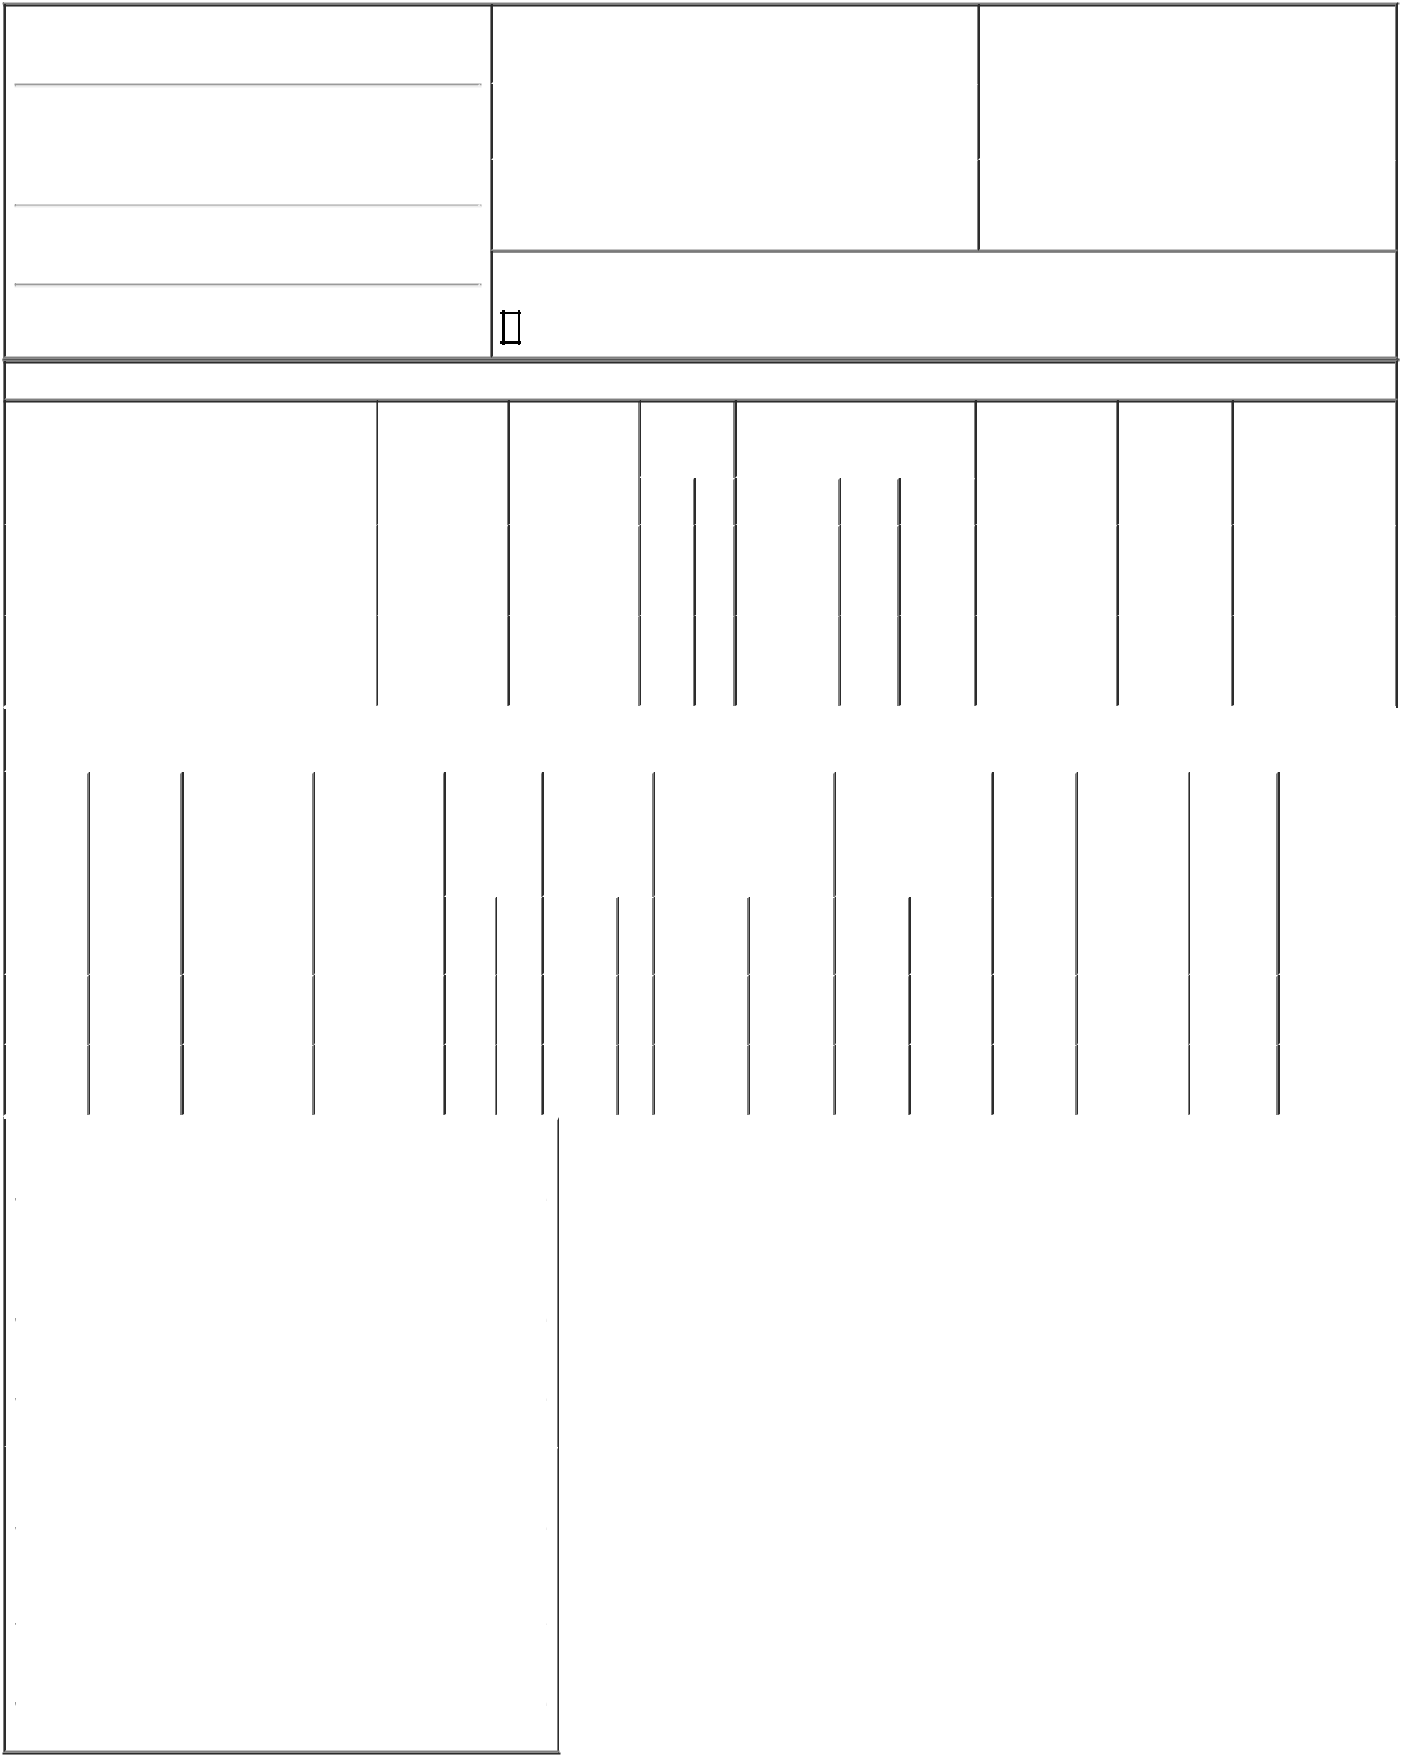

1. Name and Address of Reporting Person*
Katz Avi S

(Last) | (First) | (Middle)
C/O GIGCAPITAL GROUP
1731 EMBARCADERO ROAD, SUITE 200
(Street)
PALO ALTO | CA | 94303
(City) | (State) | (Zip)

2. |  | Issuer Name and Ticker or Trading Symbol |  | 5. Relationship of Reporting Person(s) to Issuer
 | QT IMAGING HOLDINGS, INC. [ QTI ] |  |  | (Check all applicable)
 |  |  |  | X Director |  | X | 10% Owner
 |  |  |  | X | Officer (give title |  | Other (specify
3. |  | Date of Earliest Transaction (Month/Day/Year) |  | X |  |  | Other (specify
 |  |  |  | X | below) |  | below)
09/23/2021 |  |  |  |  | below) |  | below)
 |  |  |  |  |  | Chairman
4. |  | If Amendment, Date of Original Filed (Month/Day/Year) |  | 6. Individual or Joint/Group Filing (Check Applicable Line)
 |  |  |  |  | Form filed by One Reporting Person
 |  |  |  | X Form filed by More than One Reporting Person

Rule 10b5-1(c) Transaction Indication

Check this box to indicate that a transaction was made pursuant to a contract, instruction or written plan that is intended to satisfy the affirmative defense conditions of Rule 10b5-1(c). See Instruction 10.

Table I - Non-Derivative Securities Acquired, Disposed of, or Beneficially Owned

 | 1. Title of Security (Instr. 3) |  |  |  |  |  | 2. Transaction |  | 2A. Deemed |  |  |  |  | 3. | 4. Securities Acquired (A) or |  |  |  | 5. Amount of |  |  | 6. Ownership |  | 7. Nature of Indirect
 |  |  |  |  |  |  | Date |  | Execution Date, |  |  |  |  | Transaction | Disposed Of (D) (Instr. 3, 4 and 5) |  |  |  | Securities |  |  | Form: Direct |  | Beneficial Ownership
 |  |  |  |  |  |  | (Month/Day/Year) |  | if any |  |  |  |  | Code (Instr. |  |  |  |  | Beneficially |  |  | (D) or Indirect |  | (Instr. 4)
 |  |  |  |  |  |  |  |  | (Month/Day/Year) |  |  |  |  | 8) |  |  |  |  | Owned Following |  |  | (I) (Instr. 4)
 |  |  |  |  |  |  |  |  |  |  |  |  |  |  |  |  |  |  | Reported
 |  |  |  |  |  |  |  |  |  |  |  |  |  | Code V | Amount | (A) or | Price |  | Transaction(s)
 |  |  |  |  |  |  |  |  |  |  |  |  |  | Code V | Amount | (D) |  |  | (Instr. 3 and 4)
 |  |  |  |  |  |  |  |  |  |  |  |  |  |  |  |  | $10⁽¹⁾ |  |  |  |  |  |  | By
 | Common Stock |  |  |  |  |  | 09/23/2021 |  |  |  |  |  |  | A | 795,000 | A | $10⁽¹⁾ |  |  | 6,530,000⁽²⁾ |  | I |  | GigAcquisitions5,
 |  |  |  |  |  |  |  |  |  |  |  |  |  |  |  |  |  |  |  |  |  |  |  | LLC⁽³⁾
 |  |  |  |  |  |  |  |  |  |  |  |  |  |  |  |  | $10⁽¹⁾ |  |  |  |  |  |  | By
 | Common Stock |  |  |  |  |  | 03/04/2024 |  |  |  |  |  |  | M | 94,364⁽⁶⁾ | A | $10⁽¹⁾ |  |  | 6,624,364 |  | I |  | GigAcquisitions5,
 |  |  |  |  |  |  |  |  |  |  |  |  |  |  |  |  |  |  |  |  |  |  |  | _{LLC}(3)
 |  |  |  |  |  |  | Table II - Derivative Securities Acquired, Disposed of, or Beneficially Owned
 |  |  |  |  |  |  | (e.g., puts, calls, warrants, options, convertible securities)
 | 1. Title of |  | 2. |  | 3. Transaction |  | 3A. Deemed | 4. |  | 5. Number of |  |  |  | 6. Date Exercisable and |  | 7. Title and Amount |  |  |  | 8. Price of | 9. Number of |  | 10. |  | 11. Nature of
 | Derivative |  | Conversion |  | Date |  | Execution Date, | Transaction |  | Derivative |  |  |  | Expiration Date |  | of Securities |  |  |  | Derivative | derivative |  | Ownership |  | Indirect
 | Security |  | or Exercise |  | (Month/Day/Year) |  | if any | Code (Instr. |  | Securities |  |  |  | (Month/Day/Year) |  | Underlying |  |  |  | Security | Securities |  | Form: |  | Beneficial
 | (Instr. 3) |  | Price of |  |  |  | (Month/Day/Year) | 8) |  | Acquired (A) |  |  |  |  |  | Derivative Security |  |  |  | (Instr. 5) | Beneficially |  | Direct (D) |  | Ownership (Instr.
 |  |  | Derivative |  |  |  |  |  |  | or Disposed |  |  |  |  |  | (Instr. 3 and 4) |  |  |  |  | Owned |  | or Indirect |  | 4)
 |  |  | Security |  |  |  |  |  |  | of (D) (Instr. 3, |  |  |  |  |  |  |  |  |  |  | Following |  | (I) (Instr. 4)
 |  |  |  |  |  |  |  |  |  | 4 and 5) |  |  |  |  |  |  |  |  |  |  | Reported
 |  |  |  |  |  |  |  |  |  |  |  |  |  |  |  |  |  |  |  |  | Transaction(s)
 |  |  |  |  |  |  |  |  |  |  |  |  |  |  |  |  | Amount |  |  |  | (Instr. 4)
 |  |  |  |  |  |  |  |  |  |  |  |  |  |  |  |  | or
 |  |  |  |  |  |  |  |  |  |  |  |  |  | Date | Expiration |  | Number
 |  |  |  |  |  |  |  | Code | V | (A) |  | (D) |  | Exercisable | Date | Title | of Shares
 | Private |  |  |  |  |  |  |  |  |  |  |  |  |  |  | Common | 795,000 |  |  | $10⁽¹⁾ |  |  |  |  | By
 |  |  | $11.5 |  | 09/23/2021 |  |  | A |  | 795,000 |  |  |  | (4) | (5) | Common |  |  |  | $10⁽¹⁾ |  | 795,000 | I |  | GigAcquisitions5,
 | Warrants |  |  |  |  |  |  |  |  |  |  |  |  |  |  | Stock |  |  |  |  |  |  |  |  | _{LLC}(3)
 | Private |  |  |  |  |  |  |  |  | 94,364⁽⁶⁾ |  |  |  |  |  | Common | 94,364 |  |  | $10⁽¹⁾ |  |  |  |  | By
 |  |  | $11.5 |  | 03/04/2024 |  |  | M |  |  |  |  |  | (4) | (5) | Common |  |  |  | $10⁽¹⁾ |  | 94,364 | I |  | GigAcquisitions5,
 | Warrants |  |  |  |  |  |  | M |  |  |  |  |  | (4) | (5) | Stock |  |  |  | $10⁽¹⁾ |  | 94,364 | I
 |  |  |  |  |  |  |  |  |  |  |  |  |  |  |  | Stock |  |  |  |  |  |  |  |  | LLC⁽³⁾
 | 1. Name and Address of Reporting Person*
 |  | Katz Avi S
 |  | (Last) |  |  | (First) |  | (Middle)
 |  | C/O GIGCAPITAL GROUP
 |  | 1731 EMBARCADERO ROAD, SUITE 200
 | (Street)
 |  | PALO ALTO |  |  | CA |  | 94303
 |  | (City) |  |  | (State) |  | (Zip)
 | 1. Name and Address of Reporting Person*
 |  | GigAcquisitions5, LLC
 |  | (Last) |  |  | (First) |  | (Middle)
 |  | 1731 EMBARCADERO RD., SUITE 200
 | (Street)
 |  | PALO ALTO |  |  | CA |  | 94303
 |  | (City) |  |  | (State) |  | (Zip)

Explanation of Responses:

- $10.00 is the price per Private Unit, with each Private Unit consisting of (i) one share of Common Stock, and (ii) one Private Warrant exercisable at price of $11.50 per share of Common Stock.

- Includes 5,735,000 founder shares of Common Stock previously reported in the Form 3 filed by the Reporting Persons on September 23, 2021.

- The Common Stock and Private Warrants are held directly by GigAcquisitions5, LLC (the "Sponsor"). The Common Stock and Private Warrants held by the Sponsor are beneficially owned by Dr. Avi S. Katz, GigCapital5, Inc.'s Executive Chairman of the Board of Directors. Dr. Katz is also the Manager of the Sponsor, who has sole voting and dispositive power over the shares held by the Sponsor.

- The Private Warrants will become exercisable on the later of 30 days after the completion of the Company's initial business combination or 12 months from the completion of the Company's initial public offering.

- The Private Warrants will expire on the fifth anniversary of the Company's completion of its initial business combination.

- Upon the Closing of the Company's initial business combination, Sponsor elected to partially convert $943,640 in principal balance outstanding under the convertible Working Capital Note into 94,364 shares of Common Stock and 94,364 warrants.

/s/ Dr. Avi S. Katz

/s/ Dr. Avi S. Katz, Managing

Member

** Signature of Reporting Person

03/06/2024

03/06/2024

Date

Reminder: Report on a separate line for each class of securities beneficially owned directly or indirectly.

* If the form is filed by more than one reporting person, see Instruction 4 (b)(v).

- Intentional misstatements or omissions of facts constitute Federal Criminal Violations See 18 U.S.C. 1001 and 15 U.S.C. 78ff(a). Note: File three copies of this Form, one of which must be manually signed. If space is insufficient, see Instruction 6 for procedure.
Persons who respond to the collection of information contained in this form are not required to respond unless the form displays a currently valid OMB Number.

