SEC Form 4

FORM 4

Check this box if no longer subject to Section 16. Form 4 or Form 5 obligations may continue. See Instruction 1(b).

UNITED STATES SECURITIES AND EXCHANGE COMMISSION
Washington, D.C. 20549
Washington, D.C. 20549 |  | OMB APPROVAL
STATEMENT OF CHANGES IN BENEFICIAL OWNERSHIP
STATEMENT OF CHANGES IN BENEFICIAL OWNERSHIP |  | OMB Number: | 3235-0287
STATEMENT OF CHANGES IN BENEFICIAL OWNERSHIP |  | Estimated average burden
Filed pursuant to Section 16(a) of the Securities Exchange Act of 1934 |  | hours per response: | 0.5
or Section 30(h) of the Investment Company Act of 1940
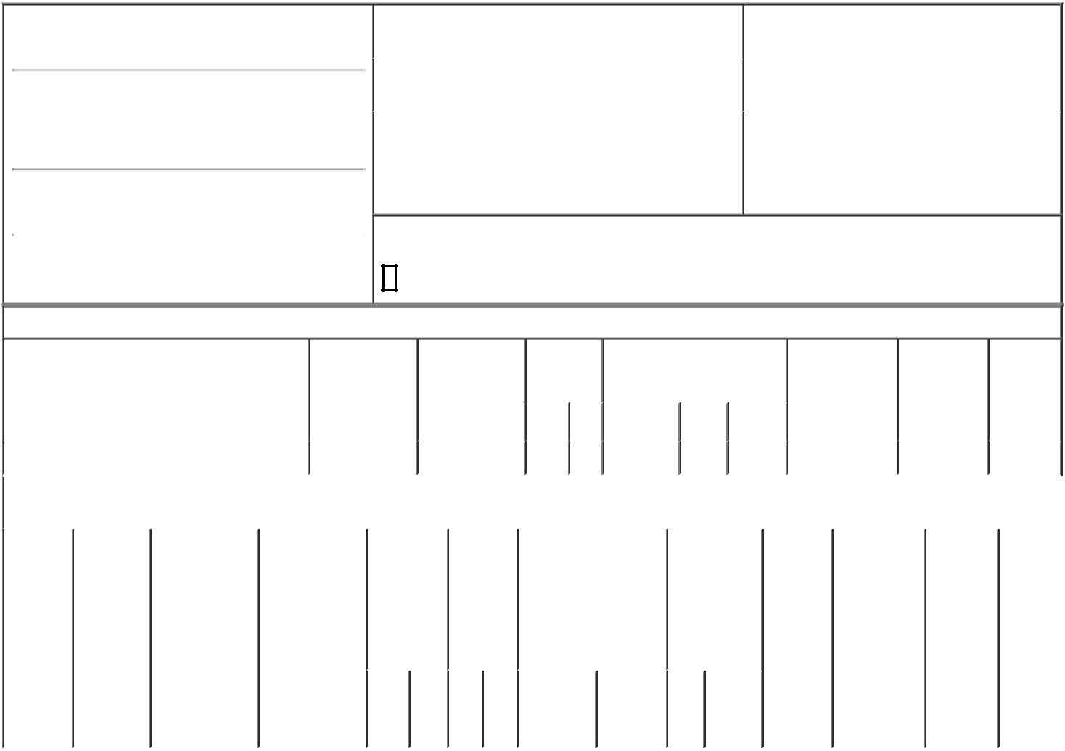

1. Name and Address of Reporting Person*
McMorrow Gerald

(Last) (First) (Middle)

C/O QT IMAGING HOLDINGS, INC. 3 HAMILTON LANDING, SUITE 160

(Street)
 | NOVATO | CA | 94949
 | (City) | (State) | (Zip)

2. |  | Issuer Name and Ticker or Trading Symbol |  | 5. | Relationship of Reporting Person(s) to Issuer
 | QT IMAGING HOLDINGS, INC. [ QTI ] |  |  | (Check all applicable)
 |  |  |  |  | X Director | 10% Owner
3. |  | Date of Earliest Transaction (Month/Day/Year) |  |  | Officer (give title | Other (specify
03/04/2024 |  |  |  |  | below) | below)
4. |  | If Amendment, Date of Original Filed (Month/Day/Year) |  | 6. | Individual or Joint/Group Filing (Check Applicable
Line)

X Form filed by One Reporting Person

Form filed by More than One Reporting

Person

Rule 10b5-1(c) Transaction Indication

Check this box to indicate that a transaction was made pursuant to a contract, instruction or written plan that is intended to satisfy the affirmative defense conditions of Rule 10b5-1(c). See Instruction 10.

Table I - Non-Derivative Securities Acquired, Disposed of, or Beneficially Owned

 | 1. Title of Security (Instr. 3) |  |  | 2. Transaction |  | 2A. Deemed |  | 3. |  | 4. Securities Acquired (A) or |  |  |  |  |  | 5. Amount of |  | 6. Ownership | 7. Nature
 |  |  |  | Date |  | Execution Date, |  |  | Transaction | Disposed Of (D) (Instr. 3, 4 and Securities |  |  |  |  |  |  |  | Form: Direct | of Indirect
 |  |  |  | (Month/Day/Year) |  | if any |  |  | Code (Instr. | 5) |  |  |  |  |  | Beneficially |  | (D) or Indirect | Beneficial
 |  |  |  |  |  | (Month/Day/Year) |  | 8) |  |  |  |  |  |  |  | Owned Following |  | (I) (Instr. 4) | Ownership
 |  |  |  |  |  |  |  |  |  |  |  |  |  |  |  | Reported |  |  | (Instr. 4)
 |  |  |  |  |  |  |  |  | Code V | Amount | (A) or |  | Price |  |  | Transaction(s)
 |  |  |  |  |  |  |  |  | Code V | Amount | (D) |  |  |  |  | (Instr. 3 and 4)
 | Common Stock |  |  | 03/04/2024 |  |  |  |  | A | 5,904 | A |  | (1) |  | 5,904 |  |  | D
 |  |  | Table II - Derivative Securities Acquired, Disposed of, or Beneficially Owned
 |  |  |  | (e.g., puts, calls, warrants, options, convertible securities)
 | 1. Title of | 2. | 3. Transaction | 3A. Deemed | 4. |  | 5. Number | 6. Date Exercisable and |  |  | 7. Title and |  |  |  | 8. Price of |  | 9. Number of 10. |  | 11. Nature
 | Derivative | Conversion | Date | Execution Date, | Transaction |  | of | Expiration Date |  |  | Amount of |  |  |  | Derivative |  | derivative | Ownership | of Indirect
 | Security | or Exercise | (Month/Day/Year) | if any | Code (Instr. |  | Derivative | (Month/Day/Year) |  |  | Securities |  |  |  | Security |  | Securities | Form: | Beneficial
 | (Instr. 3) | Price of |  | (Month/Day/Year) | 8) |  | Securities |  |  |  | Underlying |  |  |  | (Instr. 5) |  | Beneficially | Direct (D) | Ownership
 |  | Derivative |  |  |  |  | Acquired |  |  |  | Derivative |  |  |  |  |  | Owned | or Indirect | (Instr. 4)
 |  | Security |  |  |  |  | (A) or |  |  |  | Security (Instr. |  |  |  |  |  | Following | (I) (Instr. 4)
 |  |  |  |  |  |  | Disposed |  |  |  | 3 and 4) |  |  |  |  |  | Reported
 |  |  |  |  |  |  | of (D) |  |  |  |  |  |  |  |  |  | Transaction(s)
 |  |  |  |  |  |  | (Instr. 3, 4 |  |  |  |  |  |  |  |  |  | (Instr. 4)
 |  |  |  |  |  |  | and 5)
 |  |  |  |  |  |  |  |  |  |  |  | Amount
 |  |  |  |  |  |  |  |  |  |  |  | or
 |  |  |  |  |  |  |  |  |  |  |  | Number
 |  |  |  |  |  |  |  | Date |  | Expiration |  | of
 |  |  |  |  | Code | V | (A) (D) | Exercisable |  | Date | Title | Shares

Explanation of Responses:

- Received in exchange for 17,226 shares of QT Imaging, Inc. ("QT Imaging") in connection with the merger of QT Imaging into a subsidiary of QT Imaging Holdings, Inc. (the "Company") pursuant to the exchange ratio set forth in the business combination agreement between QT Imaging and the Company. The closing price of the Company's Common Stock on the effective date of the merger was $3.53.

/s/ Gerald McMorrow |  | 03/06/2024
** Signature of Reporting Person |  | Date

Reminder: Report on a separate line for each class of securities beneficially owned directly or indirectly.

* If the form is filed by more than one reporting person, see Instruction 4 (b)(v).

- Intentional misstatements or omissions of facts constitute Federal Criminal Violations See 18 U.S.C. 1001 and 15 U.S.C. 78ff(a). Note: File three copies of this Form, one of which must be manually signed. If space is insufficient, see Instruction 6 for procedure.

Persons who respond to the collection of information contained in this form are not required to respond unless the form displays a currently valid OMB Number.

