SEC Form 4

FORM 4

Check this box if no longer subject to Section 16. Form 4 or Form 5 obligations may continue. See Instruction 1(b).

UNITED STATES SECURITIES AND EXCHANGE COMMISSION
Washington, D.C. 20549
Washington, D.C. 20549 |  | OMB APPROVAL
STATEMENT OF CHANGES IN BENEFICIAL OWNERSHIP
STATEMENT OF CHANGES IN BENEFICIAL OWNERSHIP |  | OMB Number: | 3235-0287
 |  | Estimated average burden
Filed pursuant to Section 16(a) of the Securities Exchange Act of 1934 |  | hours per response: | 0.5
or Section 30(h) of the Investment Company Act of 1940
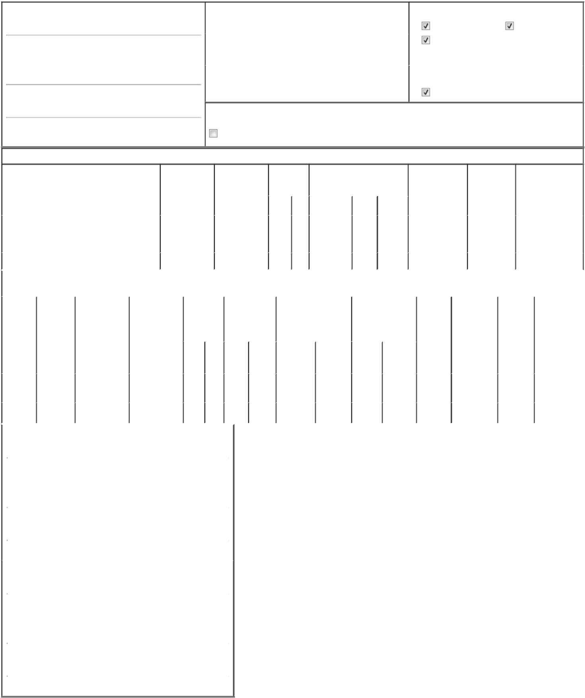

1. Name and Address of Reporting Person*
Katz Avi S

(Last) (First) (Middle)

C/O QT IMAGING HOLDINGS, INC. 3 HAMILTON LANDING, SUITE 160

(Street)

NOVATO CA 94949

(City) (State) (Zip)

2. |  | Issuer Name and Ticker or Trading Symbol |  | 5. Relationship of Reporting Person(s) to Issuer
QT IMAGING HOLDINGS, INC. [ QTI ] |  |  |  | (Check all applicable)
 |  |  |  | Director | 10% Owner
 |  |  |  | Officer (give title | Other (specify
3. |  | Date of Earliest Transaction (Month/Day/Year) |  | Officer (give title | Other (specify
 |  |  |  | below) | below)
06/27/2024 |  |  |  | below) | below)
 |  |  |  | Chairman
4. |  | If Amendment, Date of Original Filed (Month/Day/Year) |  | 6. Individual or Joint/Group Filing (Check Applicable Line)
 |  |  |  | Form filed by One Reporting Person
 |  |  |  | Form filed by More than One Reporting Person

Rule 10b5-1(c) Transaction Indication

Check this box to indicate that a transaction was made pursuant to a contract, instruction or written plan that is intended to satisfy the affirmative defense conditions of Rule 10b5-1(c). See Instruction 10.

Table I - Non-Derivative Securities Acquired, Disposed of, or Beneficially Owned

1. Title of Security (Instr. 3) |  |  |  |  |  | 2. Transaction |  |  | 2A. Deemed |  |  |  |  |  |  | 3. | 4. Securities Acquired (A) or |  |  |  | 5. Amount of |  |  | 6. Ownership |  | 7. Nature of Indirect
 |  |  |  |  |  | Date |  |  | Execution Date, |  |  |  |  |  |  | Transaction | Disposed Of (D) (Instr. 3, 4 and 5) |  |  |  | Securities |  |  | Form: Direct |  | Beneficial Ownership
 |  |  |  |  |  | (Month/Day/Year) |  |  | if any |  |  |  |  |  |  | Code (Instr. |  |  |  |  | Beneficially |  |  | (D) or Indirect |  | (Instr. 4)
 |  |  |  |  |  |  |  |  | (Month/Day/Year) |  |  |  |  |  |  | 8) |  |  |  |  | Owned Following |  |  | (I) (Instr. 4)
 |  |  |  |  |  |  |  |  |  |  |  |  |  |  |  |  |  |  |  |  | Reported
 |  |  |  |  |  |  |  |  |  |  |  |  |  |  |  | Code V | Amount | (A) or | Price |  | Transaction(s)
 |  |  |  |  |  |  |  |  |  |  |  |  |  |  |  | Code V | Amount | (D) |  |  | (Instr. 3 and 4)
 |  |  |  |  |  |  |  |  |  |  |  |  |  |  |  |  |  |  |  |  |  |  |  |  |  | By
Common Stock |  |  |  |  |  | 06/27/2024 |  |  |  |  |  |  |  |  |  | _{J}(1) | 783,591 | D | $0 |  |  | 5,840,773⁽²⁾ |  | I |  | GigAcquisitions5,
 |  |  |  |  |  |  |  |  |  |  |  |  |  |  |  |  |  |  |  |  |  |  |  |  |  | _{LLC}(3)
Common Stock |  |  |  |  |  | 06/27/2024 |  |  |  |  |  |  |  |  |  | _{J}(1) | 26,593 | A | $0 |  |  | 26,593 |  | D
 |  |  |  |  |  | Table II - Derivative Securities Acquired, Disposed of, or Beneficially Owned
 |  |  |  |  |  |  | (e.g., puts, calls, warrants, options, convertible securities)
1. Title of |  | 2. |  | 3. Transaction |  | 3A. Deemed | 4. |  |  | 5. Number of |  |  |  |  |  | 6. Date Exercisable and |  | 7. Title and Amount |  |  |  | 8. Price of | 9. Number of |  | 10. |  | 11. Nature of
Derivative |  | Conversion |  | Date |  | Execution Date, |  | Transaction |  | Derivative |  |  |  |  |  | Expiration Date |  | of Securities |  |  |  | Derivative | derivative |  | Ownership |  | Indirect
Security |  | or Exercise |  | (Month/Day/Year) |  | if any |  | Code (Instr. |  | Securities |  |  |  |  |  | (Month/Day/Year) |  | Underlying |  |  |  | Security | Securities |  | Form: |  | Beneficial
(Instr. 3) |  | Price of |  |  |  | (Month/Day/Year) | 8) |  |  | Acquired (A) or |  |  |  |  |  |  |  | Derivative Security |  |  |  | (Instr. 5) | Beneficially |  | Direct (D) |  | Ownership (Instr.
 |  | Derivative |  |  |  |  |  |  |  | Disposed of (D) |  |  |  |  |  |  |  | (Instr. 3 and 4) |  |  |  |  | Owned |  | or Indirect |  | 4)
 |  | Security |  |  |  |  |  |  |  | (Instr. 3, 4 and 5) |  |  |  |  |  |  |  |  |  |  |  |  | Following |  | (I) (Instr. 4)
 |  |  |  |  |  |  |  |  |  |  |  |  |  |  |  |  |  |  |  |  |  |  | Reported
 |  |  |  |  |  |  |  |  |  |  |  |  |  |  |  |  |  |  | Amount |  |  |  | Transaction(s)
 |  |  |  |  |  |  |  |  |  |  |  |  |  |  |  |  |  |  | or |  |  |  | (Instr. 4)
 |  |  |  |  |  |  |  |  |  |  |  |  |  |  |  | Date | Expiration |  | Number
 |  |  |  |  |  |  |  | Code V |  | (A) |  |  |  | (D) |  | Exercisable | Date | Title | of Shares
Private |  |  |  |  |  |  |  | _{J}(4) |  |  |  |  |  |  |  |  |  | Common | 783,591 |  |  |  |  |  |  |  | By
 |  | $2.3 |  | 06/27/2024 |  |  |  | _{J}(4) |  |  |  |  |  | 783,591 04/03/2024 |  |  | 03/04/2029 | Common |  |  |  | $0 |  | 105,773 | I |  | GigAcquisitions5,
Warrants |  |  |  |  |  |  |  |  |  |  |  |  |  |  |  |  |  | Stock |  |  |  |  |  |  |  |  | LLC⁽³⁾
Private |  | $2.3 |  | 06/27/2024 |  |  |  | _{J}(4) |  | 26,593 |  |  |  |  |  | 04/03/2024 | 03/04/2029 | Common | 26,593 |  |  | $0 |  | 26,593 | D
Warrants |  |  |  |  |  |  |  |  |  |  |  |  |  |  |  |  |  | Stock
1. Name and Address of Reporting Person*
 | Katz Avi S
 | (Last) |  |  | (First) |  | (Middle)
 | C/O QT IMAGING HOLDINGS, INC.
 | 3 HAMILTON LANDING, SUITE 160
(Street)
 | NOVATO |  |  | CA |  | 94949
 | (City) |  |  | (State) |  | (Zip)
1. Name and Address of Reporting Person*
 | GigAcquisitions5, LLC
 | (Last) |  |  | (First) |  | (Middle)
 | C/O QT IMAGING HOLDINGS, INC.
 | 3 HAMILTON LANDING, SUITE 160
(Street)
 | NOVATO |  |  | CA |  | 94949
 | (City) |  |  | (State) |  | (Zip)

Explanation of Responses:

- Distribution of shares of Common Stock to direct and indirect members of GigAcqusitions5, LLC (the "Sponsor").

- The total reported shares is a result of the deduction of the number of disposed shares of Common Stock from 6,624,364 shares of Common Stock as previously reported in Form 4 filed by the Reporting Person on March 6, 2024.

- The Common Stock is held directly by Sponsor. The shares held by the Sponsor are beneficially owned by Dr. Katz. Dr. Katz is also the Manager of the Sponsor, who has sole voting and dispositive power over the shares held by the Sponsor.

- Distribution of Private Warrants to direct and indirect members of the Sponsor.

/s/ Dr. Avi S. Katz |  | 06/28/2024
/s/ Dr. Avi S. Katz, Managing |  | 06/28/2024

Member

** Signature of Reporting Person Date

Reminder: Report on a separate line for each class of securities beneficially owned directly or indirectly.

* If the form is filed by more than one reporting person, see Instruction 4 (b)(v).

- Intentional misstatements or omissions of facts constitute Federal Criminal Violations See 18 U.S.C. 1001 and 15 U.S.C. 78ff(a). Note: File three copies of this Form, one of which must be manually signed. If space is insufficient, see Instruction 6 for procedure.
Persons who respond to the collection of information contained in this form are not required to respond unless the form displays a currently valid OMB Number.

