SEC Form 4

FORM 4

Check this box if no longer subject to Section 16. Form 4 or Form 5 obligations may continue. See Instruction 1(b).

UNITED STATES SECURITIES AND EXCHANGE COMMISSION
Washington, D.C. 20549
Washington, D.C. 20549 |  | OMB APPROVAL
STATEMENT OF CHANGES IN BENEFICIAL OWNERSHIP
STATEMENT OF CHANGES IN BENEFICIAL OWNERSHIP |  | OMB Number: | 3235-0287
 |  | Estimated average burden
Filed pursuant to Section 16(a) of the Securities Exchange Act of 1934 |  | hours per response: | 0.5
or Section 30(h) of the Investment Company Act of 1940
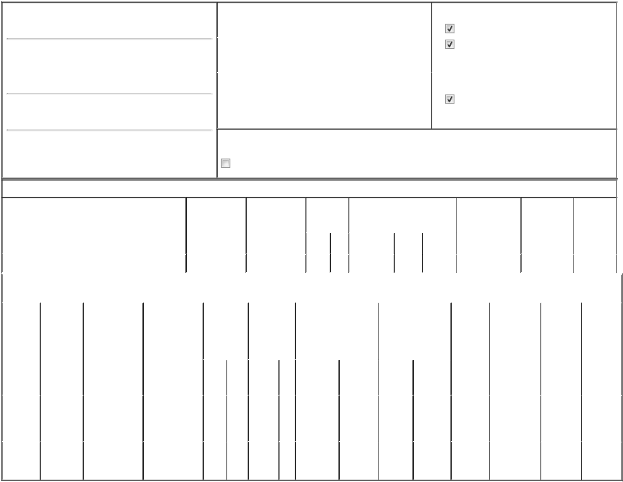

1. Name and Address of Reporting Person*
Dinu Raluca

(Last) (First) (Middle)

C/O QT IMAGING HOLDINGS, INC.

3 HAMILTON LANDING SUITE 160

(Street)

NOVATO CA 94949

(City) (State) (Zip)

2. |  | Issuer Name and Ticker or Trading Symbol |  | 5. Relationship of Reporting Person(s) to Issuer
QT IMAGING HOLDINGS, INC. [ QTI ] |  |  |  | (Check all applicable)
 |  |  |  | Director | 10% Owner
 |  |  |  | Officer (give title | Other (specify
3. |  | Date of Earliest Transaction (Month/Day/Year) |  | Officer (give title | Other (specify
 |  |  |  | below) | below)
07/03/2024 |  |  |  | below) | below)
 |  |  |  | Chief Executive Officer
4. |  | If Amendment, Date of Original Filed (Month/Day/Year) |  | 6. Individual or Joint/Group Filing (Check Applicable
Line)

Form filed by One Reporting Person

Form filed by More than One Reporting

Person

Rule 10b5-1(c) Transaction Indication

Check this box to indicate that a transaction was made pursuant to a contract, instruction or written plan that is intended to satisfy the affirmative defense conditions of Rule 10b5-1(c). See Instruction 10.

Table I - Non-Derivative Securities Acquired, Disposed of, or Beneficially Owned

 | 1. Title of Security (Instr. 3) |  |  | 2. Transaction |  |  | 2A. Deemed |  | 3. |  |  | 4. Securities Acquired (A) or |  |  |  | 5. Amount of |  | 6. Ownership |  | 7. Nature of
 |  |  |  | Date |  |  | Execution Date, |  |  | Transaction |  | Disposed Of (D) (Instr. 3, 4 and |  |  |  | Securities |  | Form: Direct |  | Indirect
 |  |  |  | (Month/Day/Year) |  |  | if any |  |  | Code (Instr. |  | 5) |  |  |  | Beneficially |  | (D) or Indirect |  | Beneficial
 |  |  |  |  |  |  | (Month/Day/Year) 8) |  |  |  |  |  |  |  |  | Owned Following |  | (I) (Instr. 4) |  | Ownership
 |  |  |  |  |  |  |  |  |  |  |  |  |  |  |  | Reported |  |  |  | (Instr. 4)
 |  |  |  |  |  |  |  |  |  | Code V |  | Amount | (A) or | Price |  | Transaction(s)
 |  |  |  |  |  |  |  |  |  | Code V |  | Amount | (D) | Price |  | (Instr. 3 and 4)
 | Common Stock |  |  |  |  |  |  |  |  |  |  |  |  |  | 26,592 |  |  |  | D
 |  |  |  | Table II - Derivative Securities Acquired, Disposed of, or Beneficially Owned
 |  |  |  | (e.g., puts, calls, warrants, options, convertible securities)
 | 1. Title of | 2. | 3. Transaction | 3A. Deemed |  | 4. | 5. Number of |  | 6. Date Exercisable and |  |  |  | 7. Title and Amount |  | 8. Price of |  | 9. Number of |  | 10. | 11. Nature
 | Derivative | Conversion | Date | Execution Date, |  | Transaction | Derivative |  | Expiration Date |  |  |  | of Securities |  | Derivative |  | derivative |  | Ownership of Indirect
 | Security | or Exercise | (Month/Day/Year) | if any |  | Code (Instr. | Securities |  | (Month/Day/Year) |  |  |  | Underlying |  | Security |  | Securities |  | Form: | Beneficial
 | (Instr. 3) | Price of |  | (Month/Day/Year) |  | 8) | Acquired (A) |  |  |  |  |  | Derivative Security |  | (Instr. 5) |  | Beneficially |  | Direct (D) | Ownership
 |  | Derivative |  |  |  |  | or Disposed |  |  |  |  |  | (Instr. 3 and 4) |  |  |  | Owned |  | or Indirect | (Instr. 4)
 |  | Security |  |  |  |  | of (D) (Instr. |  |  |  |  |  |  |  |  |  | Following |  | (I) (Instr. 4)
 |  |  |  |  |  |  | 3, 4 and 5) |  |  |  |  |  |  |  |  |  | Reported
 |  |  |  |  |  |  |  |  |  |  |  |  |  |  |  |  | Transaction(s)
 |  |  |  |  |  |  |  |  |  |  |  |  |  | Amount |  |  | (Instr. 4)
 |  |  |  |  |  |  |  |  |  |  |  |  |  | or
 |  |  |  |  |  |  |  |  | Date |  | Expiration |  |  | Number
 |  |  |  |  |  | Code V | (A) | (D) | Exercisable |  | Date |  | Title | of Shares
 | Employee
 | Stock |  |  |  |  |  |  |  | (1) |  |  |  | Common | 550,000
 | Option | $0.748 | 07/03/2024 |  |  | A | 550,000 |  |  |  | 07/03/2034 |  | Common | 550,000 | $0 |  | 550,000 |  | D
 | (right to |  |  |  |  |  |  |  |  |  |  |  | Stock
 | buy)
 | Stock
 | Option | $0.748 | 07/03/2024 |  |  | A | 40,000 |  | (1) |  | 07/03/2034 |  | Common | 40,000 | $0 |  | 40,000 |  | D
 | (right to | $0.748 | 07/03/2024 |  |  | A | 40,000 |  |  |  |  |  | Stock
buy)

Explanation of Responses:

- One-third of the option will vest on February 15, 2025, and the remaining two thirds will vest in eight equal quarterly installments on each subsequent May 15, August 15, November 15 and February 15, such that the option will be fully vested on February 15, 2027, subject to the Reporting Person's continued service to the Issuer, through each vesting date.

/s/ Dr. Raluca Dinu |  | 07/09/2024
** Signature of Reporting Person |  | Date

Reminder: Report on a separate line for each class of securities beneficially owned directly or indirectly.

* If the form is filed by more than one reporting person, see Instruction 4 (b)(v).

- Intentional misstatements or omissions of facts constitute Federal Criminal Violations See 18 U.S.C. 1001 and 15 U.S.C. 78ff(a). Note: File three copies of this Form, one of which must be manually signed. If space is insufficient, see Instruction 6 for procedure.
Persons who respond to the collection of information contained in this form are not required to respond unless the form displays a currently valid OMB Number.

