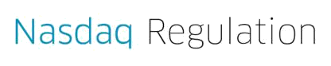

Eun Ah Choi

Senior Vice President

Global Head of Regulatory Operations

August 28, 2024

Division of Corporation Finance
U.S. Securities and Exchange Commission
100 F Street, N.E.
Washington, D.C. 20549

Division of Corporation Finance:

This is to certify that on August 28, 2024, The Nasdaq Stock Market LLC (the "Exchange") received from GigCapital7 Corp.

(the "Registrant") a copy of the Registrant's application on Form 8-A 12(b) for the registration of the following securities:

Class A Ordinary Shares, par value $0.0001 per share Units, each consisting of one Class A ordinary share and one redeemable Warrant Warrants to purchase one Class A Ordinary Share

We further certify that the security described above has been approved by the Exchange for listing and registration upon official notice of issuance.

We understand that the Registrant is seeking effectiveness of the Form 8-A 12(b) concurrently with effectiveness of its 1933 Act Registration Statement, and we hereby join in such request.

Sincerely,
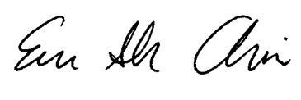

The Nasdaq Stock Market LLC, 805 King Farm Blvd., Rockville, MD 20850

