SEC Form 3
FORM 3 | UNITED STATES SECURITIES AND EXCHANGE
 | COMMISSION
 | COMMISSION |  | OMB APPROVAL
 | Washington, D.C. 20549
 | Washington, D.C. 20549 |  | OMB Number: | 3235-
 |  |  | OMB Number: | 0104
 | INITIAL STATEMENT OF BENEFICIAL OWNERSHIP OF |  |  | 0104
 | INITIAL STATEMENT OF BENEFICIAL OWNERSHIP OF |  | Estimated average burden
 | SECURITIES |  | response: | 0.5
 |  |  | hours per


Filed pursuant to Section 16(a) of the Securities Exchange Act of 1934

or Section 30(h) of the Investment Company Act of 1940
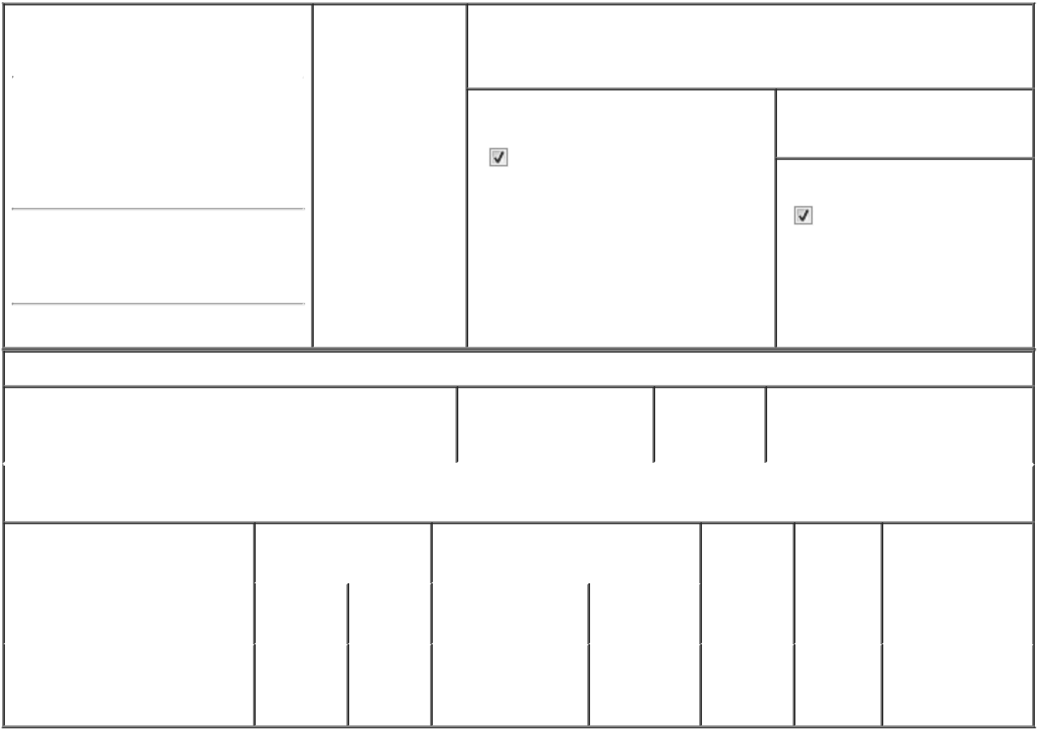

1. Name and Address of Reporting Person* |  |  | 2. Date of Event
 | Dinu Raluca |  | Requiring Statement
 |  |  | (Month/Day/Year)
 |  |  | 08/28/2024

3. Issuer Name and Ticker or Trading Symbol

GigCapital7 Corp. [ GIGGU ]

(Last) (First) (Middle)

C/O GIGCAPITAL7 CORP.

1731 EMBARCADERO ROAD SUITE 200

(Street)
PALO | CA | 94303
ALTO | CA | 94303

- Relationship of Reporting Person(s) to Issuer
(Check all applicable)

Director 10% Owner

Officer (give Other (specify

title below) below)

- If Amendment, Date of Original Filed (Month/Day/Year)

- Individual or Joint/Group Filing (Check Applicable Line)
Form filed by One Reporting Person

Form filed by More than One Reporting Person

(City) (State) (Zip)

Table I - Non-Derivative Securities Beneficially Owned

 | 1. Title of Security (Instr. 4) | 2. Amount of Securities | 3. Ownership | 4. Nature of Indirect Beneficial
 |  | Beneficially Owned (Instr. | Form: Direct | Ownership (Instr. 5)
 |  | 4) | (D) or Indirect
 |  |  | (I) (Instr. 5)

Table II - Derivative Securities Beneficially Owned

(e.g., puts, calls, warrants, options, convertible securities)

1. Title of Derivative Security (Instr. | 2. Date Exercisable and |  | 3. Title and Amount of Securities |  | 4. | 5. | 6. Nature of Indirect
4) | Expiration Date |  | Underlying Derivative Security (Instr. |  | Conversion | Ownership | Beneficial
 | (Month/Day/Year) |  | 4) |  | or Exercise | Form: | Ownership (Instr. 5)
 |  |  |  |  | Price of | Direct (D)
 |  |  |  | Amount or | Price of | Direct (D)
 |  |  |  | Amount or | Derivative | or Indirect
 | Date | Expiration | Title | Number of | Security | (I) (Instr. 5)
 | Exercisable | Date | Title | Shares
 |  |  | Class A ordinary |  |  |  | By
Class B ordinary shares | (1) | (1) | Class A ordinary | 16,040,583⁽²⁾ | (1) | I | GigAcquisitions7
Class B ordinary shares | (1) | (1) | shares
 |  |  | shares |  |  |  | Corp.⁽³⁾

Explanation of Responses:

- The Class B ordinary shares are convertible for the Issuer's Class A ordinary shares as described under the heading "Description of Securities" in the Issuer's Registration Statement on Form S-1 (File No. 333-280015) and have no expiration date.

- Includes up to 2,500,000 Class B ordinary shares that are subject to forfeiture depending on the extent to which the underwriters' over-allotment is exercised, if at all.

- The Class B ordinary shares are held directly by GigAcquisitions7 Corp. (the "Sponsor"). The shares held by the Sponsor are beneficially owned by Dr. Raluca Dinu, GigCapital7 Corp.'s Director and Dr. Katz, GigCapital7 Corp.'s Chairman of the Board of Directors. Dr. Katz and Dr. Dinu are the members of the Sponsor, who both have the voting and dispositive power over the shares held by the Sponsor.

 | /s/ Dr. Raluca Dinu |  | 08/28/2024
 | ** Signature of Reporting |  | Date
 | Person |  | Date
Reminder: Report on a separate line for each class of securities beneficially owned directly or indirectly.
* If the form is filed by more than one reporting person, see Instruction 5 (b)(v).

- Intentional misstatements or omissions of facts constitute Federal Criminal Violations See 18 U.S.C. 1001 and 15 U.S.C. 78ff(a). Note: File three copies of this Form, one of which must be manually signed. If space is insufficient, see Instruction 6 for procedure.

Persons who respond to the collection of information contained in this form are not required to respond unless the form displays a currently valid OMB Number.

