SEC Form 3
FORM 3 | UNITED STATES SECURITIES AND EXCHANGE
 | COMMISSION
 | COMMISSION |  | OMB APPROVAL
 | Washington, D.C. 20549
 | Washington, D.C. 20549 |  | OMB Number: | 3235-
 |  |  | OMB Number: | 0104
 | INITIAL STATEMENT OF BENEFICIAL OWNERSHIP OF |  |  | 0104
 | INITIAL STATEMENT OF BENEFICIAL OWNERSHIP OF |  | Estimated average burden
 | SECURITIES |  | response: | 0.5
 |  |  | hours per


Filed pursuant to Section 16(a) of the Securities Exchange Act of 1934

or Section 30(h) of the Investment Company Act of 1940
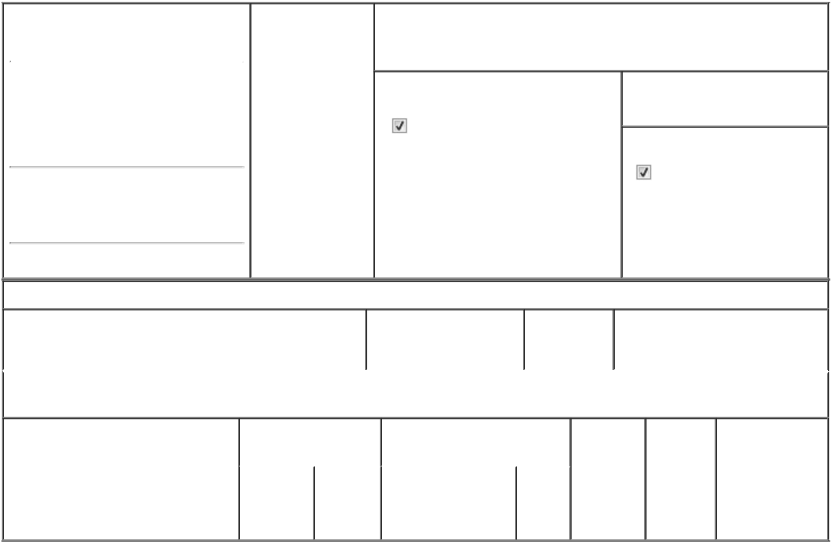

1. Name and Address of Reporting Person* |  |  | 2. Date of Event
 | Moshfeghi Darius M |  | Requiring Statement
 |  |  | (Month/Day/Year)
 |  |  | 08/30/2024

3. Issuer Name and Ticker or Trading Symbol

GigCapital7 Corp. [ GIGGU ]

(Last) (First) (Middle)

C/O GIGCAPITAL7 CORP.

1731 EMBARCADERO RD., SUITE

200

(Street)
PALO | CA | 94303
ALTO | CA | 94303

- Relationship of Reporting Person(s) to Issuer
(Check all applicable)

Director 10% Owner

Officer (give Other (specify

title below) below)

- If Amendment, Date of Original Filed (Month/Day/Year)

- Individual or Joint/Group Filing (Check Applicable Line)
Form filed by One Reporting Person

Form filed by More than One Reporting Person

(City) (State) (Zip)

Table I - Non-Derivative Securities Beneficially Owned

 | 1. Title of Security (Instr. 4) | 2. Amount of Securities | 3. Ownership | 4. Nature of Indirect Beneficial
 |  | Beneficially Owned (Instr. | Form: Direct | Ownership (Instr. 5)
 |  | 4) | (D) or Indirect
 |  |  | (I) (Instr. 5)

Table II - Derivative Securities Beneficially Owned

(e.g., puts, calls, warrants, options, convertible securities)

1. Title of Derivative Security (Instr. 4) | 2. Date Exercisable and |  | 3. Title and Amount of Securities |  | 4. | 5. | 6. Nature of
 | Expiration Date |  | Underlying Derivative Security |  | Conversion | Ownership | Indirect Beneficial
 | (Month/Day/Year) |  | (Instr. 4) |  | or Exercise | Form: | Ownership (Instr.
 |  |  |  |  | Price of | Direct (D) | 5)
 |  |  |  | Amount | Price of | Direct (D) | 5)
 |  |  |  | Amount | Derivative | or Indirect
 |  |  |  | or | Security | (I) (Instr. 5)
 |  |  |  | Number
 | Date | Expiration |  | of
 | Exercisable | Date | Title | Shares

Explanation of Responses:

No securities are beneficially owned.

 | /s/ Professor Darius M. |  |  | 08/30/2024
 | Moshfeghi |  |  | 08/30/2024
 | ** Signature of Reporting |  |  | Date
 | Person |  |  | Date
Reminder: Report on a separate line for each class of securities beneficially owned directly or indirectly.
* If the form is filed by more than one reporting person, see Instruction 5 (b)(v).

- Intentional misstatements or omissions of facts constitute Federal Criminal Violations See 18 U.S.C. 1001 and 15 U.S.C. 78ff(a). Note: File three copies of this Form, one of which must be manually signed. If space is insufficient, see Instruction 6 for procedure.

Persons who respond to the collection of information contained in this form are not required to respond unless the form displays a currently valid OMB Number.

DARIUS M. MOSHFEGHI

POWER OF ATTORNEY
FOR SECTION 16 REPORTING PURPOSES

Know all by these presents, that the undersigned hereby constitutes and appoints each of Jeffrey Selman, Elena Nrtina, and Christine M. Marshall, or any of them signing singly, and with full power of substitution, as the undersigned's true and lawful attorney-in-fact to:

- prepare, execute for and on behalf of the undersigned Forms 3, 4, and 5 in accordance with Section 16(a) of the Securities Exchange Act of 1934 and the rules thereunder, and any other forms or reports the undersigned may be required to file in connection with the undersigned's ownership, acquisition, or disposition of securities of GigCapital7 Corp. (the "Company"),

- do and perform any and all acts for and on behalf of the undersigned
which may be necessary or desirable to complete and execute any such Form 3, 4, or 5, or other form or report, and timely file such

form or report with the United States Securities and Exchange Commission and any stock exchange or similar authority, and

- take any other action of any type whatsoever in connection with the foregoing, which, in the opinion of such attorney-in-fact, may be of benefit to, in the best interest of, or legally required by,

the undersigned, it being understood that the documents executed by such attorney-in-fact on behalf of the undersigned pursuant to this Power of Attorney shall be in such form and shall contain such terms and conditions as such attorney-in-fact may approve in such attorney-in-fact's discretion. The undersigned hereby grants to each such attorney-in-fact full power and authority to do and perform any and every act and thing whatsoever requisite, necessary, or proper to be done in the exercise of

any of the rights and powers herein granted, as fully to all intents and purposes as the undersigned might or could do if personally present,

with full power of substitution or revocation, hereby ratifying and confirming all that such attorney-in-fact, or such attorney-in-fact's substitute or substitutes, shall lawfully do or cause to be done by virtue

of this power of attorney and the rights and powers herein granted.
The undersigned acknowledges that the foregoing attorney-in-fact, in serving in such capacity at the request of the undersigned, is not assuming, nor is

the Company assuming, any of the undersigned's responsibilities to comply with Section 16 of the Securities Exchange Act of 1934. This Power of Attorney shall remain in full force and effect until

the undersigned is no longer required to file Forms 3, 4, and 5 with respect to the undersigned's holdings of and transactions in securities issued by the Company, unless earlier revoked by the undersigned in a signed writing delivered to the foregoing attorneys-in-fact.

IN WITNESS WHEREOF, the undersigned has caused this Power of Attorney to be executed as of August 26, 2024.
Darius M. Moshfeghi

