SEC Form 4

FORM 4

Check this box if no longer subject to Section 16. Form 4 or Form 5 obligations may continue. See Instruction 1(b).

Check this box to indicate that a transaction was made pursuant to a contract, instruction or written plan for the purchase or sale of equity securities of the issuer that is intended to satisfy the affirmative defense conditions of Rule 10b5-1(c). See Instruction 10.

UNITED STATES SECURITIES AND EXCHANGE COMMISSION
Washington, D.C. 20549
Washington, D.C. 20549 |  | OMB APPROVAL
STATEMENT OF CHANGES IN BENEFICIAL OWNERSHIP
STATEMENT OF CHANGES IN BENEFICIAL OWNERSHIP |  | OMB Number: | 3235-0287
 |  | Estimated average burden
Filed pursuant to Section 16(a) of the Securities Exchange Act of 1934 |  | hours per response: | 0.5
or Section 30(h) of the Investment Company Act of 1940
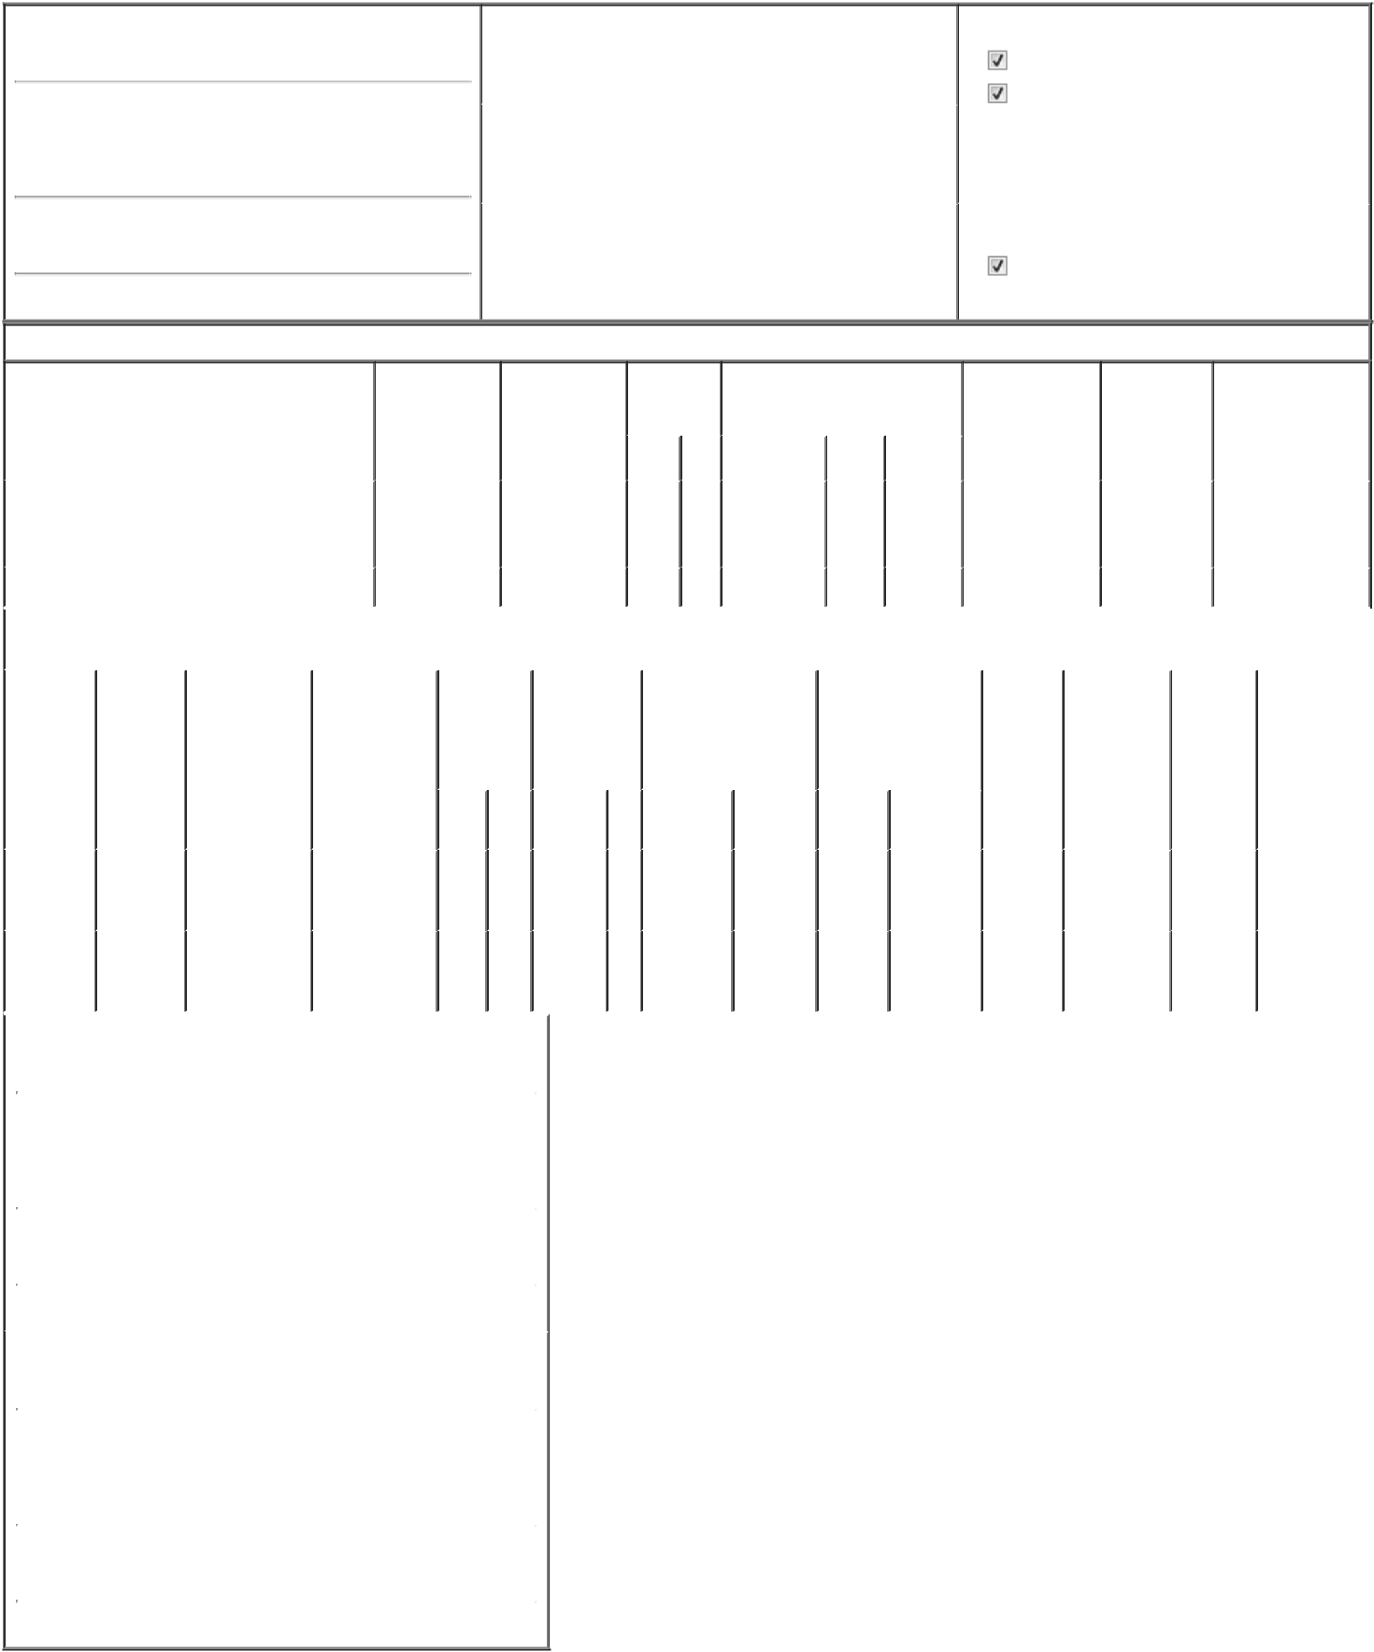

1. Name and Address of Reporting Person*
Katz Avi S

(Last) | (First) | (Middle)
C/O QT IMAGING HOLDINGS, INC.
3 HAMILTON LANDING, SUITE 160
(Street)
NOVATO | CA | 94949
(City) | (State) | (Zip)

2. |  | Issuer Name and Ticker or Trading Symbol |  | 5. Relationship of Reporting Person(s) to Issuer
QT IMAGING HOLDINGS, INC. [ QTI ] |  |  |  | (Check all applicable)
 |  |  |  | Director | 10% Owner
 |  |  |  | Officer (give title | Other (specify
 |  |  |  | below) | below)
3. |  | Date of Earliest Transaction (Month/Day/Year) |  | below) | below)
 |  |  |  | Chairman
11/12/2024 |  |  |  | Chairman
4. |  | If Amendment, Date of Original Filed (Month/Day/Year) |  | 6. Individual or Joint/Group Filing (Check Applicable Line)
 |  |  |  | Form filed by One Reporting Person
 |  |  |  | Form filed by More than One Reporting Person

Table I - Non-Derivative Securities Acquired, Disposed of, or Beneficially Owned

1. Title of Security (Instr. 3) |  |  |  |  |  | 2. Transaction |  | 2A. Deemed |  |  |  |  | 3. | 4. Securities Acquired (A) or |  |  |  | 5. Amount of |  | 6. Ownership |  | 7. Nature of Indirect
 |  |  |  |  |  | Date |  | Execution Date, |  |  |  |  | Transaction | Disposed Of (D) (Instr. 3, 4 and 5) |  |  |  | Securities |  | Form: Direct |  | Beneficial Ownership
 |  |  |  |  |  | (Month/Day/Year) |  | if any |  |  |  |  | Code (Instr. |  |  |  |  | Beneficially |  | (D) or Indirect |  | (Instr. 4)
 |  |  |  |  |  |  |  | (Month/Day/Year) |  |  |  |  | 8) |  |  |  |  | Owned Following (I) (Instr. 4)
 |  |  |  |  |  |  |  |  |  |  |  |  |  |  |  |  |  | Reported
 |  |  |  |  |  |  |  |  |  |  |  |  | Code V | Amount | (A) or | Price |  | Transaction(s)
 |  |  |  |  |  |  |  |  |  |  |  |  | Code V | Amount | (D) |  |  | (Instr. 3 and 4)
 |  |  |  |  |  |  |  |  |  |  |  |  |  |  |  |  |  |  |  |  |  | By
Common Stock |  |  |  |  |  | 11/12/2024 |  |  |  |  |  |  | _{P}(1) | 2,671,232 | A | $0.584 |  |  | 2,671,232 | I |  | GigAcquisitions5,
 |  |  |  |  |  |  |  |  |  |  |  |  |  |  |  |  |  |  |  |  |  | LLC⁽²⁾
Common Stock |  |  |  |  |  | 11/12/2024 |  |  |  |  |  |  | P | 470,890 | A | $0.584 |  |  | 657,960 | D
 |  |  |  |  |  | Table II - Derivative Securities Acquired, Disposed of, or Beneficially Owned
 |  |  |  |  |  | (e.g., puts, calls, warrants, options, convertible securities)
1. Title of |  | 2. |  | 3. Transaction |  | 3A. Deemed | 4. |  | 5. Number of |  |  |  | 6. Date Exercisable and |  | 7. Title and Amount of |  |  |  | 8. Price of | 9. Number of | 10. |  | 11. Nature of
Derivative |  | Conversion |  | Date |  | Execution Date, | Transaction |  | Derivative |  |  |  | Expiration Date |  | Securities Underlying |  |  |  | Derivative | derivative | Ownership |  | Indirect
Security |  | or Exercise |  | (Month/Day/Year) |  | if any | Code (Instr. |  | Securities |  |  |  | (Month/Day/Year) |  | Derivative Security |  |  |  | Security | Securities | Form: |  | Beneficial
(Instr. 3) |  | Price of |  |  |  | (Month/Day/Year) | 8) |  | Acquired (A) |  |  |  |  |  | (Instr. 3 and 4) |  |  |  | (Instr. 5) | Beneficially | Direct (D) |  | Ownership (Instr.
 |  | Derivative |  |  |  |  |  |  | or Disposed of |  |  |  |  |  |  |  |  |  |  | Owned | or Indirect |  | 4)
 |  | Security |  |  |  |  |  |  | (D) (Instr. 3, 4 |  |  |  |  |  |  |  |  |  |  | Following | (I) (Instr. 4)
 |  |  |  |  |  |  |  |  | and 5) |  |  |  |  |  |  |  |  |  |  | Reported
 |  |  |  |  |  |  |  |  |  |  |  |  |  |  |  |  |  |  |  | Transaction(s)
 |  |  |  |  |  |  |  |  |  |  |  |  |  |  |  | Amount or |  |  |  | (Instr. 4)
 |  |  |  |  |  |  |  |  |  |  |  |  | Date | Expiration |  | Number of
 |  |  |  |  |  |  | Code V |  | (A) |  | (D) |  | Exercisable | Date | Title | Shares
Subscription |  |  |  |  |  |  |  |  |  |  |  |  |  |  |  |  |  |  |  |  |  |  | By
Warrants |  |  |  |  |  |  |  |  |  |  |  |  |  |  | Common | 2,671,232
 |  | $0.672 |  | 11/12/2024 |  |  | P |  | 2,671,232 |  |  |  | 05/12/2025 | 05/12/2030 | Common |  |  |  | $0.672 | 2,671,232 | I |  | GigAcquisitions5,
(right to |  |  |  |  |  |  |  |  |  |  |  |  |  |  | Stock |  |  |  |  |  |  |  | _{LLC}(2)
buy)
Subscription
Warrants |  | $0.672 |  | 11/12/2024 |  |  | P |  | 470,890 |  |  |  | 05/12/2025 | 05/12/2030 | Common | 470,890 |  |  | $0.672 | 470,890 | D
(right to |  |  |  |  |  |  | P |  |  |  |  |  | 05/12/2025 | 05/12/2030 | Stock |  |  |  | $0.672 | 470,890 | D
buy)
1. Name and Address of Reporting Person*
 | Katz Avi S
 | (Last) |  |  | (First) |  | (Middle)
 | C/O QT IMAGING HOLDINGS, INC.
 | 3 HAMILTON LANDING, SUITE 160
(Street)
 | NOVATO |  |  | CA |  | 94949
 | (City) |  |  | (State) |  | (Zip)
1. Name and Address of Reporting Person*
 | GigAcquisitions5, LLC
 | (Last) |  |  | (First) |  | (Middle)
 | C/O QT IMAGING HOLDINGS, INC.
 | 3 HAMILTON LANDING, SUITE 160
(Street)
 | NOVATO |  |  | CA |  | 94949
 | (City) |  |  | (State) |  | (Zip)

Explanation of Responses:

- The shares shown were issued in exchange for principal under the Twelfth Amended and Restated Promissory Note (the "Promissory Note") of the Issuer held by GigAcqusitions5, LLC (the "Sponsor"), which Promissory Note was surrendered by the Sponsor for cancellation.

- The Common Stock is held directly by the Sponsor. The shares held by the Sponsor are beneficially owned by Dr. Katz. Dr. Katz is also the Manager of the Sponsor, who has sole voting and dispositive power over the shares

held by the Sponsor.

/s/ Dr. Avi S. Katz

/s/ Dr. Avi S. Katz, Managing

Member

** Signature of Reporting Person

11/14/2024

11/14/2024

Date

Reminder: Report on a separate line for each class of securities beneficially owned directly or indirectly.

* If the form is filed by more than one reporting person, see Instruction 4 (b)(v).

- Intentional misstatements or omissions of facts constitute Federal Criminal Violations See 18 U.S.C. 1001 and 15 U.S.C. 78ff(a). Note: File three copies of this Form, one of which must be manually signed. If space is insufficient, see Instruction 6 for procedure.

Persons who respond to the collection of information contained in this form are not required to respond unless the form displays a currently valid OMB Number.

