SEC Form 4

FORM 4

Check this box if no longer subject to Section 16. Form 4 or Form 5 obligations may continue. See Instruction 1(b).

Check this box to indicate that a transaction was made pursuant to a contract, instruction or written plan for the purchase or sale of equity securities of the issuer that is intended to satisfy the affirmative defense conditions of Rule 10b5-1(c). See Instruction 10.

UNITED STATES SECURITIES AND EXCHANGE COMMISSION
Washington, D.C. 20549
Washington, D.C. 20549 |  | OMB APPROVAL
STATEMENT OF CHANGES IN BENEFICIAL OWNERSHIP
STATEMENT OF CHANGES IN BENEFICIAL OWNERSHIP |  | OMB Number: | 3235-0287
 |  | Estimated average burden
Filed pursuant to Section 16(a) of the Securities Exchange Act of 1934 |  | hours per response: | 0.5
or Section 30(h) of the Investment Company Act of 1940
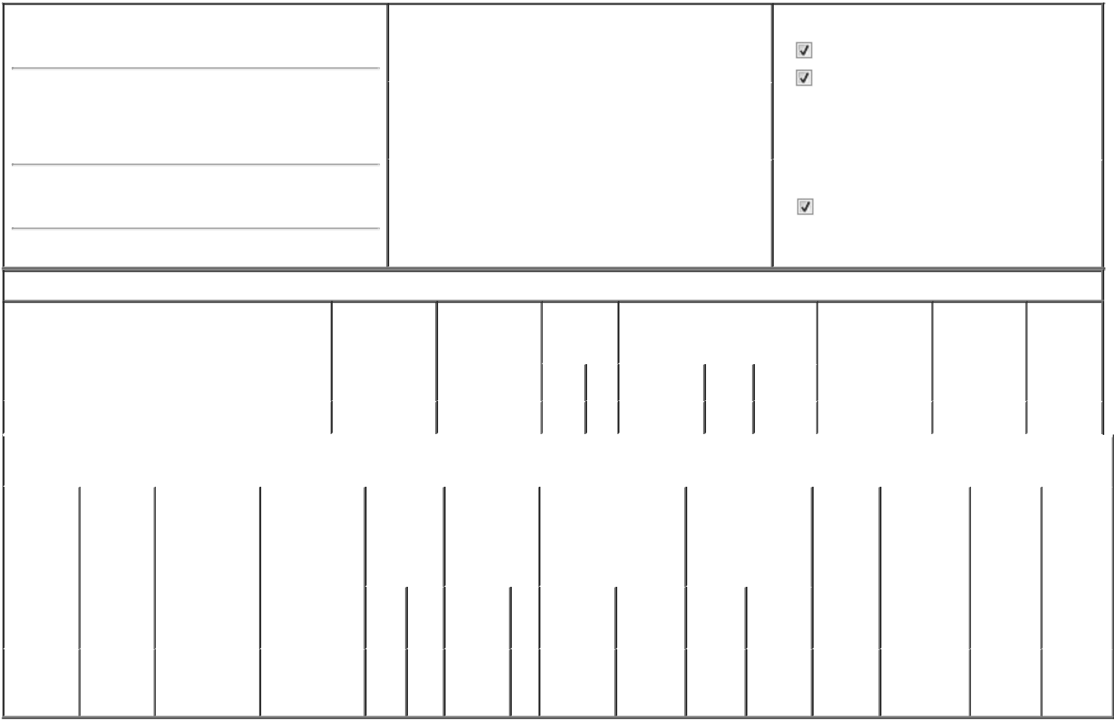

1. Name and Address of Reporting Person*
Dinu Raluca

(Last) (First) (Middle)

C/O QT IMAGING HOLDINGS, INC.

3 HAMILTON LANDING SUITE 160

(Street)

NOVATO CA 94949

(City) (State) (Zip)

2. |  | Issuer Name and Ticker or Trading Symbol |  | 5. | Relationship of Reporting Person(s) to Issuer
 | QT IMAGING HOLDINGS, INC. [ QTI ] |  |  | (Check all applicable)
 |  |  |  |  | Director | 10% Owner
 |  |  |  |  | Officer (give title | Other (specify
 |  |  |  |  | below) | below)
3. |  | Date of Earliest Transaction (Month/Day/Year) |  |  | below) | below)
 |  |  |  |  | Chief Executive Officer
04/09/2025
4. |  | If Amendment, Date of Original Filed (Month/Day/Year) |  | 6. | Individual or Joint/Group Filing (Check Applicable
Line)

Form filed by One Reporting Person

Form filed by More than One Reporting Person

Table I - Non-Derivative Securities Acquired, Disposed of, or Beneficially Owned

 | 1. Title of Security (Instr. 3) |  |  | 2. Transaction |  | 2A. Deemed |  | 3. | 4. Securities Acquired (A) or |  |  |  |  | 5. Amount of |  | 6. Ownership |  | 7. Nature of
 |  |  |  | Date |  | Execution Date, |  | Transaction | Disposed Of (D) (Instr. 3, 4 and 5) |  |  |  |  | Securities |  | Form: Direct |  | Indirect
 |  |  |  | (Month/Day/Year) |  | if any |  | Code (Instr. |  |  |  |  |  | Beneficially |  | (D) or Indirect |  | Beneficial
 |  |  |  |  |  | (Month/Day/Year) |  | 8) |  |  |  |  |  | Owned Following |  | (I) (Instr. 4) |  | Ownership
 |  |  |  |  |  |  |  |  |  |  |  |  |  | Reported |  |  |  | (Instr. 4)
 |  |  |  |  |  |  |  | Code V | Amount |  | (A) or | Price |  | Transaction(s)
 |  |  |  |  |  |  |  | Code V | Amount |  | (D) |  |  | (Instr. 3 and 4)
 | Common Stock |  |  | 04/09/2025 |  |  |  | P | 392,465⁽¹⁾ |  | A | $0.637 |  | 1,168,035 |  |  | D
 |  |  |  | Table II - Derivative Securities Acquired, Disposed of, or Beneficially Owned
 |  |  |  | (e.g., puts, calls, warrants, options, convertible securities)
 | 1. Title of | 2. | 3. Transaction | 3A. Deemed | 4. | 5. Number of |  | 6. Date Exercisable and |  | 7. Title and Amount |  |  |  | 8. Price of | 9. Number of |  | 10. | 11. Nature
 | Derivative | Conversion | Date | Execution Date, | Transaction | Derivative |  | Expiration Date |  | of Securities |  |  |  | Derivative | derivative |  | Ownership of Indirect
 | Security | or Exercise | (Month/Day/Year) | if any | Code (Instr. | Securities |  | (Month/Day/Year) |  | Underlying |  |  |  | Security | Securities |  | Form: | Beneficial
 | (Instr. 3) | Price of |  | (Month/Day/Year) | 8) | Acquired (A) or |  |  |  | Derivative Security |  |  |  | (Instr. 5) | Beneficially |  | Direct (D) | Ownership
 |  | Derivative |  |  |  | Disposed of |  |  |  | (Instr. 3 and 4) |  |  |  |  | Owned |  | or Indirect | (Instr. 4)
 |  | Security |  |  |  | (D) (Instr. 3, 4 |  |  |  |  |  |  |  |  | Following |  | (I) (Instr. 4)
 |  |  |  |  |  | and 5) |  |  |  |  |  |  |  |  | Reported
 |  |  |  |  |  |  |  |  |  |  |  |  |  |  | Transaction(s)
 |  |  |  |  |  |  |  |  |  |  |  | Amount |  |  | (Instr. 4)
 |  |  |  |  |  |  |  |  |  |  |  | or
 |  |  |  |  |  |  |  | Date | Expiration |  |  | Number
 |  |  |  |  | Code V | (A) | (D) | Exercisable | Date | Title |  | of Shares
 | Subscription
 | Warrants | $0.72 | 04/09/2025 |  | P | 784,929⁽¹⁾ |  | 10/09/2025 | 04/09/2035 | Common |  | 784,929 |  | $0 | 784,929 |  | D
 | (right to |  |  |  |  |  |  |  |  |  | Stock
buy)

Explanation of Responses:

- These shares and warrants represent 50% of the shares and warrants that were purchased jointly with the Reporting Person's spouse, Dr. Avi S. Katz, who is also a director of the Issuer and is separately reporting the other 50% of such purchased shares and warrants.

/s/ Dr. Raluca Dinu |  | 04/10/2025
** Signature of Reporting Person |  | Date

Reminder: Report on a separate line for each class of securities beneficially owned directly or indirectly.

* If the form is filed by more than one reporting person, see Instruction 4 (b)(v).

- Intentional misstatements or omissions of facts constitute Federal Criminal Violations See 18 U.S.C. 1001 and 15 U.S.C. 78ff(a). Note: File three copies of this Form, one of which must be manually signed. If space is insufficient, see Instruction 6 for procedure.
Persons who respond to the collection of information contained in this form are not required to respond unless the form displays a currently valid OMB Number.

