SEC Form 4

FORM 4

Check this box if no longer subject to Section 16. Form 4 or Form 5 obligations may continue. See Instruction 1(b).

Check this box to indicate that a transaction was made pursuant to a contract, instruction or written plan for the purchase or sale of equity securities of the issuer that is intended to satisfy the affirmative defense conditions of Rule 10b5-1(c). See Instruction 10.

UNITED STATES SECURITIES AND EXCHANGE COMMISSION
Washington, D.C. 20549
Washington, D.C. 20549 |  | OMB APPROVAL
STATEMENT OF CHANGES IN BENEFICIAL OWNERSHIP
STATEMENT OF CHANGES IN BENEFICIAL OWNERSHIP |  | OMB Number: | 3235-0287
STATEMENT OF CHANGES IN BENEFICIAL OWNERSHIP |  | Estimated average burden
Filed pursuant to Section 16(a) of the Securities Exchange Act of 1934 |  | hours per response: | 0.5
or Section 30(h) of the Investment Company Act of 1940
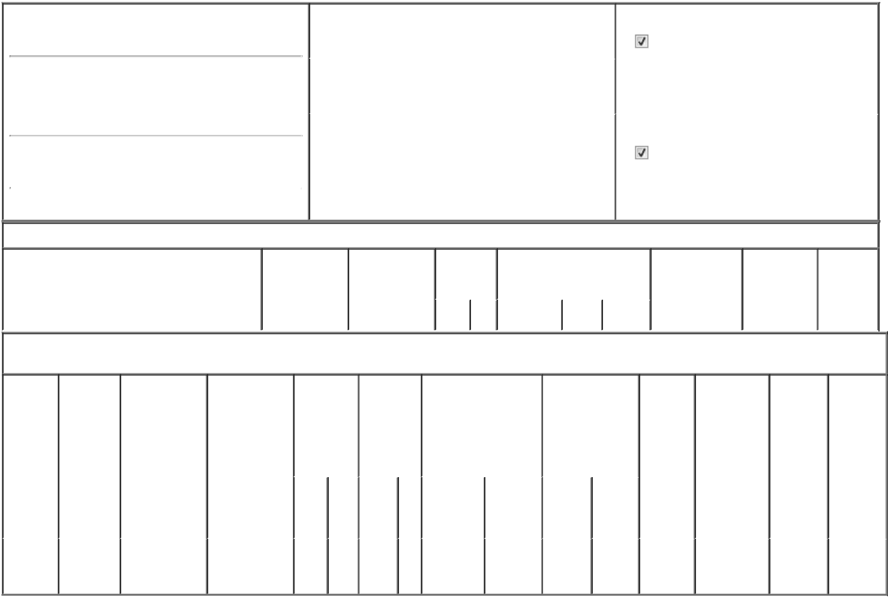

1. Name and Address of Reporting Person*
DICKSON DANIEL H

(Last) (First) (Middle)

C/O QT IMAGING HOLDINGS, INC.

3 HAMILTON LANDING SUITE 160

(Street)
 | NOVATO | CA | 94949
 | (City) | (State) | (Zip)

2. |  | Issuer Name and Ticker or Trading Symbol |  | 5. | Relationship of Reporting Person(s) to Issuer
 | QT IMAGING HOLDINGS, INC. [ QTIH ] |  |  | (Check all applicable)
 |  |  |  |  | Director | 10% Owner
 |  |  |  |  | Officer (give title | Other (specify
3. |  | Date of Earliest Transaction (Month/Day/Year) |  |  | Officer (give title | Other (specify
 |  |  |  |  | below) | below)
04/21/2025
4. |  | If Amendment, Date of Original Filed (Month/Day/Year) |  | 6. | Individual or Joint/Group Filing (Check Applicable
Line)

Form filed by One Reporting Person

Form filed by More than One Reporting

Person

Table I - Non-Derivative Securities Acquired, Disposed of, or Beneficially Owned

1. Title of Security (Instr. 3) | 2. Transaction | 2A. Deemed | 3. | 4. Securities Acquired (A) or |  |  | 5. Amount of | 6. Ownership | 7. Nature
 | Date | Execution Date, | Transaction | Disposed Of (D) (Instr. 3, 4 and |  |  | Securities | Form: Direct | of Indirect
 | (Month/Day/Year) | if any | Code (Instr. | 5) |  |  | Beneficially | (D) or Indirect | Beneficial
 |  | (Month/Day/Year) | 8) |  |  |  | Owned Following | (I) (Instr. 4) | Ownership
 |  |  |  |  |  |  | Reported |  | (Instr. 4)
 |  |  | Code V | Amount | (A) or | Price | Transaction(s)
 |  |  | Code V | Amount | (D) | Price | (Instr. 3 and 4)

Table II - Derivative Securities Acquired, Disposed of, or Beneficially Owned

(e.g., puts, calls, warrants, options, convertible securities)

1. Title of | 2. | 3. Transaction | 3A. Deemed | 4. | 5. Number |  | 6. Date Exercisable and |  | 7. Title and Amount |  | 8. Price of | 9. Number of | 10. | 11. Nature
Derivative | Conversion | Date | Execution Date, | Transaction | of |  | Expiration Date |  | of Securities |  | Derivative | derivative | Ownership | of Indirect
Security | or Exercise | (Month/Day/Year) | if any | Code (Instr. | Derivative |  | (Month/Day/Year) |  | Underlying |  | Security | Securities | Form: | Beneficial
(Instr. 3) | Price of |  | (Month/Day/Year) | 8) | Securities |  |  |  | Derivative Security |  | (Instr. 5) | Beneficially | Direct (D) | Ownership
 | Derivative |  |  |  | Acquired |  |  |  | (Instr. 3 and 4) |  |  | Owned | or Indirect | (Instr. 4)
 | Security |  |  |  | (A) or |  |  |  |  |  |  | Following | (I) (Instr. 4)
 |  |  |  |  | Disposed |  |  |  |  |  |  | Reported
 |  |  |  |  | of (D) (Instr. |  |  |  |  |  |  | Transaction(s)
 |  |  |  |  | 3, 4 and 5) |  |  |  |  |  |  | (Instr. 4)
 |  |  |  |  |  |  |  |  |  | Amount
 |  |  |  |  |  |  |  |  |  | or
 |  |  |  |  |  |  |  |  |  | Number
 |  |  |  |  |  |  | Date | Expiration |  | of
 |  |  |  | Code V | (A) | (D) | Exercisable | Date | Title | Shares
Stock
Option | $0.665 | 04/21/2025 |  | A | 42,500 |  | (1) | 04/21/2035 | Common | 42,500 | $0 | 42,500 | D
(right to |  |  |  |  |  |  |  |  | Stock
buy)

Explanation of Responses:

- The grant will vest in four equal quarterly installments beginning on May 15, 2025, and continuing on August 15, 2025, November 15, 2025 and February 15, 2026, such that the grant will be fully vested on February 15, 2026, subject to continued service with the Issuer through each vesting date.

/s/ Daniel H. Dickson |  | 04/23/2025
** Signature of Reporting Person |  | Date

Reminder: Report on a separate line for each class of securities beneficially owned directly or indirectly.

* If the form is filed by more than one reporting person, see Instruction 4 (b)(v).

- Intentional misstatements or omissions of facts constitute Federal Criminal Violations See 18 U.S.C. 1001 and 15 U.S.C. 78ff(a). Note: File three copies of this Form, one of which must be manually signed. If space is insufficient, see Instruction 6 for procedure.
Persons who respond to the collection of information contained in this form are not required to respond unless the form displays a currently valid OMB Number.

