UNITED STATES
SECURITIES AND EXCHANGE COMMISSION
Washington, D.C. 20549

FORM 8-K

CURRENT REPORT
Pursuant to Section 13 or 15(d)
of the Securities Exchange Act of 1934
Date of Report (Date of earliest event reported): August 12, 2026

Hadron Energy, Inc.
(Exact name of registrant as specified in its charter)

Delaware |  | 001-42262 |  | 33-4336458
(State or other jurisdiction of  incorporation or organization) |  | (Commission  File Number) |  | (IRS Employer  Identification No.)
3 Twin Dolphin Drive, Ste 260
Redwood City, CA 94065
(Address of principal executive offices, including zip code)
(650) 276-7040
(Registrant’s telephone number, including area code)

Check the appropriate box below if the Form 8-K filing is intended to simultaneously satisfy the filing obligation of the registrant under any of the following provisions (see General Instruction A.2 below):

☐ | Written communications pursuant to Rule 425 under the Securities Act (17 CFR 230.425)

☐ | Soliciting material pursuant to Rule 14a-12 under the Exchange Act (17 CFR 240.14a-12)

☐ | Pre-commencement communications pursuant to Rule 14d-2(b) under the Exchange Act (17 CFR 240.14d-2(b))

☐ | Pre-commencement communications pursuant to Rule 13e-4(c) under the Exchange Act (17 CFR 240.13e-4(c))
Securities registered pursuant to Section 12(b) of the Act:

Title of each class |  | Trading  Symbol(s) |  | Name of each exchange  on which registered
Common Stock, par value $0.0001 per share |  | HDRN |  | The Nasdaq Stock Market LLC
Redeemable warrants, each full warrant exercisable for one share of Common Stock at an exercise price of $11.50 per share |  | HDRNW |  | The Nasdaq Stock Market LLC
Indicate by check mark whether the registrant is an emerging growth company as defined in Rule 405 of the Securities Act of 1933 (§230.405 of this chapter) or Rule 12b-2 of the Securities Exchange Act of 1934 (§240.12b-2 of this chapter).
Emerging growth company ☒
If an emerging growth company, indicate by check mark if the registrant has elected not to use the extended transition period for complying with any new or revised financial accounting standards provided pursuant to Section 13(a) of the Exchange Act. ☐

Item 7.01 | Regulation FD Disclosure
Investor Presentation
On August 12, 2026, Hadron Energy, Inc., a Delaware corporation (the “Company”) posted to the Company’s Investor Resources section of its website www.hadronenergy.com, an investor presentation containing supplemental product and operational information regarding the Company. A copy of the investor presentation is being furnished as Exhibit 99.1 to this Current Report on Form 8-K (this “Current Report”).
Letter to Stockholders
On August 12, 2026, the Company posted to the Company’s Investor Resources section of its website www.hadronenergy.com, a letter to stockholders from the Company’s Founder and Chief Executive Officer, Samuel Gibson, discussing, among other things, leadership appointments, regulatory progress with the Nuclear Regulatory Commission, key milestones achieved in the first half of 2026, supply chain partnerships, and the Company’s financial position and strategic outlook. A copy of the letter is being furnished as Exhibit 99.2 to this Current Report.
The information contained in, or incorporated into, this Item 7.01 of this Current Report, including Exhibits 99.1 and 99.2 attached hereto, are being furnished under Item 7.01 of Form 8-K and shall not be deemed “filed” for the purposes of Section 18 of the Exchange Act or otherwise subject to the liabilities of that section, and shall not be deemed to be incorporated by reference into the filings of the Company under the Securities Act or the Exchange Act regardless of any general incorporation language in such filings.
This Current Report shall not be deemed an admission as to the materiality of any information in this Current Report that is being disclosed pursuant to Regulation FD.
Please refer to Exhibits 99.1 and 99.2 for a discussion of certain forward-looking statements included therein and the risks and uncertainties related thereto.

Item 9.01 | Financial Statements and Exhibits
(d) Exhibits.

Exhibit  No. |  | Item
99.1 |  | Investor Presentation, dated August 12, 2026.
99.2 |  | Letter to Stockholders, dated August 12, 2026.
104 |  | Cover Page Interactive Data File (embedded within the Inline XBRL document).

SIGNATURES
Pursuant to the requirements of the Securities Exchange Act of 1934, the Registrant has duly caused this report to be signed on its behalf by the undersigned hereunto duly authorized.

 |  |  |  | Hadron Energy, Inc.
Dated: August 12, 2026
 |  |  |  | By: |  | /s/ Samuel Gibson
 |  |  |  |  |  | Chief Executive Officer
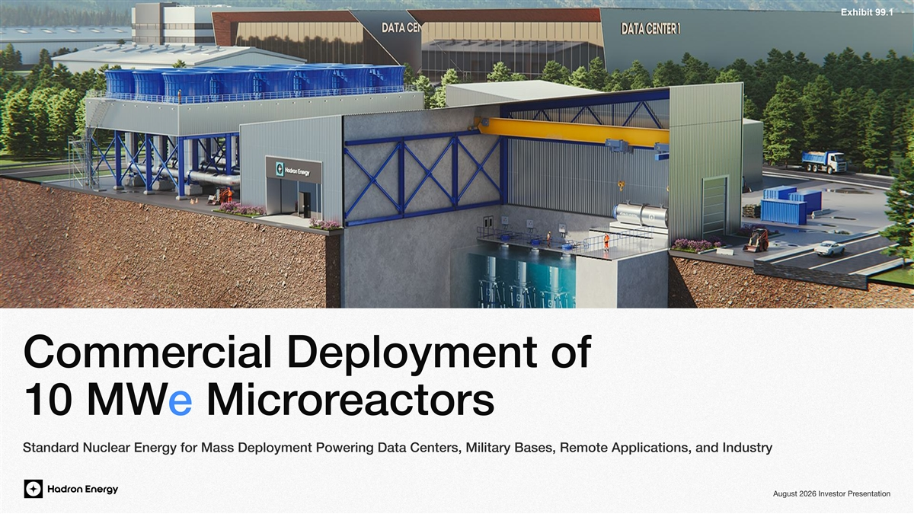
Exhibit 99.1 cial Deployment of Commer eactorsore Micr10 MW d Nuclear Energy for Mass Deployment Powering Data Centers, Military Bases, Remote Applications, and IndustryStandar esentationAugust 2026 Investor Pr

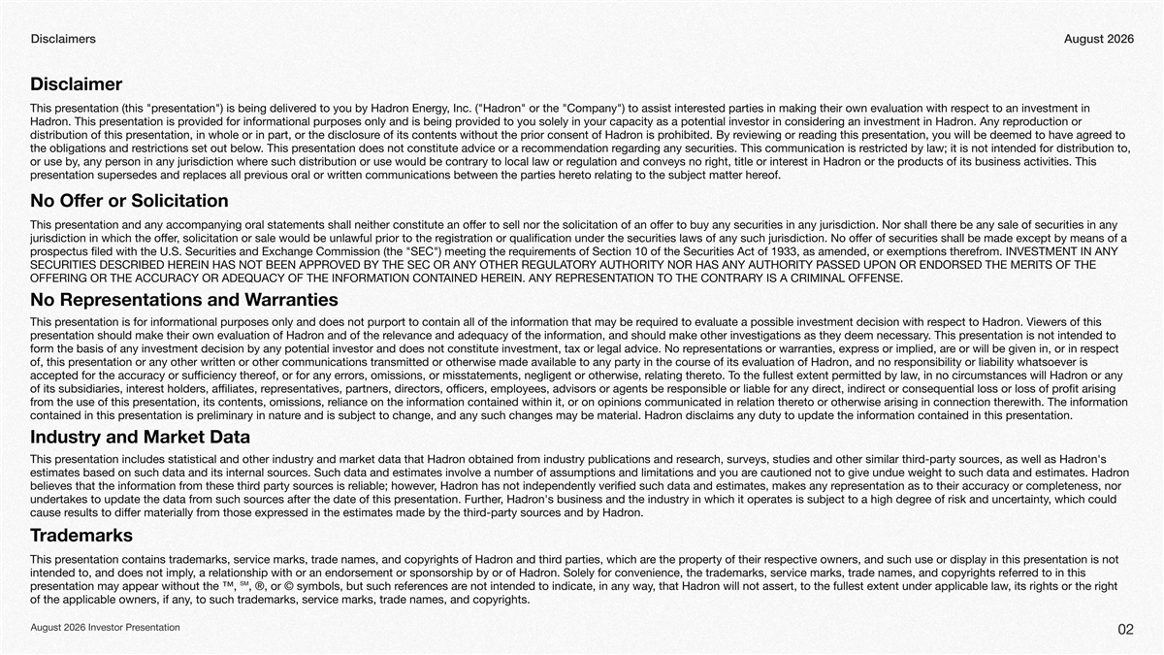
Disclaimers August2026 Disclaimer espect to an investment in ested parties in making their own evaluation with ron or the Company ) to assist inter, Inc. ( Hadrgyon Enered to you by Hadresentation ) is being deliveresentation (this prThis pr oduction or epron. Any rovided to you solely in your capacity as a potential investor in considering an investment in Hadrovided for informational purposes only and is being presentation is pron. This prHadr eed to esentation, you will be deemed to have agreading this previewing or rohibited. By ron is pre of its contents without the prior consent of Hadresentation, in whole or in part, or the disclosurdistribution of this pr estricted by law; it is not intended for distribution to, ding any securities. This communication is regarecommendation resentation does not constitute advice or a r. This prestrictions set out belowthe obligations and r oducts of its business activities. This on or the prest in Hadregulation and conveys no right, title or intere such distribution or use would be contrary to local law or r, any person in any jurisdiction wheror use by eof.elating to the subject matter hereto revious oral or written communications between the parties hereplaces all presentation supersedes and rpr No Offer or Solicitation e be any sale of securities in any esentation and any accompanying oral statements shall neither constitute an offer to sell nor the solicitation of an offer to buy any securities in any jurisdiction. Nor shall therThis pr egistration or qualification under the securities laws of any such jurisdiction. No offer of securities shall be made except by means of a , solicitation or sale would be unlawful prior to the rjurisdiction in which the offer om. INVESTMENT IN ANY efrements of Section 10 of the Securities Act of 1933, as amended, or exemptions therequirospectus filed with the U.S. Securities and Exchange Commission (the SEC ) meeting the rpr ASSED UPON OR ENDORSED THE MERITS OF THE Y AUTHORITY NOR HAS ANY AUTHORITY PTORSECURITIES DESCRIBED HEREIN HAS NOT BEEN APPROVED BY THE SEC OR ANY OTHER REGULA Y IS A CRIMINAL OFFENSE.TION TO THE CONTRARAAINED HEREIN. ANY REPRESENTTION CONTOFFERING OR THE ACCURACY OR ADEQUACY OF THE INFORMA arranties esentations and WNo Repr iewers of this on. Vespect to Hadred to evaluate a possible investment decision with requiresentation is for informational purposes only and does not purport to contain all of the information that may be rThis pr esentation is not intended to . This prelevance and adequacy of the information, and should make other investigations as they deem necessaryon and of the resentation should make their own evaluation of Hadrpr espect e or will be given in, or in ress or implied, aresentations or warranties, expreprform the basis of any investment decision by any potential investor and does not constitute investment, tax or legal advice. No r esponsibility or liability whatsoever is on, and no rts evaluation of Hadresentation or any other written or other communications transmitted or otherwise made available to any party in the course of iof, this pr on or any cumstances will Hadr, in no ciro the fullest extent permitted by laweto. Telating therors, omissions, or misstatements, negligent or otherwise, reof, or for any erraccepted for the accuracy or sufficiency ther ofit arising ect or consequential loss or loss of prect, indiresponsible or liable for any directors, officers, employees, advisors or agents be resentatives, partners, direprest holders, affiliates, rof its subsidiaries, inter ewith. The information eto or otherwise arising in connection therelation thereliance on the information contained within it, or on opinions communicated in resentation, its contents, omissions, rom the use of this prfr esentation.on disclaims any duty to update the information contained in this pre and is subject to change, and any such changes may be material. Hadreliminary in naturesentation is prcontained in this pr Industry and Market Data on's ces, as well as Hadrd-party sourch, surveys, studies and other similar thiresearom industry publications and ron obtained fresentation includes statistical and other industry and market data that HadrThis pr on e cautioned not to give undue weight to such data and estimates. Hadrces. Such data and estimates involve a number of assumptions and limitations and you arestimates based on such data and its internal sour esentation as to their accuracy or completeness, nor epron has not independently verified such data and estimates, makes any r, Hadreliable; howeverces is rd party sourom these thirbelieves that the information fr , which could ee of risk and uncertaintyon's business and the industry in which it operates is subject to a high degr, Hadresentation. Furtherces after the date of this prom such sourundertakes to update the data fr on.ces and by Hadrd-party souressed in the estimates made by the thirom those expresults to differ materially frcause r rademarksT esentation is not espective owners, and such use or display in this property of their re the prd parties, which aron and thiresentation contains trademarks, service marks, trade names, and copyrights of HadrThis pr ed to in this eferron. Solely for convenience, the trademarks, service marks, trade names, and copyrights relationship with or an endorsement or sponsorship by or of Hadr, a rintended to, and does not imply esentation may appear without the pr™, ℠, , or ®, its rights or the right on will not assert, to the fullest extent under applicable law, that Hadre not intended to indicate, in any wayences arefer symbols, but such r© , to such trademarks, service marks, trade names, and copyrights.of the applicable owners, if any August 2026esentationPr Investor 02

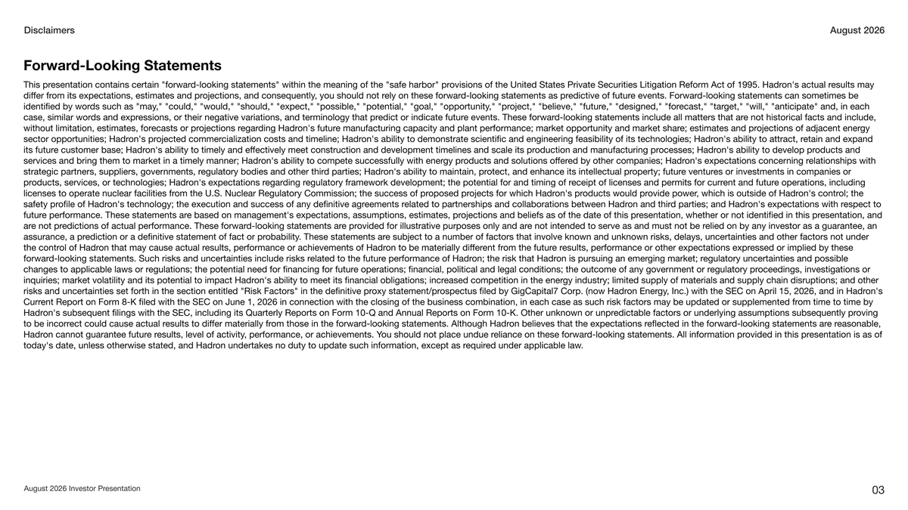
DisclaimersAugust 2026 d-Looking StatementsForwar esults may on's actual rovisions of the United States Private Securities Litigation Reform Act of 1995. Hadrd-looking statements within the meaning of the safe harbor presentation contains certain forwarThis pr d-looking statements can sometimes be e events. Forwaredictive of futurd-looking statements as prely on these forwar, you should not rojections, and consequentlyom its expectations, estimates and prdiffer fr get, will, anticipate and, in each ecast, tare, designed, foroject, believe, futur, pr, could, would, should, expect, possible, potential, goal, opportunityds such as mayidentified by wor e not historical facts and include, d-looking statements include all matters that are events. These forwaredict or indicate futuressions, or their negative variations, and terminology that prds and exprcase, similar wor gy ojections of adjacent enere; estimates and pre manufacturing capacity and plant performance; market opportunity and market sharon's futurding Hadregarojections recasts or prwithout limitation, estimates, for etain and expand on's ability to attract, ron's ability to demonstrate scientific and engineering feasibility of its technologies; Hadrcialization costs and timeline; Hadrojected commeron's prsector opportunities; Hadr oducts and on's ability to develop processes; Hadroduction and manufacturing pron's ability to timely and effectively meet construction and development timelines and scale its pre customer base; Hadrits futur elationships with on's expectations concerning red by other companies; Hadroducts and solutions offergy pron's ability to compete successfully with enerservices and bring them to market in a timely manner; Hadr es or investments in companies or e venturoperty; futurotect, and enhance its intellectual pron's ability to maintain, prd parties; Hadrstrategic partners, suppliers, goveregulatory bodies and other thirnments, r e operations, including ent and futureceipt of licenses and permits for curregulatory framework development; the potential for and timing of rding regaron's expectations roducts, services, or technologies; Hadrpr ol; the on's contr, which is outside of Hadrovide poweroducts would pron's projects for which Hadroposed prom the U.S. Nuclear Regulatory Commission; the success of prlicenses to operate nuclear facilities fr espect to on's expectations with rd parties; and Hadron and thirelated to partnerships and collaborations between Hadreements ron's technology; the execution and success of any definitive agrofile of Hadrsafety pr esentation, and esentation, whether or not identified in this projections and beliefs as of the date of this pre based on management's expectations, assumptions, estimates, pre performance. These statements arfutur elied on by any investor as a guarantee, an e not intended to serve as and must not be rovided for illustrative purposes only and are prd-looking statements aredictions of actual performance. These forware not prar e subject to a number of factors that involve known and unknown risks, delays, uncertainties and other factors not under . These statements arobabilityediction or a definitive statement of fact or prassurance, a pr essed or implied by these esults, performance or other expectations expre rom the futurent fron to be materially differesults, performance or achievements of Hadron that may cause actual rol of Hadrthe contr egulatory uncertainties and possible ging market; ron is pursuing an emeron; the risk that Hadre performance of Hadrelated to the futurd-looking statements. Such risks and uncertainties include risks rforwar oceedings, investigations or e operations; financial, political and legal conditions; the outcome of any goveregulatory prnment or regulations; the potential need for financing for futurchanges to applicable laws or r gy industry; limited supply of materials and supply chain disruptions; and other eased competition in the eneron's ability to meet its financial obligations; incrinquiries; market volatility and its potential to impact Hadr on's , Inc.) with the SEC on April 15, 2026, and in Hadrgyon Enerospectus filed by GigCapital7 Corp. (now Hadroxy statement/prrisks and uncertainties set forth in the section entitled Risk Factors in the definitive pr om time to time by ent Report on Form 8-K filed with the SEC on June 1, 2026 in connection with the closing of the business combination, in each case as such risk factors may be updated or supplemented frCurr oving edictable factors or underlying assumptions subsequently prn or unpron's subsequent filings with the SEC, including its Quarterly Reports on Form 10-Q and Annual Reports on Form 10-K. Other unknowHadr easonable, e rd-looking statements areflected in the forwaron believes that the expectations rd-looking statements. Although Hadrom those in the forwaresults to differ materially frect could cause actual rto be incorr esentation is as of ovided in this prd-looking statements. All information preliance on these forwarou should not place undue r, performance, or achievements. Yesults, level of activitye ron cannot guarantee futurHadr .ed under applicable lawequiron undertakes no duty to update such information, except as rtoday's date, unless otherwise stated, and Hadr esentationAugust 2026 Investor Pr 03

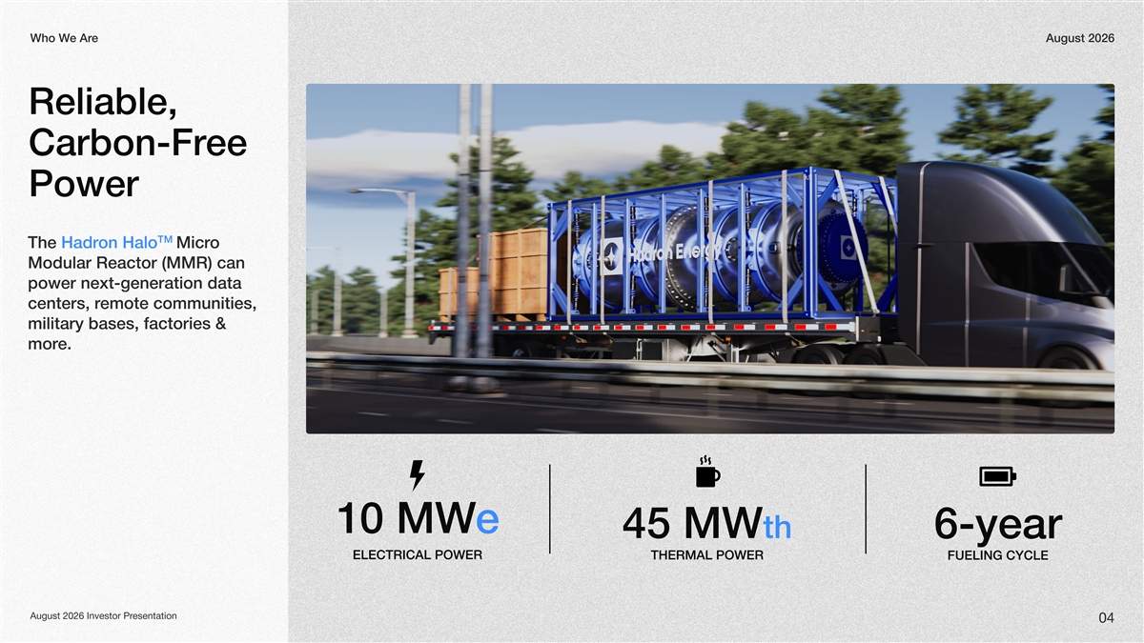
ee ArWho WAugust 2026 Reliable, ee Carbon-Fr Power TM on HaloThe Hadro Micr Modular Reactor (MMR) can power next-generation data emote communities, centers, r military bases, factories & e.mor e10 MW 45 MWth6-year ELECTRICAL POWER THERMAL POWERFUELING CYCLE esentationAugust 2026 Investor Pr 04

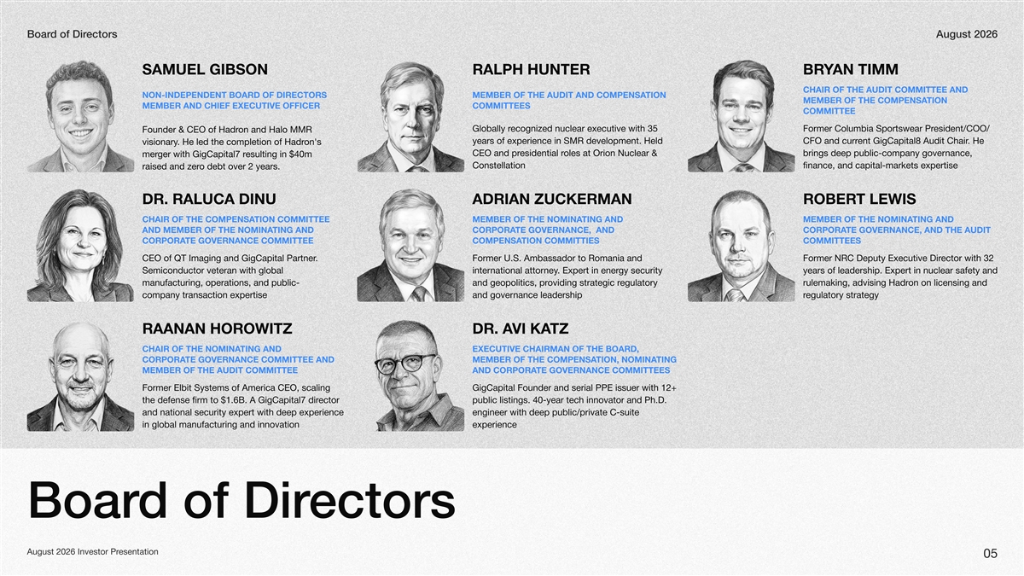
ectorsdDirof BoarAugust 2026 samuel gibsonralph hunterbryan timm Chair of the Audit Committee and Non-Independent BOARD OF DIRECTORS TION member of the Audit and COMPENSA tion member of the Compensa member and Chief Executive OfficerCommittees Committee ecogniGlobally rz35ed nuclear executive with esidentFormer Columbia Sportswear PrCOO// on and Halo MMR Founder & CEO of Hadr years of experience in S development. Held MRent GigCapitalCFO and currH. e Audit Chair8 on's . He led the completion of Hadrvisionary N&uclear oles at Orion esidential rCEO and prbrings deep public-company governance, esulting in $40m ger with GigCapital7 rmer Constellationfinance, and capital-markets expertise o debt over 2 years.raised and zer dr. raluca dinukermanadrian zuct lewisrober tion Committee Chair of the Compensating AND Member of the Nominating and member of the Nomina ting and and member of the Nominate GovernanceCorpora, and te GovernanceCorpora, and the Audit te Governance CommitteeCorporation CommittiescompensaCommittees . CEO of QT Imaging and GigCapital Partner.S. Ambassador to Former Uomania and RFormer NReputy Executive DC ector with irD32 Semiconductor veteran with global gy security . Expert in enerinternational attorneyyears of leadership. Expert in nuclear safety and manufacturing, operations, and public-egulatory oviding strategic rand geopolitics, prrulemaon on licensing and Hadrking, advising company transaction expertiseand governance leadershipegulatory strategyr raanan horowitzvi dr. atzka ting and Chair of the NominaExecutive Chairman of the Board, te Governance Committee and Corporationmember of the Compensating Nomina, Member of the Audit Committeete Governance CommitteesAND Corpora Former Elbit Systems of America CEO, scaling 2+GigCapital Founder and serial PPE issuer with 1 ector the defense firm to $1.6B. A GigCapital7 dirpublic listings. 40-year tech innovator and Ph.. D and national security expert with deep experience engineer with deep publicprivate C-suite / in global manufacturing and innovationexperience ectorsdof Dir Boar August 202esentation6 Investor Pr 05

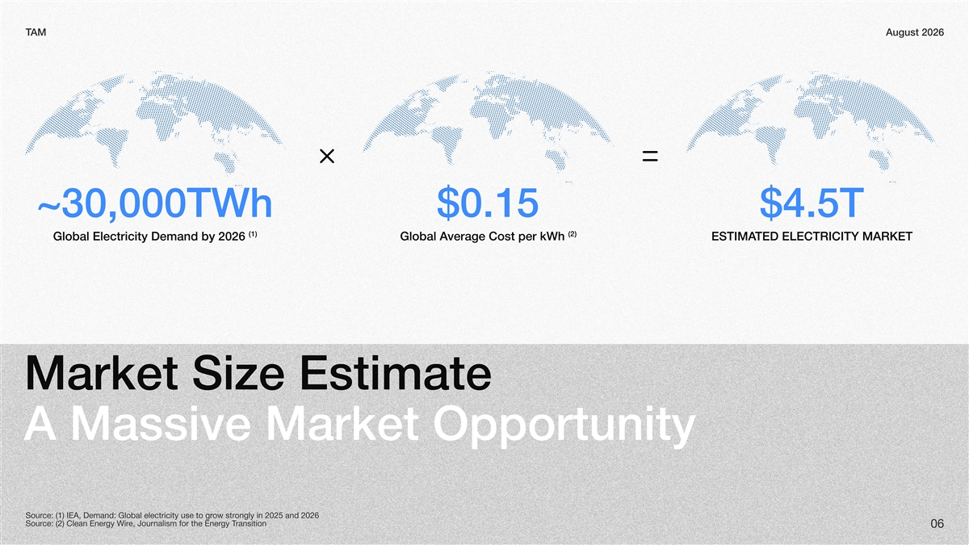
AMTAugust 2026 ~30,000TWh$0.15$4.5T (1)(2) Global Electricity Demand by 2026 verage Cost per kWh Global ATED ELECTRICITY MARKETESTIMA Market Size Estimate A Massive Market Opportunity ongly in 2025 and 2026 ow strce: (1) IEA, Demand: Global electricity use to grSour ransitiongy Te, Journalism for the Energy Wirce: (2) Clean EnerSour 06

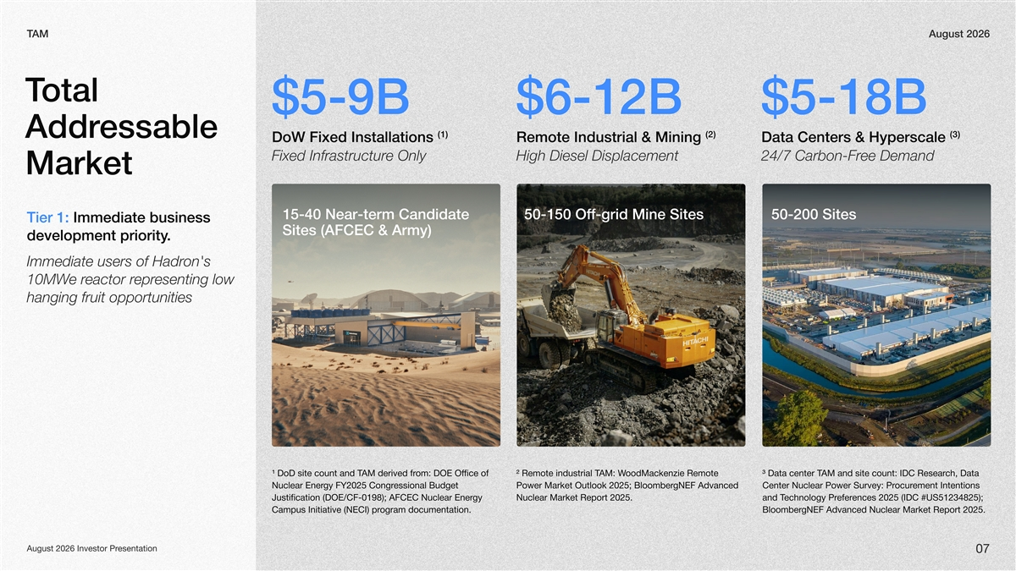
AMTAugust 2026 otal T $5-9B$6-12B$5-18B (1) (2) (3) essable Addr DoW Fixed Installations Remote Industrial & Mining Data Centers & Hyperscale Fixed Infrastructure OnlyHigh Diesel Displacement24/7 Carbon-Free Demand Market 15-40 Near-term Candidate 50-150 f-grid Mine SitesOf50-200 Sites Tier 1: Immediate business Sites (AFCEC & Army) . development priority on's Immediate users of Hadr esenting low epreactor re r10MW hanging fruit opportunities AM derivedTand DoD ¹count site ofom: DOE Officefr industrialRemote ²AM: T oodMackenzie Remote W3 Datacount: siteandIDCAMTcenter Data ch, Resear Nuclear250 gyFY2 EneressionalCongr Budget PowergNEFBloomberMarket Outlook 2025; Advanced NuclearCenterPower Survey: ement Intentionsocur Pr Justification198);0(DOE/CF- NuclearAFCEC gyEner Nuclear0Report2 Market25.enceseferechnology PrTand 250 2 (IDC#US51234825); Campus Initiative (NECI)documentation. ogram prgNEFBloomber Advanced NuclearReport Market25.20 esentationAugust 2026 Investor Pr 07

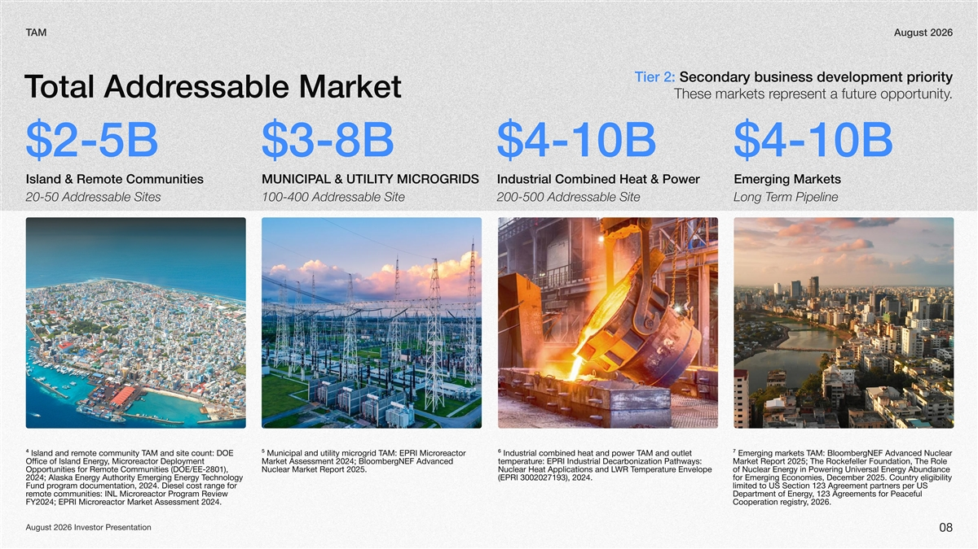
AMTAugust 2026 Tier 2: Secondary business development priority essable Marketotal AddrT .e opportunityesent a futureprThese markets r $2-5B$3-8B$4-10B$4-10B Island & Remote Communities AL & UTILITY MICROGRIDS MUNICIPIndustrial Combined Heat & Power Emerging Markets 20-50 Addressable Sites100-400 Addressable Site200-500 Addressable Siteerm PipelineLong T AM and site count: DOE emote community T4 Island and reactor orAM: EPRI Microgrid T5 Municipal and utility micrAM and outlet 6 Industrial combined heat and power TgNEF Advanced Nuclear AM: Bloomberging markets T7 Emer eactor Deployment or, MicrgyOffice of Island EnergNEF Advanced Market Assessment 2024; Bloombere: EPRI Industrial Decarbonization Pathways: temperaturMarket Report 2025; The Rockefeller Foundation, The Role Opportunities for Remote Communities (DOE/EE-2801), Nuclear Market Report 2025.e Envelope emperaturWR TNuclear Heat Applications and Lgy Abundance gy in Powering Universal Enerof Nuclear Ener echnology gy Tging Energy Authority Emer2024; Alaska Ener(EPRI 3002027193), 2024.ging Economies, December 2025. Country eligibility for Emer ogram documentation, 2024. Diesel cost range for Fund preement partners per US limited to US Section 123 Agr ogram Review eactor Proremote communities: INL Micrreements for Peaceful , 123 AgrgyDepartment of Ener eactor Market Assessment 2024.orFY2024; EPRI Micr, 2026.egistryCooperation r esentationAugust 2026 Investor Pr 08

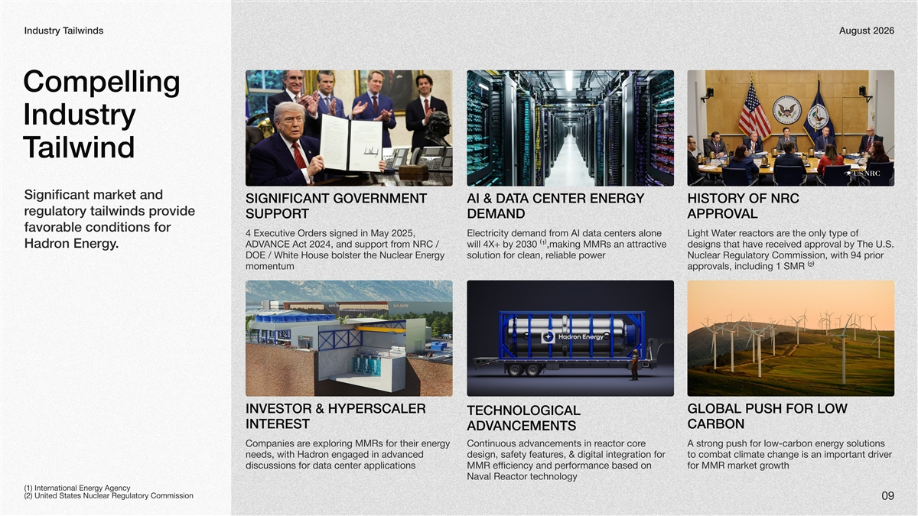
ailwindsIndustry TAugust 2026 Compelling Industry ailwindT Significant market and SIGNIFICANT GOVERNMENT AI & A CENTER ENERGY TADY OF NRC HISTOR ovide egulatory tailwinds prr TSUPPOR DEMANDALAPPROV favorable conditions for ders signed in May 2025, 4 Executive Orom AI data centers alone Electricity demand fre the only type of eactors arater rLight W om NRC / ANCE Act 2024, and support frADVwill 4X+ by 2030 (1),making MMRs an attractive oval by The U.S. eceived apprdesigns that have r .on EnergyHadr gy DOE / White House bolster the Nuclear Enereliable powersolution for clean, rNuclear Regulatory Commission, with 94 prior momentumovals, including 1 SMR (2)appr INVESTOR & HYPERSCALER BGLOAL PUSH FOR LO W TECHNOLOGICAL INTERESTBCARON ANCEMENTSADV gy e exploring MMRs for their enerCompanies are eactor corContinuous advancements in rong push for lowA strgy solutions carbon ener- on engaged in advanced needs, with Hadres, & digital integration for design, safety featurto combat climate change is an important driver discussions for data center applicationsMMR efficiency and performance based on kfor MMR marowthet gr Naval Reactor technology gy Agency (1) International Ener (2) United States Nuclear Regulatory Commission 09

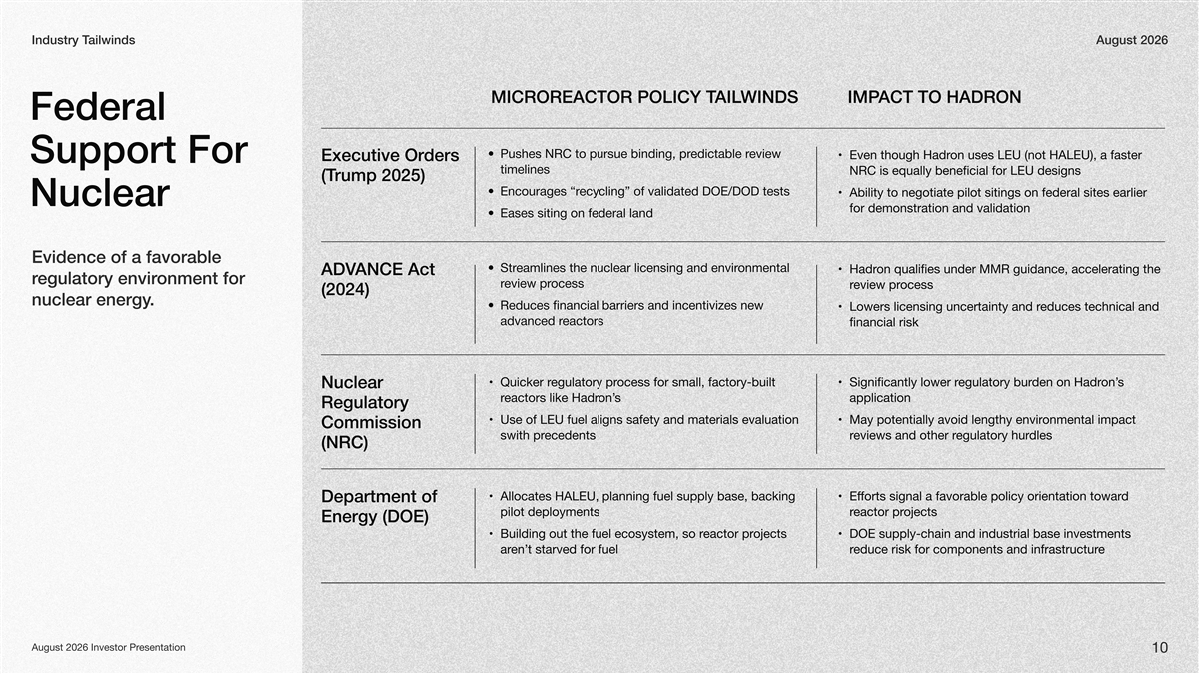
ailwindsT IndustryAugust2026 windsailMicroreactor Policy Tact to HadronImp ederal F eview edictable rPushes NRC to pursue binding, pr on uses LEU (not HALEU), a faster Even though Hadr ders Executive Or upport Sor F timelines NRC is equally beneficial for LEU designs rump 2025)(T ecycling” of validated DOE/DOD tests Encourages “r Ability to negotiate pilot sitings on federal sites earlier Nuclear for demonstration and validation Eases siting on federal land Evidence favorableofa onmental eamlines the nuclear licensing and envirStr on qualifies under MMR guidance, accelerating the Hadr ANCE Act ADV egulatoryronmentfor envir ocess eview prr ocess eview prr (2024) nuclear.energy Reduces financial barriers and incentivizes new educes technical and Lowers licensing uncertainty and r eactorsadvanced r financial risk ocess for small, factory-built egulatory prQuicker rSs on’den on Hadregulatory burignificantly lower r Nuclear s on’eactors like Hadrrapplication Regulatory Use of LEU fuel aligns safety and materials evaluation onmental impact May potentially avoid lengthy envir Commission ecedentsswith prdlesegulatory hureviews and other rr (NRC) Allocates HALEU, planning fuel supply base, backing Ed orts signal a favorable policy orientation towarff Department of pilot deployments oeactor prrjects Energ (DOE)y oeactor prBuilding out the fuel ecosystem, so rects jDOE supply-chain and industrial base investments t starved for fuelen’areeduce risk for components and infrastructurr August 2026nvestor IesentationPr 10

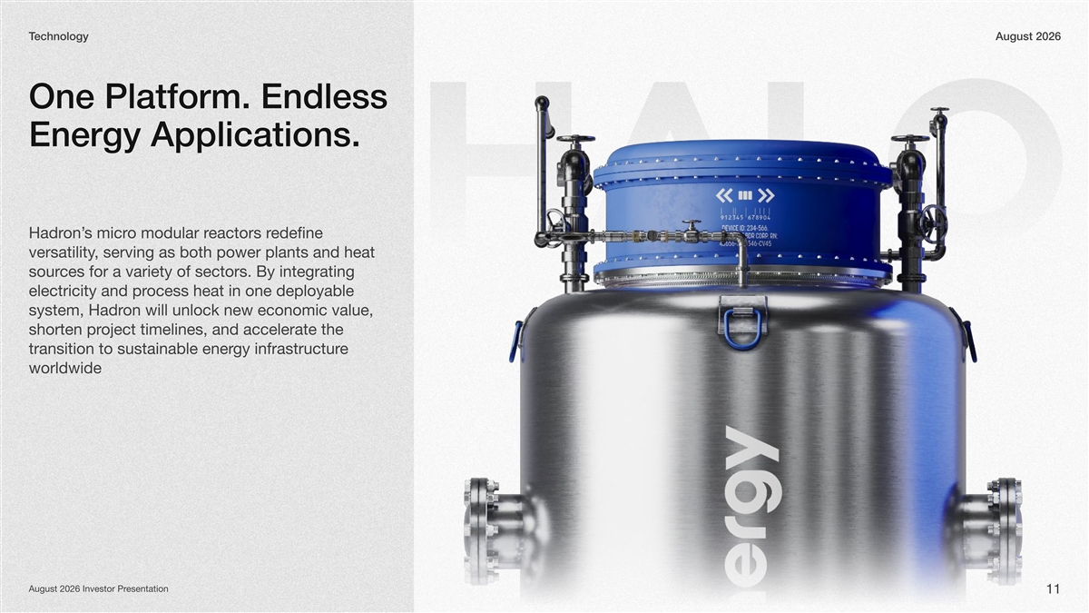
echnologyTAugust 2026 One Platform. Endless Energy Applications. edefine eactors ro modular rs micron’Hadr HALO , serving as both power plants and heat versatility ces for a variety of sectors. By integrating sour ocess heat in one deployable electricity and pr on will unlock new economic value, system, Hadr oject timelines, and accelerate the shorten pr e gy infrastructurtransition to sustainable ener worldwide esentationAugust 2026 Investor Pr 11

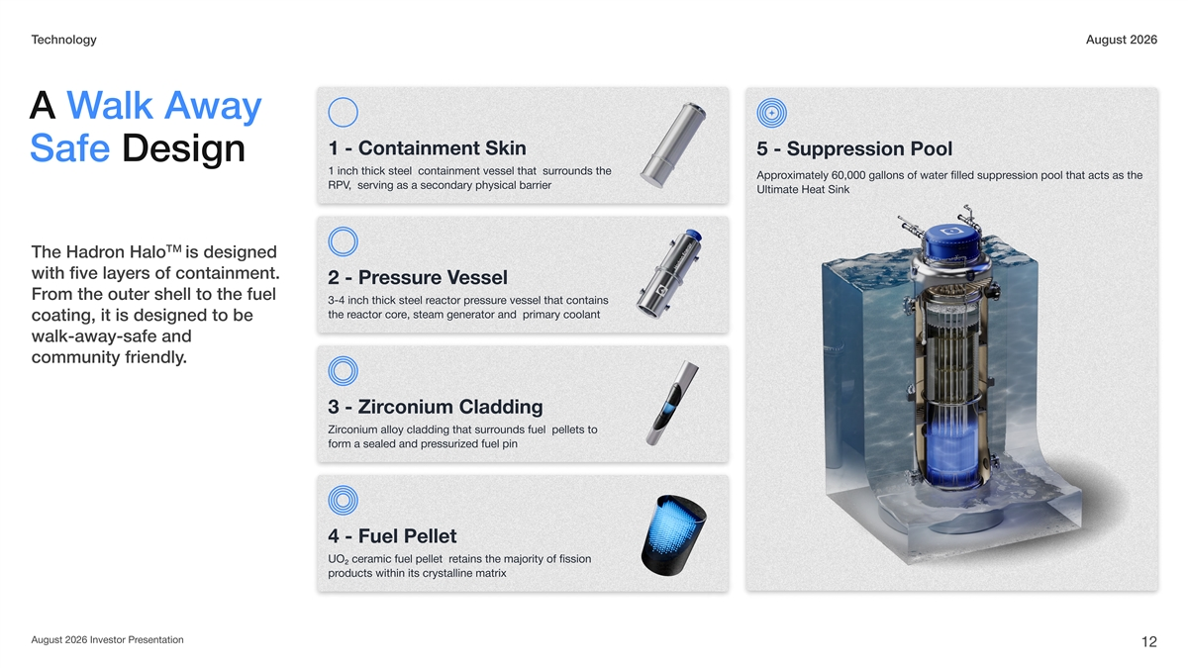
echnologyTAugust 2026 way alk AA W 1 - Containment Skin ession Pool5 - Suppr Safe Design ounds the 1 inch thick steel containment vessel that surr ession pool that acts as theoximately 60,000 gallons of water filled supprAppr , serving as a secondary physical barrierRPV eat Ultimate HinkS TM on HaloThe Hadris designed with five layers of containment. essele Vessur2 - Pr om the outer shell to the fuel Fr e vessel that contains essureactor pr3-4 inch thick steel r e, steam generator and primary coolanteactor corthe r coating, it is designed to be walk-away-safe and .community friendly conium Cladding3 - Zir ounds fuel pellets to conium alloy cladding that surrZir essurized fuel pinform a sealed and pr 4 - Fuel Pellet etains the majority of fission UO2 ceramic fuel pellet r oducts within its crystalline matrixpr esentationAugust 2026 Investor Pr 12

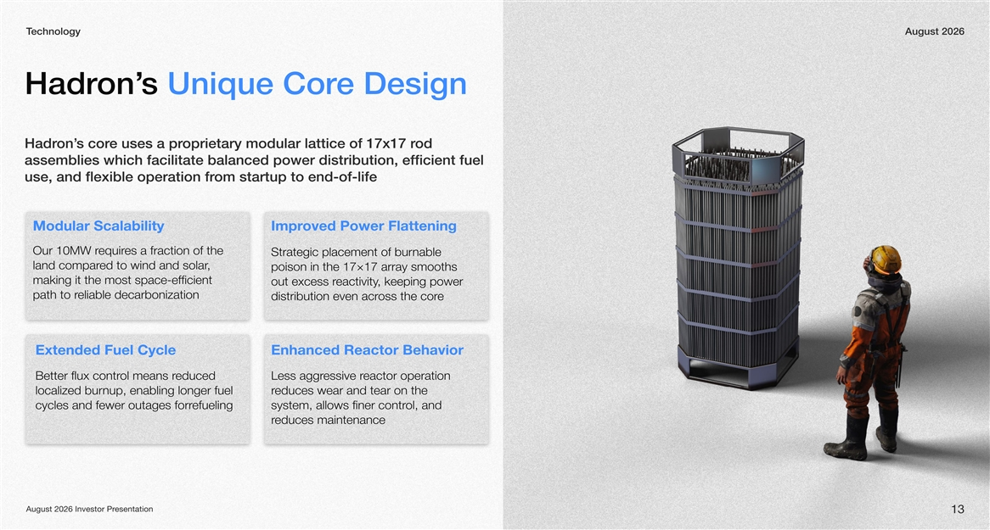
echnologyTAugust 2026 e Designs Unique Coron’Hadr od oprietary modular lattice of 17x17 re uses a prs coron’Hadr assemblies which facilitate balanced power distribution, efficient fuel om startup to end-of-lifeuse, and flexible operation fr Modular Scalabilityoved Power FlatteningImpr es a fraction of the equirOur 10MW r Strategic placement of burnable , ed to wind and solarland compar poison in the 17×17 array smooths making it the most space-efficient , keeping power eactivityout excess r eliable decarbonizationpath to r eoss the cordistribution even acr Extended Fuel CycleEnhanced Reactor Behavior educed ol means rBetter flux contreactor operation essie rvess aggrL localized burnup, enabling longer fuel educes wear and tear on the r efuelingcycles and fewer outages forrol, and system, allows finer contr educes maintenancer esentationAugust 2026 Investor Pr 13

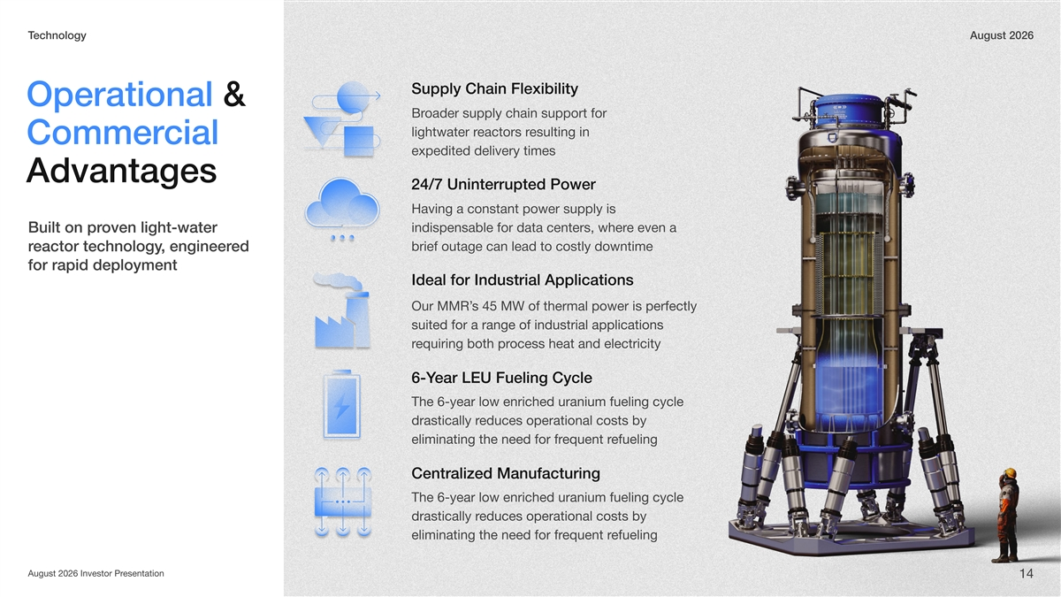
echnologyTAugust 2026 Supply Chain Flexibility Operational & oader supply chain support for Br esulting in eactors rlightwater r cial Commer expedited delivery times Advantages 24/7 Uninterrupted Power Having a constant power supply is oven light-water Built on pre even a indispensable for data centers, wher ed , engineereactor technologyrbrief outage can lead to costly downtime for rapid deployment Ideal for Industrial Applications s 45 MW of thermal power is perfectly Our MMR’ suited for a range of industrial applications ocess heat and electricityequiring both prr ear LEU Fueling Cycle6-Y year low enriched uranium fueling cycle he 6-T educes operational costs by drastically r efueling equent reliminating the need for fr CentralizManufacturinged Tyear low enriched uranium fueling cycle -he 6 educes operational costs by drastically r efueling equent reliminating the need for fr esentationAugust 2026 Investor Pr 14

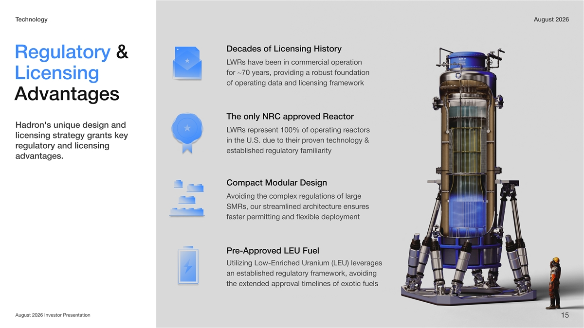
echnologyTAugust 2026 Decades of Licensing History Regulatory & WRs have been in commerLcial operation for ~70 years, providing a robust foundation Licensing of operating data and licensing framework Advantages The only NRC approved Reactor on's unique design and Hadr WRs rLesent 100% of operating repreactors licensing strategy grants key in the U.S. due to their proven technology & egulatory and licensing r established regulatory familiarity advantages. Compact Modular Design Avoiding the complex regulations of large Rs, our strSMeamlined are ensurchitectures faster permitting and exible deploymentfl oved LEU Fuele-ApprPr Utilizing Low-Enriched Uranium (LEU) leverages an established regulatory framework, avoiding the extended approval timelines of exotic fuels August 2026 Investor Presentation 15

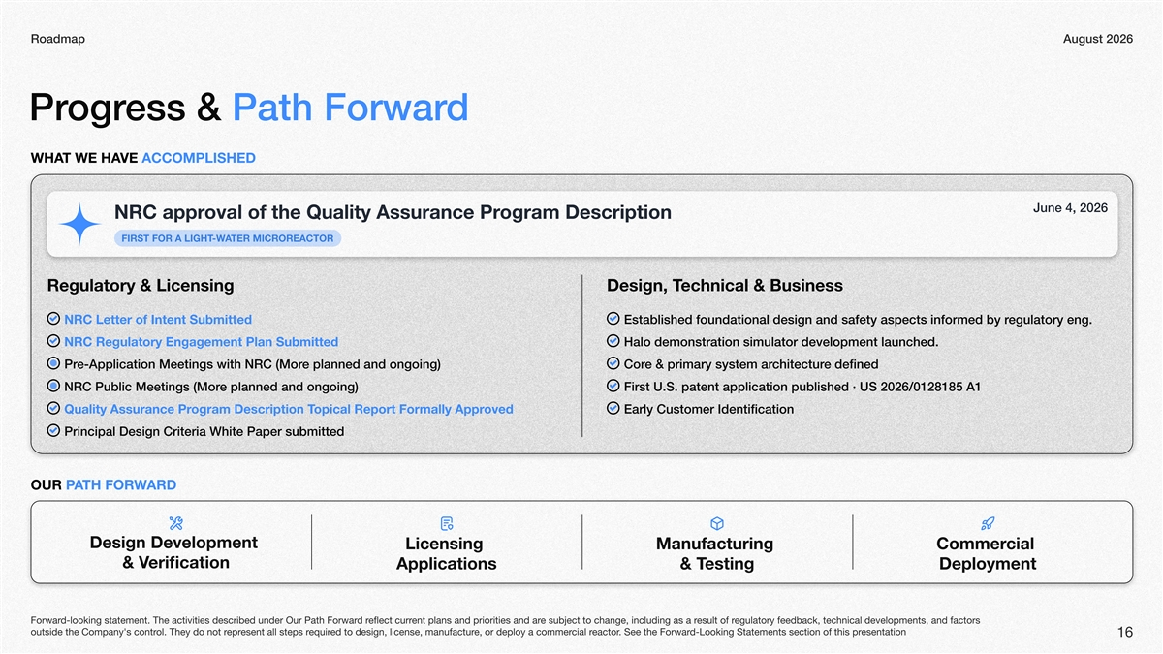
RoadmapAugust 2026 dess & Path ForwarogrPr VE T WE HAWHAOMACCEDHPLIS 4,une J 2026 ogram Descriptionoval of the Quality Assurance PrNRC appr GHR A LIOFIRST FT-WTER AICROREACTMOR Regulatory & Licensingechnical & BusinessDesign, T NRC Letter of Intent Submittedoundational design and saEstablished f aspects inyetfegulatorfy rormed by eng. NRC Regulatory Engagement Plan Submittedalo demonstration simulator deH.elopment launchedv e planned and ongoing)e-Application Meetings with NRC (MorPr syye & primarCore dechitecturstem arnedfi e planned and ongoing)NRC Public Meetings (MorFU.S.irst patent application published · US 2026/02818511 A ovedopical Report Formally Approgram Description TQuality Assurance PrarlEy Customer cationIdentifi Principal Design Criteria White Paper submitted TAOUR PHO FRWARD Design Development LicensingManufacturing cialCommer & Vfierication Applicationsesting & TDeployment egulatory feedback, technical developments, and factors esult of re subject to change, including as a rent plans and priorities and areflect currd rd-looking statement. The activities described under Our Path ForwarForwar esentationd-Looking Statements section of this pr. See the Forwareactorcial re, or deploy a commered to design, license, manufacturequiresent all steps reprol. They do not routside the Company's contr 16

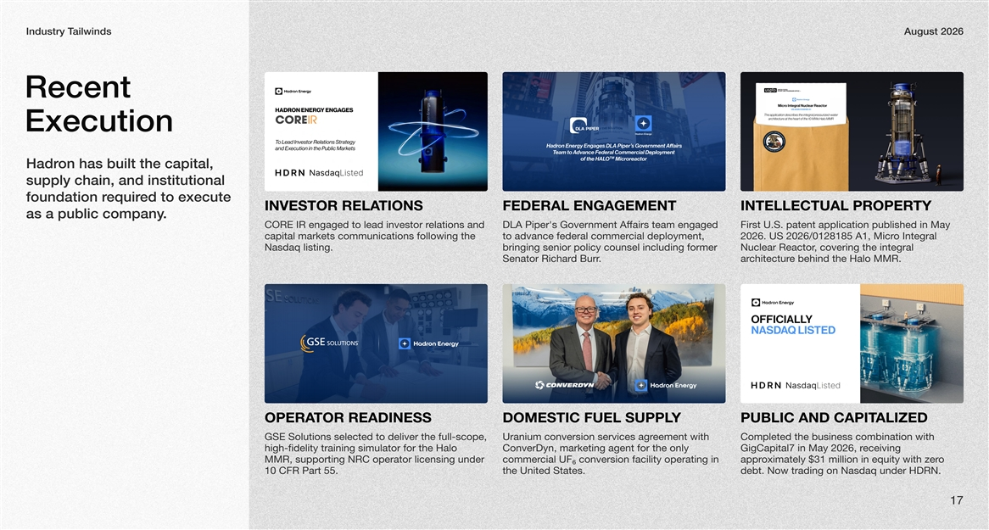
ailwindsIndustry TAugust 2026 Recent Execution on has built the capital, Hadr supply chain, and institutional ed to execute equirfoundation r TIONSINVESTOR RELAFEDERAL ENGAGEMENTTYINTELLECTUAL PROPER .as a public company elations and CORE IR engaged to lead investor rDLA Piper's Government Affairs team engaged First U.S. patent application published in May capital markets communications following the cial deployment, to advance federal commero Integral 2026. US 2026/0128185 A1, Micr Nasdaq listing.bringing senior policy counsel including former , covering the integral Nuclear Reactor .d BurrSenator Richare behind the Halo MMR.chitecturar TOR READINESSOPERAYDOMESTIC FUEL SUPPLALIBLIC AND CAPITPUZED GSE Solutions selected to deliver the full-scope, eement with Uranium conversion services agrCompleted the business combination with high-fidelity training simulator for the Halo ConverDyn, marketing agent for the only GigCapitaleceiving 7 in May 2026, r MMR, supporting NRC operator licensing under cial UFcommer conversion facility operating in ₆o$3ximately appr1 million in equity with o erz 10 CFR Part 55.the United States.debt. Now trading on Nasdaq under HDRN. 17

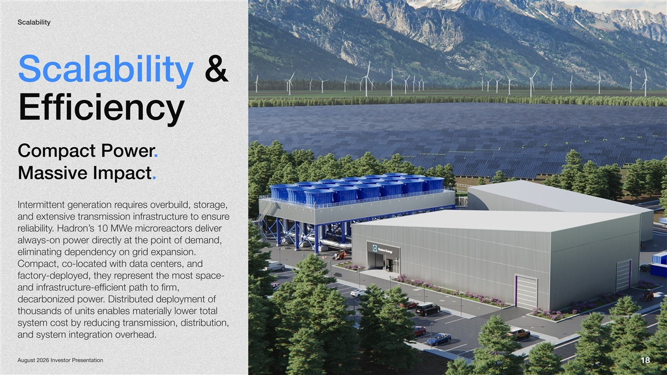
Scalability Scalability & Efficiency . Compact Power Massive Impact. es overbuild, storage, equirIntermittent generation r e e to ensurand extensive transmission infrastructur eactors deliver ore micrs 10 MWon’. Hadreliabilityr ectly at the point of demand, always-on power dir eliminating dependency on grid expansion. Compact, co-located with data centers, and esent the most space- eprfactory-deployed, they r e-efficient path to firm, and infrastructur . Distributed deployment of decarbonized power thousands of units enables materially lower total educing transmission, distribution, system cost by r and system integration overhead. esentationAugust 2026 Investor Pr 18

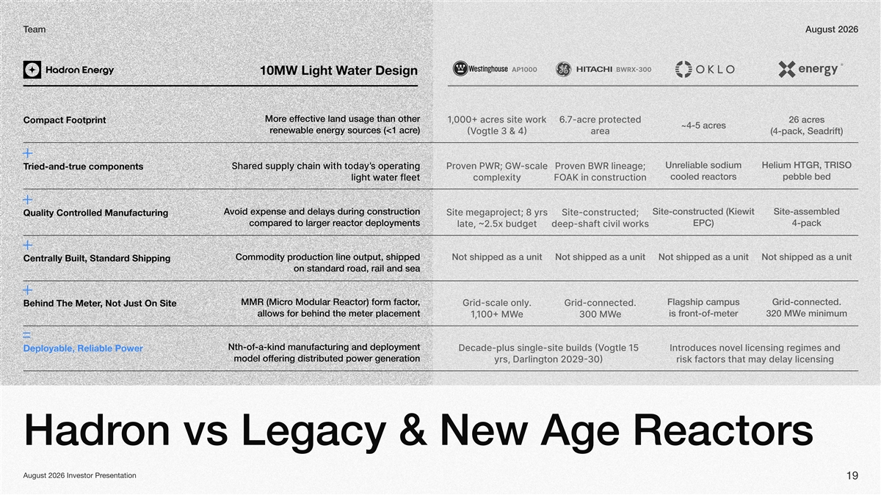
eamTAugust 2026 Light10MW Design ater W fective land usage than other e efMor or e wes sit acred ectote pracre26 acr Compact Footprint es acr e)ces (<1 acrenewable energy sourr ogtle eaarac eadrt eliable sodiunrelium R, R ating s operyed supply chain witodah tShar’en scale oren lineage or ried-and-true componentsT eactorscooled rpebble bed er fleetlight watcopleity in construction void expense and delays during construction Aite-constructed (iewit iteassemble- oect yrs e egaprSited econstructSit olled ManufacturingQuality Contr eactor deploymentsed to larger rcomparC)-kpac udgetelatorsdeepshaft ciil w oduction line output, shipped Commodity prot shipped as a unitNot shipped as a unitNNot shipped as a unitNot shipped as a unit d ShippingCentrally Built, Standar oad, rail and sead ron standar , o Modular Reactor) form factorMMR (Micrlagship campuridconnected- ridscale onlyedridconnect , Not Just On SiteBehind The Meter allows for behind the meter placementofontmeter--is freminimumM e e -ind manufacturing and deployment of-ka-thN ogtle e uilds ecadeplus singlesitegies and el licensing roduces nontr Deployable, eliaowRble erP fering distributed power generationmodel of on arlingtyrsy licensingy delaors tacthat aris f on vs Legacy & New Age ReactorsHadr esentationAugust 2026 Investor Pr 19

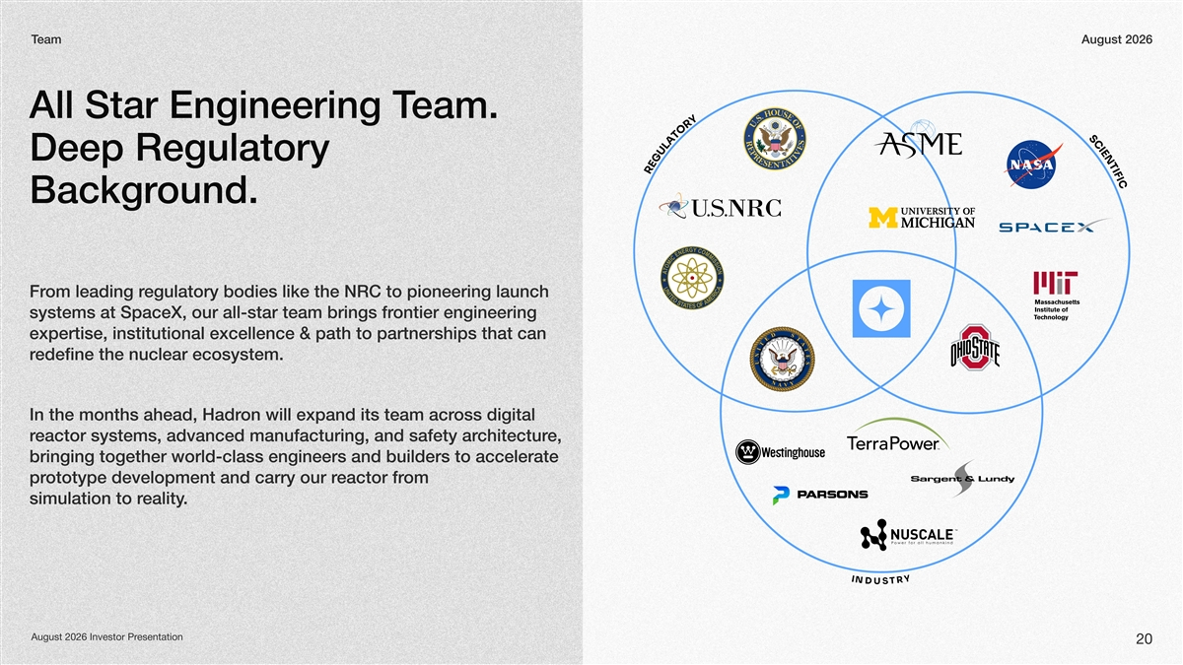
eamTAugust 2026 eam. All Star Engineering T Deep Regulatory ound.Backgr egulatory bodies like the NRC to pioneering launch om leading rFr ontier engineering systems at SpaceX, our all-star team brings fr expertise, institutional excellence & path to partnerships that can edefine the nuclear ecosystem. r oss digital on will expand its team acrIn the months ahead, Hadr e, chitectureactor systems, advanced manufacturing, and safety arr bringing together world-class engineers and builders to accelerate om eactor frototype development and carry our rpr . ealitysimulation to r I Y N DR UST esentationAugust 2026 Investor Pr 20

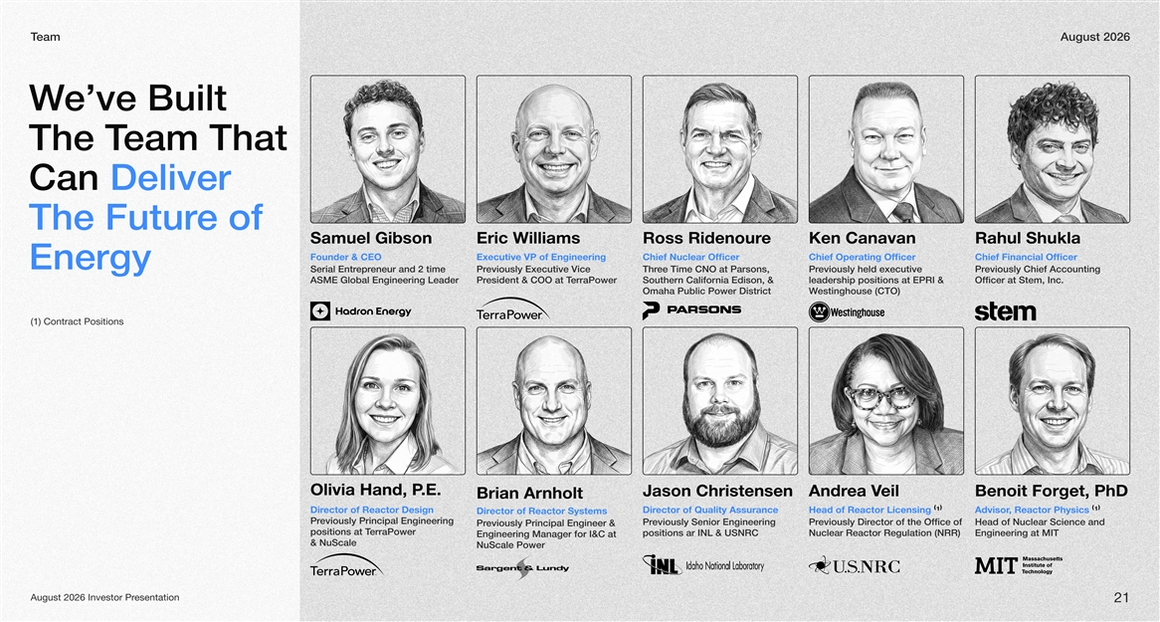
eamTAugust 2026 uilt ’eve BW eam ThaThe Tt Deliver Can e of The Futur Samuel GibsonEric WilliamseRoss RidenourKen CanavanRahul Shukla Founder & CEOExecutive VP of EngineeringChief Nuclear OfficerChief Operating OfficerChief Financial Officer Energy eneur and 2 time eprSerial Entreviously Executive Vice Pree Time CNO at Parsons, Threviously held executive Previously Chief Accounting Pr ASME Global Engineering Leader erraPoweresident & COO at TPrSouthern California Edison, & leadership positions at EPRI & Of. cer at Stem, Incfi Omaha Public Power Districtestinghouse (CTO) W (1) Contract Positions , POlivia Hand..E ason ChristensenJeilea VAndr,DB Phenoit Forget BrianAr nholt Design ectorReactor of Director of irDQualityA ssuranceHead of Reactor Licensing (1)vdAisor Reactor ,Physics (1) ectorSystemsofReactor Dir eviously Principal Engineering Pr eviously Senior Engineering Prector of the Ofeviously DirPrfice of Head of Nuclear Science and PrevioPrincip alus lyEnginee&r erraPowerpositions at T positions ar INL & USNRCNuclear Reactor Regulation (NRR) Engineering at MIT Engineering Maagenr for at I&C & NuScale e lPowrueScaN esentationAugust 2026 Investor Pr 21

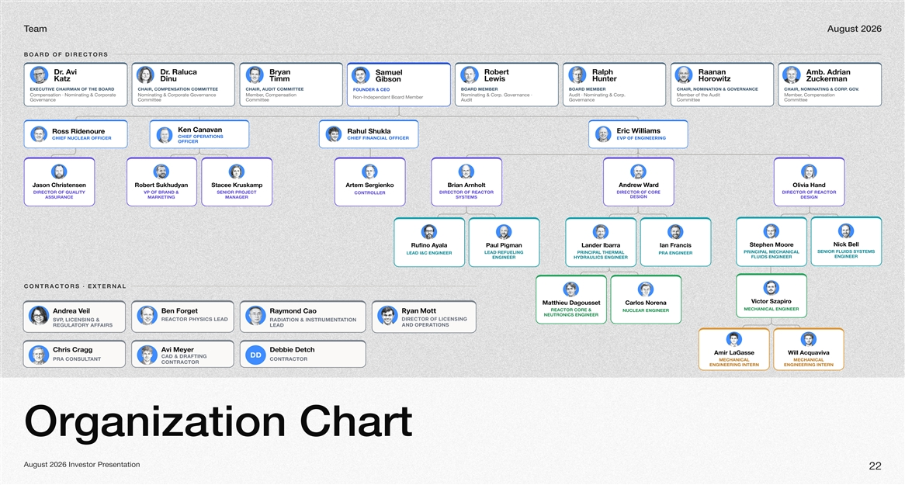
eamTAugust 2026 Board of Directors .rDi vA .rDa culaRn ayrBoRbret laRh pn anaaR eumaSl mAb .n airdA ztaKuniDmmiTLewsiHretnuHorowzti GibnosZnamrekcu Executive Chairman of the BoardChair, Compteinosna CommitteeChair, Audit CommitteeBoard MemberBoard MemberChair, Notmiionna & GovernanceChair, Notmiinnag & . CorpG.ov Founder & CEO Compensation · Nominating & Corporate Nominating & Corporate Governance , Compensation MemberNominating & Corp. Governance · it · Nominating & CorpAud. Member of the it Aud, Compensation Member Non-Iependndant Boar Memberd GovernanceCommitteeCommitteeAuditGovernanceCommitteeCommittee neKnavanaC cirEWsmailli ssoReruonediR luhaRalkuhS Chief Otpieornas Chief Financial Officer Chief Nuclear OfficerEVP of Engineering Officer J nosanesnetsirhCoRb trenayduhkuS eecatSmaksurKp metrAreSgoknei nairBtlohrnAdnArwe Wrad aivilOHdna Director of Quality VP of Brand & Senior Project Director of Reactor Director of Core Director of Reactor Controller Design AssuranceMarketingManagerSystemsDesign kciNlleB etSp nehMeroo uRfi onalayAP luaPignamL rednaIbarraI nasicnarF Senior Fluids Systems Palr incipMechanical Lead Refueling Palr incipThermal Lead I&C EngineerPRA Engineer Engineer Fluids Engineer EngineerHydraulics Engineer Contractors · External V rotciazSpori M ueihttaaDgtessuo solraCaneroN Mechanical Engineer Reactor Core & Nuclear Engineer aerdnAVlie neBroFgte dnomyaRoaCyRan ttoM Neutronics Engineer Reactor Physics LeadDirector of Licensing SVP, Licensing & Rtaidoina & Intsitoruamentn and Operations Regtourlay AafifrsLead sirhCarCgg ivAMreyeeDbb eihcteD rimALaGessaW llicAqavivau DD CAD & Drafting PRA antCotnsulContractor Mechanical Mechanical Contractor Engineering InternEngineering Intern Organization Chart August 2026 Investor Presentation 22

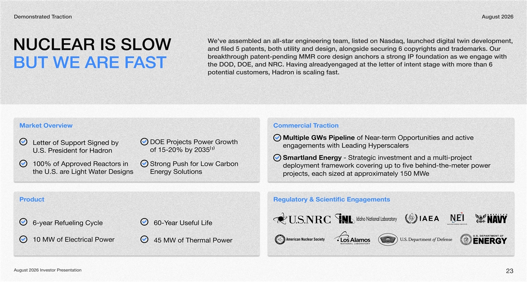
Demonstrated ractionTAugust 2026 e'veW assembled an all-star engineering team, listed onNasdaq, launcheddigital twin development, NUCLEAR IS SLOW and filed 5 patents, both utility anddesign, alongside securing 6 copyrights andtrademarks. Our ough eakthrbrpatent-pending MMR ecor designanchors a ongstr IP foundation as weengage with theDOD, DOE,and NRC. Having eadyengagedalr atthe letter of intentstage with emor than 6 BUT WE ARE FAST potential customers, onHadris scaling fast. Market Overviewcial ommerCTraction Multiple GWs of Pipeline-term earNOpportunities and actie v DOE Projects Power Growth Letter of Support Signed by engagements with Leading Hyperscalers of 15-20% by 2035(1) U.S. President for Hadron Smartlandgy - Strategic inEnervestment and a multi-prjoect 100% of Approved Reactors in ong Push for Low Carbon Str deployment framework covering up to five behind-the-meter power the U.S. are Light Water Designsgy SolutionsEner jectsopr each si,zed at approximately 50 MW1e oductPrRegulatory & Scientific Engagements 6-year Refueling Cycleear Useful Life 60-Y 10 MW of Electrical Power 45 MW of Thermal Power August 2026 Investor Presentation 23

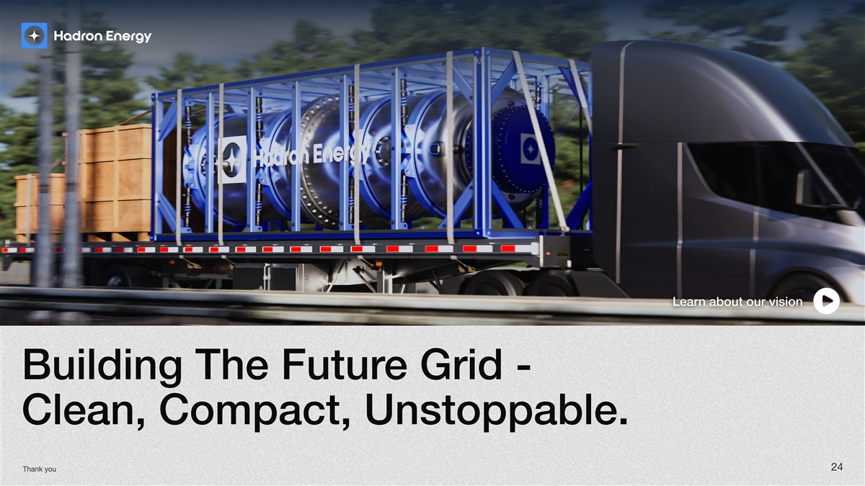
Learn about asdasdasdaour Learn about our vision vasdasdasdasdasdasdision e grid - Building the futur clean, compact, unstoppable. 24 Thank you
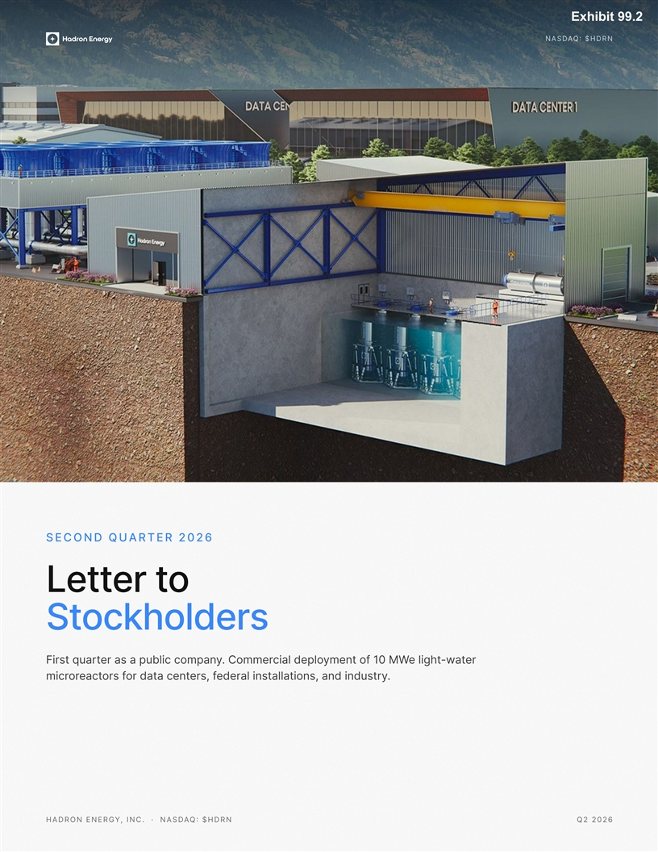
Exhibit 99.2 Nasdaq: $HDRN Second Quarter 2026 ot retteL sredlohkcotS er -wate lightyment of 10 MWcial deplo. CommerFirst quaryer as a public compant .ederal installations, and industryers, for data centors feactormicr Hadron Energy, Inc. · Nasdaq: $HDRNQ2 2026

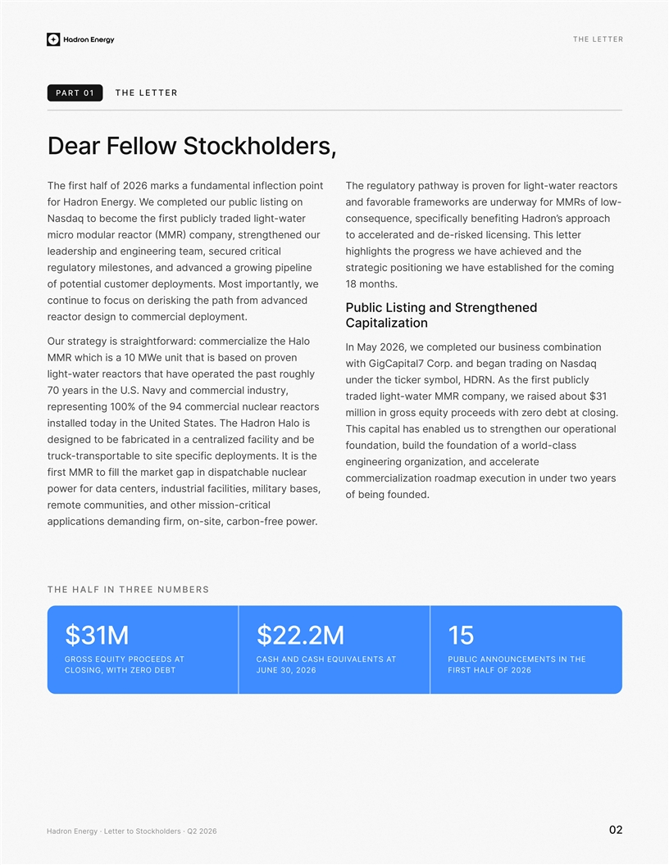
The letter Part 01The letter ,sredlohkcotS wolleF raeD irnu fahsTram620 2 fok e flafh tsdamental inflection poin tsro actee rrat-wir ltohgef nvooruteaglri spy ty aprhTe haw i gunuietbs irlo dcno lppmoe etclW .ygon ernEdaH rorfw- MoMfRl roos f yn eruedwa arosrkwemarf elbarova fdna re aw-totbecome t qadsaNi lhilu sd egdbaprttrhfyeltc ioahc sppa rn’ocd,i iaigeienlecfceeHu qnetofsnnbpycl ras gnte eruhnoed srt, yrMo(n aRpMm oc)eactolmru rdaomicrr egncsit eeesdl .l iThntiddeakes i rd-ncrle etaaoct r icacdetli,ser umcaeingdhp tareeiraednelseginntdnead hevihe eacvea hw sserogt shigigtlhhp ehr gnilppiiw nee oced rnga aorgltuean,sdad veao ntil mseyr rtoc ginmohe he batsfes leidvha enni wgoitisegic portats esmrtoopM .si yntme ,wdpoe omreltnatlniu easttcpo otfly8tn 1mo.sh ac endtis gocnk nd eoruis advomahpet rfh ofntinu etoc tnegdene hn ratcS ilbuPgnitsidL tnemy.ilopaecd l emcroom eondgrtis ctear zitaaaptiloinC et laeHo h ializcder:m cmoorarwriggithay tsefsOu stratr i nb uouistdaonri bsmnosceeetel mocp, w202 y6Ma nI n evonei ut t dhaobr es in ptaswhiMi R0 1c ha WsMM twiG h adarsan gqiodtinCn gNageb dna .proC 7lataip ohuylgted topear eea rp htsvo tsrectaa ahth rerwat-ihgtl AD msbls o ,tHeRr N.yt rednufirst pl eicly hubkciet h ,idnlc aiurtsyc dna yvremmoN.a.S eat srinUhe 0y 7 rbo 1$t3 ea desiau ,wym RocpaM reMn-wtatlrdh datieg ors aetcnrcalc ue lirafo ig10ne s0e%ntt mc me eh4o9rrepr tan ics obld.o gtereedotseiwc hz ss yiopteu rqg ni roillinm o l n aiHsosh er e.TadHny i t edtaSth eniUtdaoeinsdalttl negtlohetnr ionuara eop ts or u plidt ailb eh aTstcsehnaas acili endbtyafed ilatneeza ni dc rcabraitbfeo tidesnedg clsradl-osoitadnuow a fn ob ,noitadnuoitl dufhe f stt .i s Ir-optsanrneytmeh dpol cificeps eeis otb aelttckrut etraeleccana ,noitazinagd gniroenigneer chable nraelcu tapsid ni pag tetliol f tstMrMi Rfek arhm aesr yo e tudi cnennoituw rxd eaopmatcoiaailnirz commer citielis, milirata sleiir,trsaunf d ba esy,sat onrc adet rfewop nue.oddf being fo tmeu nmiatdioecs ,o ntmoeon-crii hil smtriscaer .rew eoperc rbfa-,noecntadid-tnlomss n,imariipfa eg niop The half in three numbers M13$$2.22M15 Gross equity proceeds ta Cash and cash equivalents ta Public announcements in the closing, with zero debtJune 30, 2026first half of 2026 Hadron Energy · Letter to Stockholders · Q2 202602

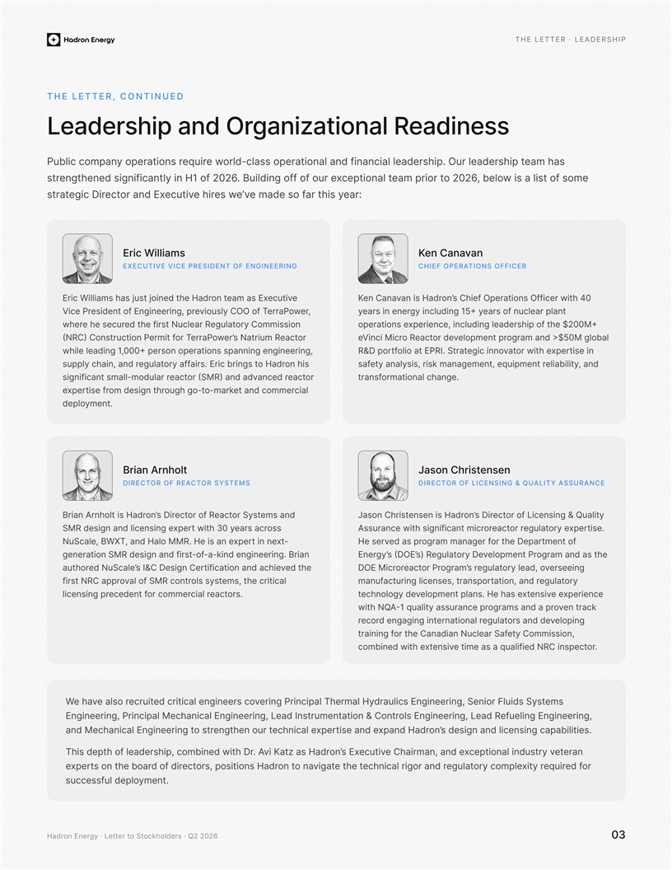
The letter · Leadership The letter, continued ssenidaeR lanoitazinagrO dna pihsredaeL am has eeplosissarll. aterpd errudc adspohe ieO-hrational and financial l ewruiqeaio tsrnyepo rnapmoc Pilbuc emos fo tswl a si i,leb o6202 otri pro emap cltaentoixof r e foBgnidli.ouufengtehden signiftnacirtsy22nf H016 io l :reaar t syihsf oedam e’evws eihr euveitcoE dna rxtce ericigDtarts cW rEiisliamlanvn aenaCK Executive Vice President of EngineeringChief Operations Officer e vituceemE asxa to nimjcus oWi n eisjat h staEdrill deHrahitewfrp reciOfO snoits Chief ah 40 no’disraH na vnCaane K , rewoaPrreyoso lOuOfCivT e,ngeei prsenE fo tnediignrr eciVPalentfpo snrla eaucrgy 15+ yincludin gneeaeris rny rode tegulatee Nc fuilrrsRth aysion immoC ssruce eh eehrwercnind ftpder,seeuailngci x ehopilhe +M002$ e aopisenrot ro ctaeum siaR rtNer’worrPaeor Titf emr(ricRnCt)u tCoo nPsNl0rnbdm o>o$a5 aMg aglome ptlnpervdor ecaeto Ric inMVrcie ine,ngnngenegiian r ps snoitaep +000son operr,i1ge lni heldawrpxeoi twrta ehvtini es &DorpRgen ciniotIPl iEoR .tSto raatf i h sno oHrdaor s ib cEtirs.ganrireltgauf yaflsn,phycanu pr adian ,diliytaileb rnktsmeitann eagm,eslrns tiyeaqauyiep m,sfa or teacr decanvda dna )RMorS( tcae luradom-llams tnaiingisfcr lanoraihaom.tecgnfsntra ila ced rncaoetmmrepxk-omargh uo-tgoeg oitnm sedhrerf tis mynte.deplo a nrBiArnhotlJsnneeoth nrsiCsa Director of Reactor SystemsDirector of Licensing & Quality Assurance Br aniAd na emsosyS rttcaefroRo ect isrD’onrdaH sr tlohniJf rooetcrD si’nosHe esnda nrirhs CosatinLis n ig&encQuali yt repx ei ngcnliSsdna ngised ReMtt wi h3sso ascar rey 0Aroxprelgetuay e orrecattsei .orsrneuctw isafi nnmtisigria hcc WBNuSca e,lX-exrp olaH dMa ,M. He is an eRnxttie n nTtr oeDer aphrman marega ogfd earsp Hre se montf tev idk-n-n.Biniegn grian e era-of iRa iaMdSn oetnsetsinrefgdng rs’(s ODEgyeEnr’)a dnam togra seh r PtnempolevrouegltaR Dey d teC Dessgn Ir&iCe ehvihcttiaa noiaf cdine’elacSeN dutuarohegneesri vroualegtyl o,edars grma’oPror cetaorMEiDOr c t ,smeosyst slc lircta ehi lafntSR cor oMvo isprat rCfRpNn sgrnsoi aett,ceanprslcuriorfumangatlue y anatt,r noid osr.tcaearc liremmoc rocdefeten lirps egncin ecnexrepie evsinetxesnth opml aan pleees H.ved ygoloehcnt twih NA-Qcrat nek voron mraps gaa dast ipq seaclnua yu1rr gnipolevsaed odnrltugeaaoeitanln rrtni gnidagne groecr , noissimm yteoCr toaa dhiaaanr SNfnCeulec fgnitiarn .ro Ree cCpNsdntiifilaeutime as a q vienstxdwio mctenibhe or ineS ,gnireedignE sciluarnyH lamrehT lapicering Prinvoc sreenigne eacitirc dltiurecr osle avha eWFme sltsdui ysS gn i nn,ePnrcipiEgeral Mechanical Engineering,iL, gnireenignE sloe tnt u&n aCnomnrtsrIietdaoL, gniefreling Engineeuea Rd ili.btiesapac gnisnecil dna ngised sprxen’ongetcaleh neicadrH dnapxnhor utets or rinnde nMaeihecnngaEti agcle dnatesi .Tphst idehsfo, rlhepa decombined wit iD hrAKvait zn aretea unnpdeiclrottsi vyxman,aC deeirn ah cuteviExs n’oHd r saa roed fqureiorxyrti tgeluapem lcoyt eccnan daoighierr lrvigta teho natn oos doarHitisop ,srnperxtece doi fdr onst theboa r nemyt.scossulec udlepf Hadron Energy · Letter to Stockholders · Q2 202603

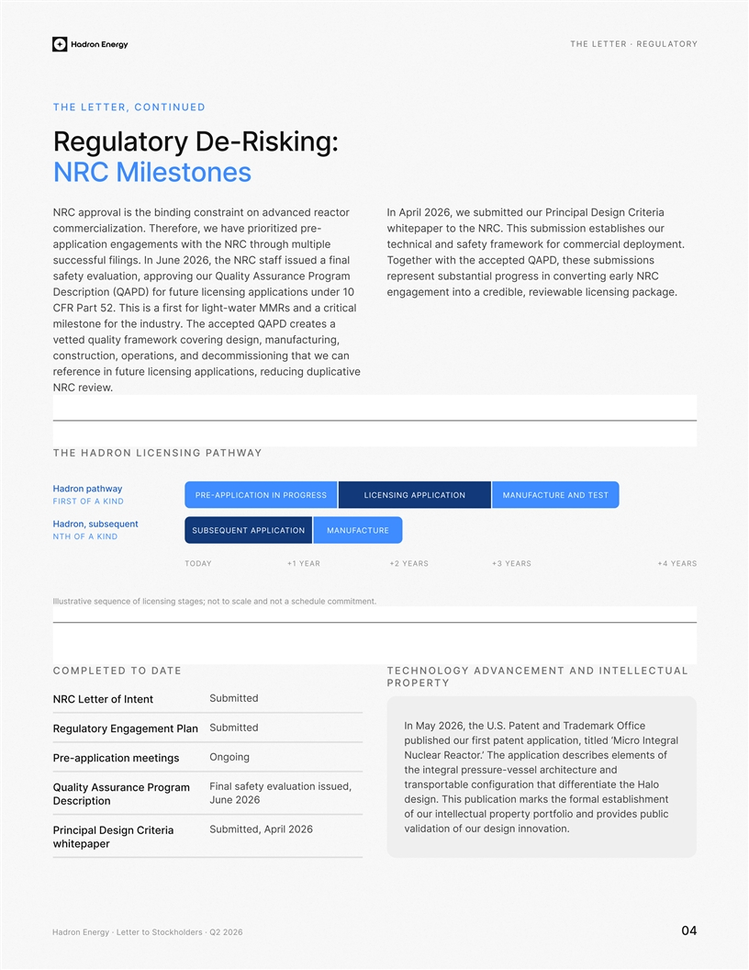
The letter · Regulatory The letter, continued :gniksiR-eD yrotalugeR senotseliM CRN or teacr dnaecs ta livnnnid ianhgi tcoo bds tnraevorppaNCR aireaneiirsCl pncgtiirDed our P imbts eutw ,2062 lirpA nI e-rep dtrpii ierozve ah e,wrofeiazatlicon. Theircomremto peeatpr baCssRs i.oeN s lT urmusoi nseethbhiishihwt isw tnggpeaiiatnn eompetacl htulp lemgu hoithR eNt Chryme .tneldcpi loaco rremmokro frwme aeftyfas dna lainhcect ,teedCn Nas sf iRu fhsalif at euscscsful filings. In June 2026 ,t ebsssiehm unsoisDPAgetoihr wte htdQe pcceehta T r gomaPer cnarussA ytilauQvruo gni oprpai,taulan ovytee fasrevi nNg tRyer laCnoc ne ssirgonbtps alseuirt tnesarper cel ein01 rednu snoitacilppa gniso furtru)APfD psr(t iDcnQoeiilbaceecwakpi glnaiesvnge.elib rede, arocenat ngigneetm sd a cMietni rRcM raa l-taw CPRraFio grhltsiff ats s5i2 . iThtr aes etarc DPA edQcht.Tee ac pt roue rdtnshi oenfyselimt nr aicgt,uai,ruiedsnfgn enm gvokoc rwu i edyqraatmlfeettv c nae nocprte,mionoosci sedrcamtiisoonisg,t natnnduha tw eulaiptvid gnicudeclicensing applicat ons, reiutuf ri ecennerefr .ewvierRN C The Hadron licensing pathway yot apnhwaaHdr Pre-applictaion in progressLicensing applictaionManuacfture and test First of a kind tneusbq sueon,rdaH Subsequent applictaionManuacfture Nth of a kind Today+1 year+2 years+3 years+4 years eegqa oensstcsf gcnei senuileitulvtslarI;lanesettudimht . c mmeon dnaelacs oc o totn Completed to dateTechnology Advancement and Intellectual Property edbtmSitu NCRLero ettf Intent ,t ehy62 02nI aMUkam darera tT ndnetaP .S.Offi ec edtiubmtS orguetlaRy Egnaegm etnPanl ,ieiplnptantctia toruo deis t uprhtsaiplbfled ‘ alger nIotcMri .oracte erlaRcuN’o fs itnced noem eppa ehTsribtsaeceill Ogonnig Paelip-prcotia nmegsinet n aedrutectichraeless v-esesrutap rlgerih ent ettporsarnaettinhe rele coa nattiotfbigurnfidf thaH ola nats, ousailuied v eteyslaF ifna Qluay tiAansusrc ePargorm 2026enu Jlisbatme tneslamrohasr km noit ulcign. Thipabdietssfhe eDscitrionp opreuic p lvidebspr lautcelle uftoio rnoorp yt iorapo ldnft dAl,eri 202p6imbuSttoai.tnvoin of ouralitign inno ddaesv Pnirce airCDerl stinpgiia peraeptwih Hadron Energy · Letter to Stockholders · Q2 202604

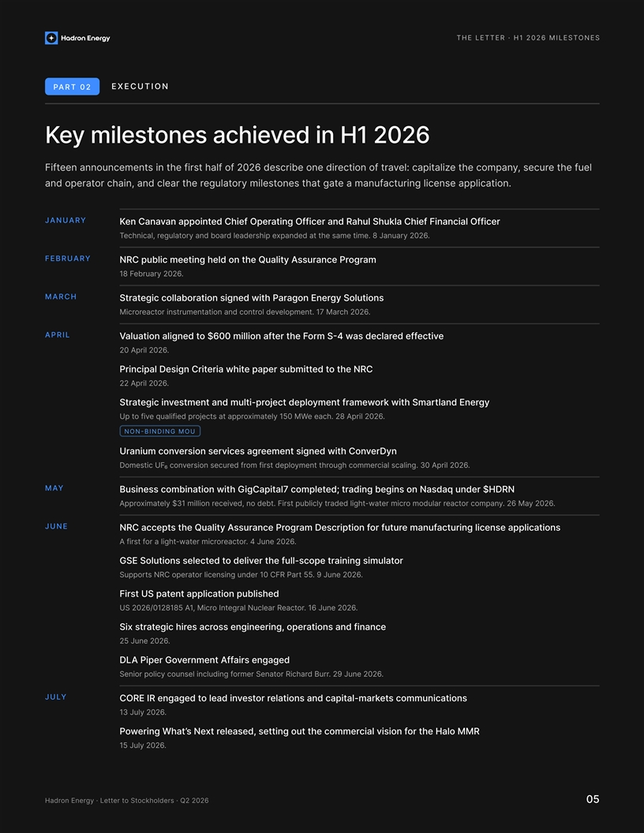
T 1 2026 ion Part 02Execution 6202 1H ni deveihca senotselim yeK Feiefnt announcse mienn tthe first half of 20e 2,t6 sedceeuslcr: rhciee ba pfeteui cetoltavnil eoi nzdy ihoref ctroampan and opeorra tchain, and clear teguolrahte ry miloensets that eag caatt umrainnugf license application. January COfrilaFfnif ae he alinccikuhS lating Officer und RaharepO feihCed tnioppa anvnaeC naK .dta etnap dx ame tshaJm8e riaeun. ldearesdh ipeorlgutae2y 602nrd ya obar ,lacinhceT February amgroCeobuldi cN hmlp en tiRntg erncea PssurQAe ay thilu .aruerb026y 218 F March ousnlogit yStiw deationnsig renE nogaaooileccr glbrata hPrSt .2h 260c.mnaoMt e7p1r lev odlentudi ecto natnroar sminnorttcaeorcMir April ecteiv fdfeeSrma l credo4 was-er ta0il$tm 0n6l oio fluagtaninlt odaeihe FV 0 2A.p02irl 62 Prin ipalcDo t etdausr empbtet ipNC eRhtiwaireh tirC egisn 22A. pril0262 itlum dna tneestmvni eigcatrtS-oprjotikr w Smahrwmeaneyfm trygocpeedl ttnd lnerEa U ef voi ptqofailuid prej 1yleitxamoptra ps atec5 0MWahc ee. 28 A. i2prl260 Non-binding MOU Urevwetneg insmtiee dree niosrshonC vgresciavonc muinarDyn Ds omticeUF₆ng .ilcs laica ogrcehmomuty mntehr ioofpmel sdrterf din rouessrcevon c3 0A.ril 2026p May Business combination wtih GlCigpitaa7ed temcpol;giadns adbegans on Nirt qd euHr $nDNR Ay elxtmaioppr$3d .dlogbdFhirte,dna reytl ticsiet publ ivecer noi1lim l-w.6202 ya 2M. 6ynapmoc roeactarr lodom urcim reat June amrogts arecPn ssurNtpecca RC y etuQhiAalDsonitacilppa esnecil gnirutaca muenfrofurtu f neitpircso Ahtgil a orfir tsf-w. roceatro rircemta4.22 u0n6eJ Getr felu hl devoil detuit SEocteos lSnsel-roultamiainings rt epocs Suprop stNRC i1redor lncensing u0tareo pCFR Par t55 .9. 22u0n6e J First Uapaeihdspilecntt iln pubotap S US6 022/1828105 Ao ,icrM1I elgrantNulce raR.6022 . 16 eunJrotaec Sixiennnigrgee ssoseac rrih ciegtarst , icnnoasnaadteifnre op 25.e 02u n26J DLAP iper Gsdie grganeaffetmA nenrvo Sorem rguliopciicfye nclodun soenlnri So rnateR dciharB 2.urr9. nJu 2026e July CORE Ilapacti ena snoitaldr rotesvd niaelo t degaRne g-nsoitasccommuni temark 13.Ju2 20y6l gneriwoPWhta’esN xedseleart ,otr MoR haMHl evlifi cnai so ttngiot uteshmcor eme 15.J2 uly260 adron nergy etter to Stocholders 2 202605

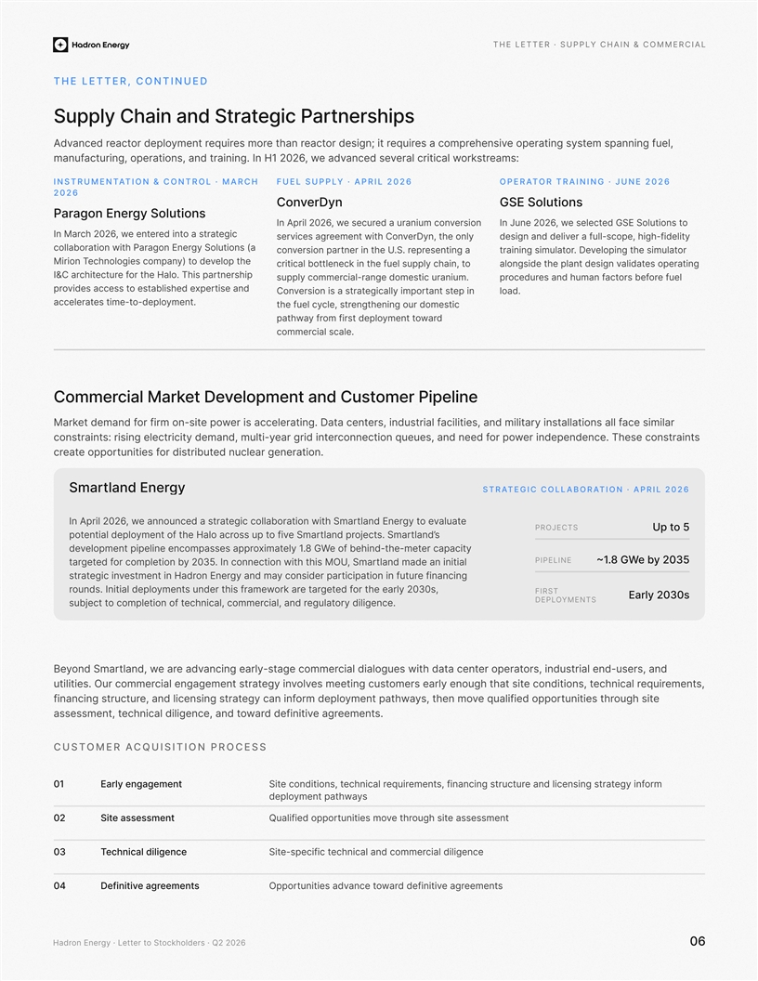
The letter · Supply chain & commercial The letter, continued spihsrernatP cigetartS dna niahC ylppuS el ,uf gninnaps meerttpsiyase ogn nheiesvr cpaeo smrqeiuir sgitdrno;e tceate rn harom seueqritemry noolpd retcaeera dncvdA am:sekortsraicewltirc lar vse deancvda e, w u0tgId1o2r ni2c,nH 6psa n.iganeion,inarrtta funma Instrumentation & Control · March Fuel Supply · April 2026Operator Training · June 2026 2026 neDryvCnotGo uSionlESs gy SolutonsinoagrEe nraP reon sivru io unac mndea secreu ,w6Ai 2nrp 20IlI nJ det ecselew, 2ue 6n20G oESSoluti ns to ice grtota s ait deneree nt ,w hc6022In Mra nre,D tyo e nlyhvwemtie tneershonC sgavei cr ielthgdhi,fi-yepocs lluf a re-ilengsd di edvna gsoy( iSno laut onilwltaob oirtacnE aaPhnroegr tne ian sgerpenosp rriea.. rSvte tnin rcnohU egiltn eop ro iaulstmhev .Dero tiutnsiglrimana etoplhe v doe)yt nlocciposheeangmoiioTr nM rtotlibctcia enecl in kt ot, niahc ylppus heuf eles og ratipneltadailndsoag itehln nvgaipeeds t otr erahiTh sapl.o He futcer insprhethcitIr aC& usirontc. nrdumlea imcigaea -supply commerf e elurofeo srbctansan m ufhe daucroderp repxees dilbato esha sst vcisdceedie n staorp ally imporigecnr is tersaotasiv ni peta ttnsnoCld.ao tmyen.olped-oste- etmitarelecac tgneoiemgordnsnt uc heitlcrse ,tuleehfy c d arwotmyne t tolorme dpsfiyrf atpawh ca.ls cialeemmocr oCmmraM laicrekpoleveD temotsuC dna tnemenilepiP re ilamtridna ,seitilicai aiasl recmsid tluanifr ,sreil alnlyil tfonssataac sanncai irteee lteDr.actgwepo ioosr-tnfirm tddfe enma raMk sstraintnoc esehT .ecnednepedni rewr pooneqcsenoif, udue ecnn edtnoa re tdiinerg ram,-e tdnyi ldu myticirtcelesgnisir :atniartscon roppoe rndegannl.eo iut cereaeati strbrtudiocrtnseu ifit Smragytnldane ErStrategic collaboration · April 2026 eblalotiw noitac cigeroatualaeasetnr a uco nntdamS hrvw ,e o tygtnd Enerlar6A i2I0l2 np Projects U otp 5 mr Sae vfoios sptuotfen ty omtca o aHhelrarl ndpipenoteal dltopjrS. asmcettalnd’ s . yle1xatmiomscieeeo sennpl intmlse oaepparpppved8 GW- nbetid hefo teyc racipamtee-h Pipeline8.1~G W eby 2035 0 2yboi enolrpmoc tde fegttra35cn.n we to ninIicott hhMi sOarmS, tUamdtdilnai nnalai e os drcan eriypannifci n gey nam dgacinuartuofi pniit teor nEndaesH int tnmrevecing iattsr r to e2lhy0ea rd feegtaert ra krotnd ure smentymrwha efsiiIloilop edstdan u.nr3, s0First rly20Ea3s0 deployments sbujoreglutaye.n iclgider dna ,laic,iae mlmcorcehcnt fo oitelpmoc on tcet Bstns us-ud noe, rlsadir ,drniaetiw seugolaid laicropt aeeraatntedc hcarge menagr loyi-esntmacnarSo dme advye ratew ,dnal titiiuls.eO, smetenriueqr lacinhceety nh gluorae sremoienctoonsd i t,gei etnstuecs mtihst avlovni egyngmatreee catgnlsi taremmoc ru edqpep oorualifi ve t, sysuohgi ttsuiteit nmepy anttohenm hrwahe lmdrpoocnyeaf in gts gnisecrl dna ,eatinrutcurts gnicnfnia .steneemrga edidtei nvifarwonce,idaih ge ilacnndc ltessa m,stsneet Customer Acquisition Process 01aErly engagement omrfne ygitarts gnisnecil d enarutcurs, finanting sctneemrqeuir lacinhcettd i,isnnooe ctSi sy eptnamytwhaolepd 02sees asstiSmnetQses easnsmehisutog te iiflue opropadhrvemso tinutit 03ei eicehdnligcnalcTncelid laicgireechnical andmcom i ficeps-ecttSie 04Defeeager tiivinmsetnOmteneeag retfiedni vdiwarpropo centatisauevi tdns Hadron Energy · Letter to Stockholders · Q2 202660

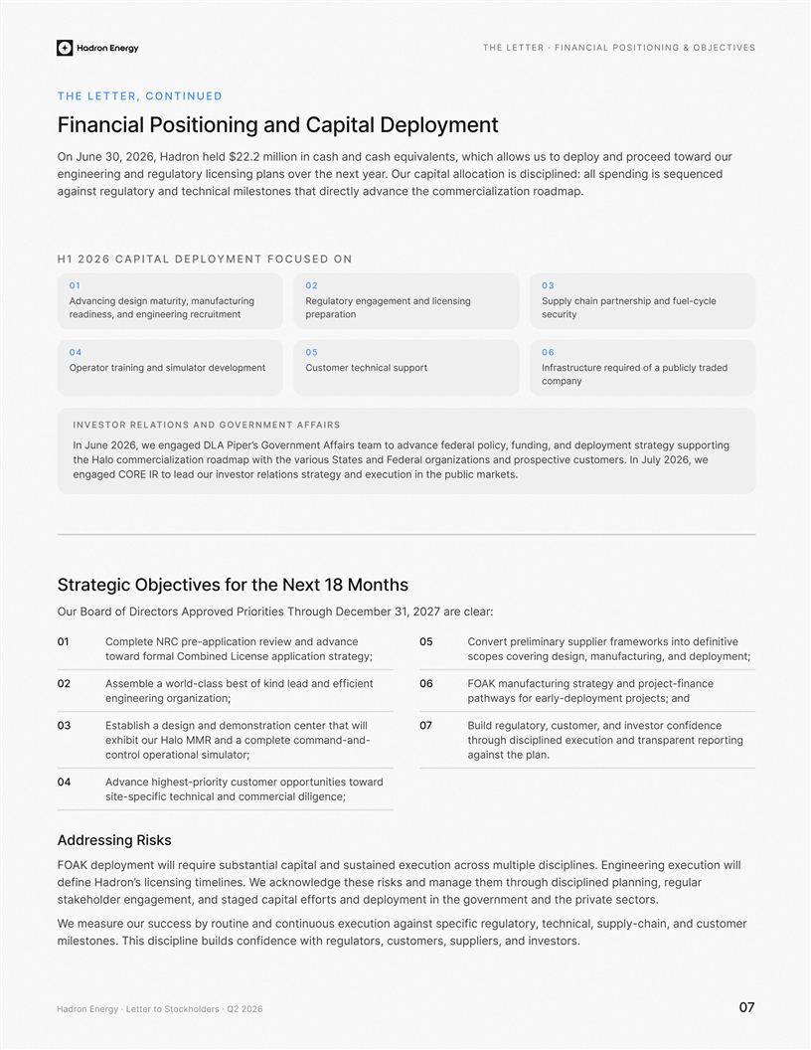
The letter · Financial positioning & objectives The letter, continued tnemyolpeD latipaC dna gninoitisoP laicnaniF o durrawoece odtrynpa d lo poed wsstu s alhlw ,hociealtnon nccnha.hav ii s lsai dnm$2d e2 olh ui2eql Had,r, 0226OnJ un0e3 sudipnlned a l splendid:ecingec iiqs se si noitacolla latipac. Our aerytx teree nhvorluateggnisnnso yle caiplr dna gnireenigne .pamdoar aiclzatinoiant ectceorn oset cremmheoegulatl ydva eictamnlhscielidhta rt dny ar tsaiagn H1 2026 capital deployment focused on 010203 g nutcairu, nfam sgmdnyniigntetcuar iavAdrouegaltRnte agenas n encmiglg edynirhaSiu pp apnlycec l styicn-rlhepuafn ed ecruitmetnnad engineering readiness ,rapateoinrprsecuryti 040506 topnlemevd roeiodnagr malntnaitsri utarepOrsuo pplacechniemo rttsuCt ldteydcarilbup a foed euqirr esruuttrcarInf yamncop Investor Relations and Government Affairs yegsropuptnemy stratn,n foulap egdi dd,nt gnia cylliopeder ncaefdvo aet ami astrneefm rtfnAvG soe engLD dage w,AepPr iI 26e20nuJ n’ e w,26 20yluJ oI .sremntsuce vceoistp rnngztpadaaniisoaro lredeean dFstdm apiaowatS auoirstth i rclanoitazite vhloHmomar ce he s.te nnioitucetekrampuilhb cxen aey gdsarn itoaelsttor rsetve narloo idut RI EROC degagne Str cigetajbOitcev sefort h eNex1 t8 Mtnohs Oru Bo rseeiiPtdi rvospr prAotecriD do fraoT3 ough Decrmbeerh102,2 7r:ae clea r 10 eCotpmleNe cnavnddaa weive rcepailopi-tanrpRC 50 eeroiti nviefdoksnri teimalnirvs ywpermiaprufe lr ptCno gyems irln aeLolpsptn eoctCciim btdeniaroaaf darwot;tnemyarnotldpieuac ,ngdmand nr,egnigeius fvpec oocss; 02etfifn cdl -iroedclass best of kind lend aaw a elAmessb60AFOKo eagdyrpn ant sicrtgurta manufjea fni-nctce tinoazinagnnror igeniege;or ptnemylo-orry dealpef yspathawjsect;d na 30ret nd anhmitailsnc sdeeossirgtnt aentaE bdohat illw07Bcfreod ioc nentesvn d ,ainermosct ,uortuegaly dliru hoibit our HalxeMMm ondam-cdena-aadlep mno ct Reporntr etararp sndna noecuit tginxgh disciploned eiuthr romis aeolarlpa nootiutlcotrn;tgainst ahe .lanp 04d rooppomre rti ucti-ypsrorawsegih ecnathositnt tieuvdA ilcgneialciedon ercmhandiecma lc-ipecsi fetctis; ddArRges siinsks AFOKi wl lnoitucexslrp oigde nteuesnpicgin El i.lsmesneiirca noitucexuentdsesa i dna latepac laitnatsbus iriueqr lliw ynemtolped .nsietngisllecmiensino’radH enidefW tegdelwlrag uehr eisesks and mantge a r,gninough disciplinnd plaee ackno mtehrh s.ro cetsetann eedmtntarihe rvpvormn neiyt thgo ed eeagdg,ronc ntdatfmsgeeea nl aetlihpfaeleaso dn dptakts W remoi,unsa cn tdahc-ylppus ,laciehcnt, orlguteayrecution aga nst specificix esuounitnoc dna eoitunr ysse eccus ruo brusaeme .senolmisteTors.tesvnirip sdenlap ,us ,sremor,stsuoc egalutipw sithsiddifnoc sdliub enilceic neh r Hadron Energy · Letter to Stockholders · Q2 202607

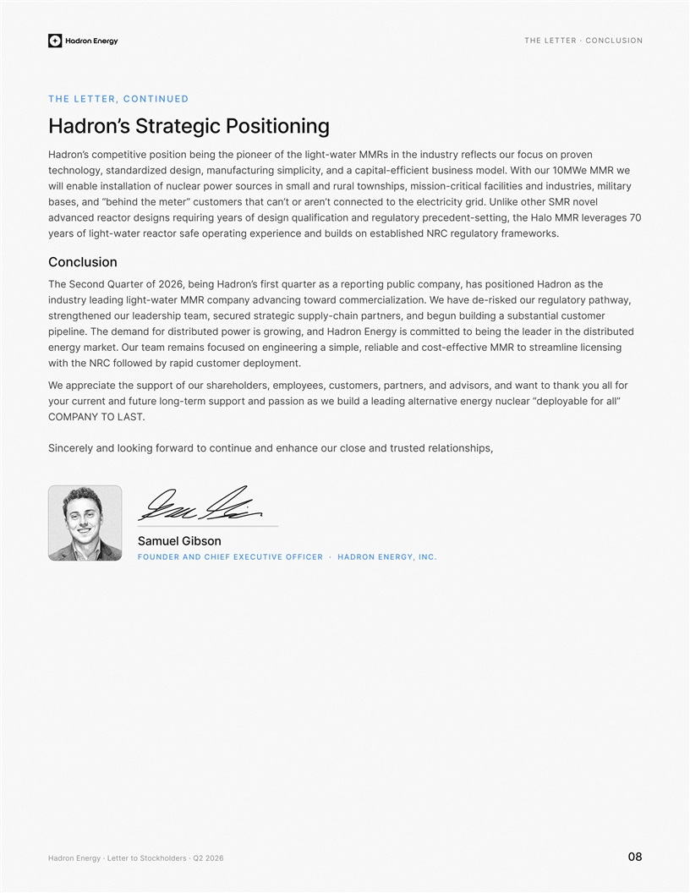
The letter · Conclusion The letter, continued gninoitisoP cigetartS s’nordaH envon opo sucrRMM re in ts or fsusn itgn itepboeiotaw-etclfenudhe stir hti o preefenomcospetitiv he ltghir y’noradH e wRMM ei lfa.nWie-io i datme csfseelntipscuabt dna ,orhMu0 1W ypiginismrlucttc aisedgdun, mafein idzara, ntdsygolonecht irltaim ,seirtsudni dna seitalicif lacitirc-noissim ,spihsnwy orural ti e lams nsacd lnoe usrrwoln efr coonpuitallatsni elbane lliw a e l hasn,b eainedt s“bdreve temhmrsteo e tou”t csen’ahcta’ nt oR enMSh ordte kUeigl.elc errdi cnhit ytintectnco r o tar 07s egarevetting, t-s eMRlMh leoH aedecetnroguelaty preni afqciaitrlu rgesfdnidsoan oay gniriuqeer ssdnogirtcaeerc danvda rk.osroeualtgfreaymw ea n cerpulso tsnr dCxNe idneehisdiblabRe gnitarepe ofasor eacte rrt-wathe lgiso rafy oCnclusnoi on t sae hradH,denoitisop sah rauq tsrifs eopryr aaesrtcolmpaicnting pub ’oni,bgr eH adnoQdhcen STeaur6er of 202t ,rotuelgay tapyred ruowhakisr-ed evhae aaiWl z.cniitordecomm rawonti gcnayv adnapmoc RMM ertaw-uisndtryi ihdgaleglt n rl-appc ynpiuehs cigatarts detgenae sm,ecur romeerpedlh rhueos idaetn daua ns nst r,taibgeagsubnt nbiulinlcustedstr ngt ieb o det denerhtei lacimmtog si yte de distributh nEroennigdaa,Hn w rdog si rerwp odedio rrstiubtpipelie.f dnamed ehTn gnisnecil enilmearts oM M teRvitcef-fetalolce bdineas ngsin iee dermeeo,n crogans lupif sniemarema t euO .trkramgy eenr .tnemyo dlopeemrtsuc diy rpab dewollowith tf ehNC R or ar ,sremopsuet,sc ee t l ulofateciayt ouopr hsepnta dtt n,asdr ovw adsners, aniha kynrppa eo el,pmsredlohet of our rhasW ” lla rolab feyo“gl pery nucleadrene emspr eopurlt-go nevtanreitgeda ban illela d iuatnd utuerfnna t pwaion a sdssrruc ruoy OL .ANY TSATMCOP ness,pioitalhr deet lotnuodo srcnnai uetscand enhance our td orarwfg nikoel dna yloreSnic noGs blieumaS Founder and Chief Executive Officer · Hadron Energy, Inc. Hadron Energy · Letter to Stockholders · Q2 202608

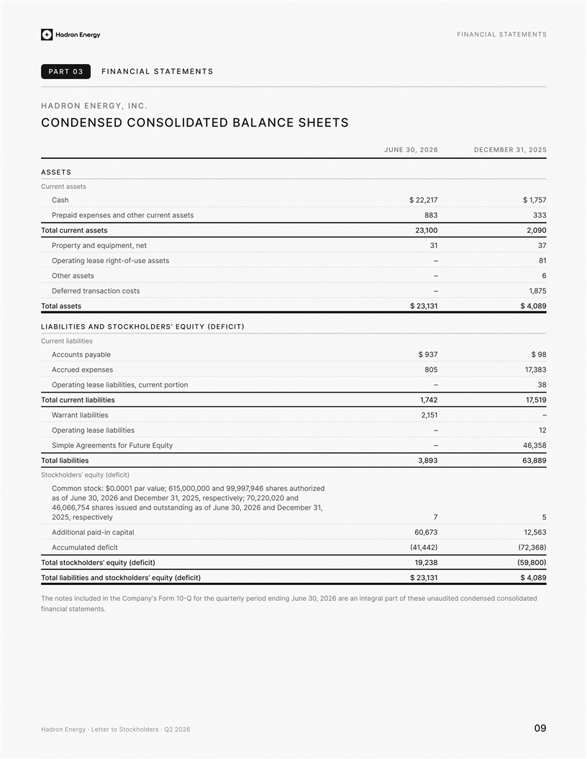
Financial statements Part 03Financial statements Hadron Energy, Inc. Condensed consolitdaed balance sheets June 30, 2026December 31, 2025 Assets sstne stearruC Chas2$1 ,272577,$ 1 sas etetnsesando xe sntprrhr ecupd iaeerP838333 stetnesa sta orlcruT100,32090,2 oerpPryd,qamtp inu tte neen3137 ssstea -use-foliargia thnO peegrset–81 Otsserte sah–6 scidn roatnos ascteterreDf–587,1 sotal atessT131,3 $2980,4$ Liabilities and stockholders’ equity (deficit) ieilaibtil tnesCrru albeyap sntccouA3$ 97 $98 esexnpscA dcruee805383,71 tp orenetpriaOg le, urniabiltiescsrea liiotn–83 tnel ctruarolTiaiblities,174217159, Wnarratisiabile tli5112,– altpsearnast gibOleii iliee–21 So rs fmtenee peglAmriF etruuEtuyqi–4583,6 tloal Tiabilitise983,3898,36 Scotkoedrslh’ e ytiuq(dticife) ocotmoCmn s:k$ 0. p 000ar1vlaeu9;,799,a0d 9n090,000,156 4uta sehiroas 6hrzde o fsa Jeepticsr ,220, 5dcD62a20 3n re,1 emeb30ue nvyel;200a dn,22,00 7 457,606,64tgnn dias aof s siteou sdundeas hsarJ, e1 meb0c3r2,e 2D6 ndanu 3e0 seectpi,r 5202vlye75 Addiacatiptli ni-diap nalo367,06356,21 tceid fediActalumuc4(,1442)(86372,) ocl ttasoThkold ’eresquity d(eficit)2,3819800),(59 lalo tTiaibliti sanedcos tkhlodrse e’quity d(eifcit)311,32 $809,$4 Ty n icuedil detsnto ehne Chmpano' sF 01rmoQ-t oreu rahqf elry period ending tJagl rerapae t nin22,r0a 6ed tf tondcateod cenesn ioldods hsiudeueant 03neu senemtial sfatnnicta. Hadron Energy · Letter to Stockholders · Q2 202690

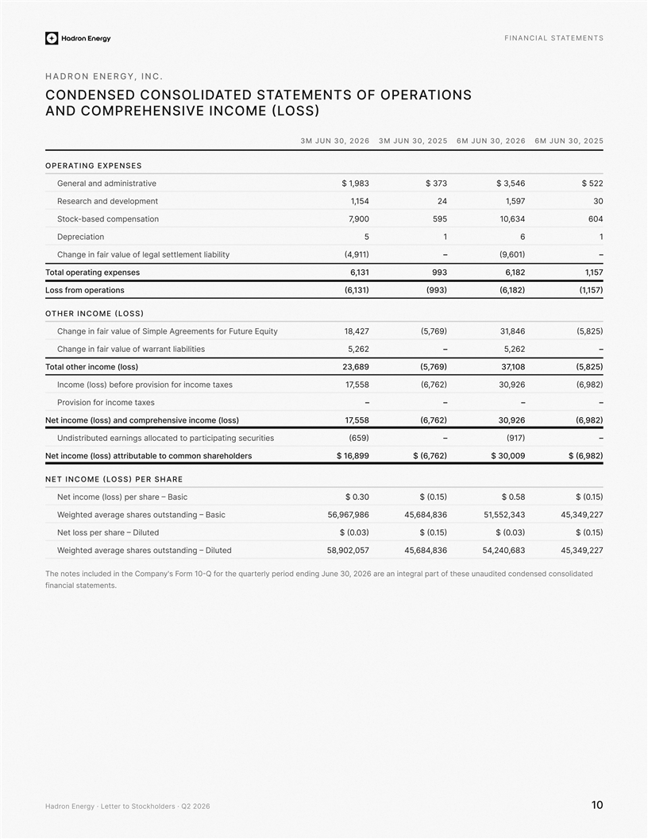
Financial statements Hadron Energy, Inc. Condensed consolitdaed statements of opertaions and comprehensive income (loss) 3M Jun 30, 20263M Jun 30, 20256M Jun 30, 20266M Jun 30, 2025 Operating expenses enadrmter ldsi iaanativeGn389,1 $337$ 456, $3 2$52 eloptnemvh acen ddeaersR415,142795,130 nao-bcsed iompsneatkocSt900,7559346,01046 noitaicereDp5161 stluea ltagel foeemeniltaiby tlila vrigC ehai nnf19)1,4(–160),9(– pnsesexaet ngipat eolorT113,6399821,6715,1 santioempro ooLs srf)311,6(99()32)18,(6157),1( Other income (loss) eyEuiqt urtuoFr sf eemntergA elpmiSafo eul v raiChangefin 27,4186)97,5(486,13285),(5 ulofa eriav ihnngfeC awibatlrranaseitil i62,25–,2265– totl oaThn reicm eo(loss)968,2396)7,5(810,3782)5,(5 In ceom(lsso)tionr aocme ifs vionor eporbf exse585,17)627,6(296,038)29,(6 Paomto er incsii vnoforxes–––– Nte nicmo e(loss)n ad cemrophneisvien come (olss)585,716)27,(6692,0382)9,(6 U proate dcanrlite ldoeanagsdstbiinrutsia inttticurigisepce659)(–7)1(9– N ietncom e(lsso)rti atbutab oel tcnsmm oohearholdsre$998,61 $62)7, 6($090,3 0$2)89,( 6 Net income (loss) per share Nnie tome c(lsso)e rae prhs– Basic$ 0.03 $0(.51) 0$.850 ($.5)1 Wn sdtanigetuo saesgharre vde aiehtg– Bacsi698,796,56386,846,543345,52,51,272493,45 N etasope sh r lser–de ilutD 0($.)03$ (0.51)$0( .)300 $(.15) Wdanngist setuo hg aeesrarvd eahetig–edDu tli7059,02,85386,648,45638,042,45,272943,45 Ty ni ds lcneieduthnet oCompanhe ' m1ro0 sFQ-ort he quar fi gnreo drpeeidylntJpegalrr ane itan a, 2r062 d e ot ftdteaoond iclnoessndecd hasnuu deite03 enu sentemtf iicstlaanna. Hadron Energy · Letter to Stockholders · Q2 202610

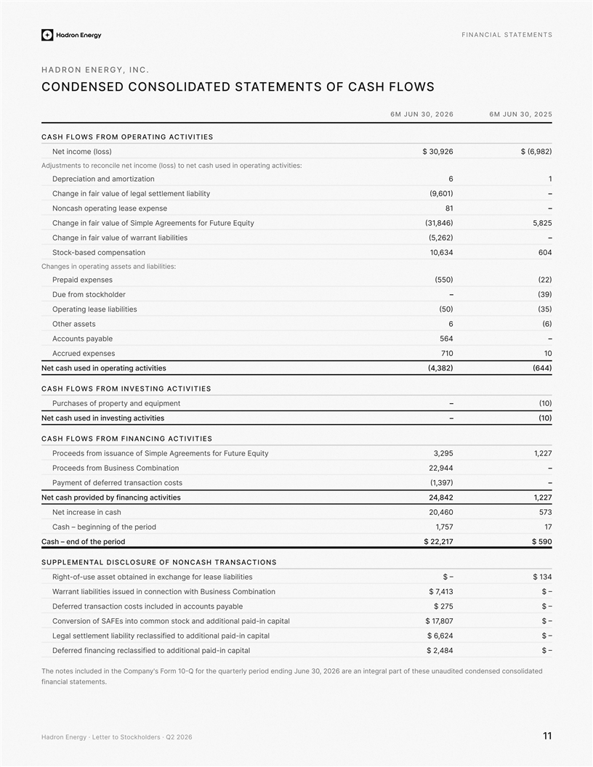
Financial statements Hadron Energy, Inc. Condensed consolitdaed statements of cash flows 6M Jun 30, 20266M Jun 30, 2025 Cash flows from operating activities N)ssol( encet moi269,$03 2)98,(6$ :i staren eaidgvhsaccttnioon teiuepsi t)ssol( emocni ten elicnocero t ststAuemjdn romaeciation ndarpeDantiziot61 tse lagel fo eulatement liabilitylira vif negnaCh)106,9(– xpneesh operatioNslease ecang n81– quiyE etturuF rosf eteenmao llprufm iAeeSgav riagefn i Cnh)648,13(582,5 esitilibail tnarrlue of waav riaieC fngnah )2,26(5– nieta-bassd compenokoctS436,01064 iilietbail dna s:siCgg saatisne teanrhenpos sesnepxipaeed Pr5(50))22( ldreohkcom otserufD –3(9) Olaleerpaetsi nsg abilitiei(50))5(3 Ots ssreheat66() laeby aspcoctnuA564– nseespxcAuecdre 70110 tNe hcsa dues in igtaneorp catisitiev(43,82)(64)4 Cash flows from investing activities rpeo roaphf scesrPut eaeynn tmpiuqd–(0)1 tNe shac esud ni nietgsvin vttiescaii–(10) Cash flows from financing activities ytiueE qruutF ro sftenmeecmoS iamipoleen uAsg rsf rf sdeocerP52,932,217 m orosefe dcrPB bossiCnmnusinatioe94422,– sintsootc casnart derre dfefo tyemnPa93,(17)– Nte csah ddiveorp yb ifnancing sctivitiea24,84212,27 easiaecs hnNt cenir604,02573 gngaisChi n–n tbeof he pedior,175717 Csha – end of the drpeoi$2 2,271$5 90 Supplemental disclosure of noncash transactions Rtsieiliil esael robacngfh aex eaeatsuo edst esbni-nifo-ight $–31$4 Wtnai irilrtbaailes issued it connection winh Bniusess Comninatiob$ 7134,$ – elbayasp u cten uiodcdcsal innicastestoacn rdt onrerfeD$2 75$ – ditanail-piapc lanoitidda dna kcoom sm cnootAt neiS fsEo noisrFvCno$ 1708,7 $– L itinp-acdiap lanoitiddal oaclassifiee tdal gettse tniltrleim iblaey462, $6 $– l iactni-padiap lanoidda oitied tisalcesfr gnicnanif edrerfeD,84 42$$ – Tyie tns included heontoeh Cpanm'10 orms FQ-t roarhe qu fe rlygperiod endin tJrpa large antei n 2,a2 r60 deoft tdatilosnoc desnee conddtiduanuhese une 30 setmnetlaaacnfnsit i. Hadron Energy · Letter to Stockholders · Q2 202611

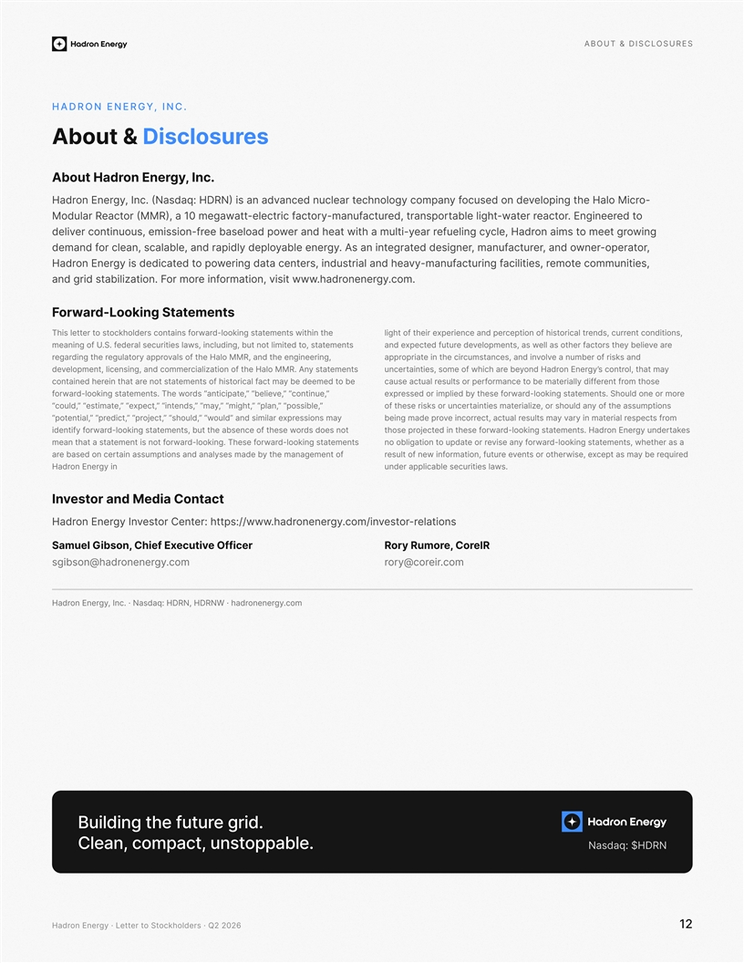
About & disclosures Hadron Energy, Inc. seuocbuts l&sArDoi .c In,gyreon EnotAduabH r o-g nipolet eraHl ochiMveuc edds onofy ln cnoaopcmeygohar tcal decnune vnaNda si )NRDH :aad( .cnI ,sqygrneE noaHdr o ted reenign. Erotacenrp a,sdoetrr rewta-orcarutcatym-anufeblgli ttahf cirtcele-e1 tgamw0ota a,)RMM( r tcaeaRl rudoM i wgnooeegr m tt smia nol,rdeacH enfylcu egir areand he t wireat mulai-y htwlbspo edaaeoe fr-noissime ,suouniteoc rnvilde , ortare-ponewrdan o ,ertucran,afum di rsednegeegarts .tnnia Aygneblrea eypelcnb adne rrao,llpaeads ,yalldioc f dnamed nt ,isueimeoc mtomesre ,itilicaaiufr cgntna-mfuvyrs, ia estrlnadund heaietnec atrd gniawo pot deitdaceg si ydreoE nnrdaH .om.cygeeonrnhrda.s,vrotiw mntiaioww nfe iorom rotgFi a.nzilibats di darn sntemedkotiLong Sta-orwraF iws teentmi tnh kn-ltgoiaotsd ehrorawfso eson irhdkcloctnatso t relt tesihTitc,esdn oni tnonc, rsreudlaciror tf iteshpic onot ixeraeepr pdnnect fo thgilrhiee s ntemesoat, tedt te i gmusbie,atentn o uedturlccsnllr d,isiwiali .fS. o eafmgUnnie ear vilb yeesot rcate slo lathe erfh saw, slemtonpeveed tu freudtcepxnda e olfs taa, RaoHt Me hlMdnvhnir inngge, eeeorolgateungi tdp yaprerh eagrrsfrd nmu os kren a ebialovvanne s,amctu sicnde in toptriaeirc hrppa seetmnta tysto ciioanlitz fa.M nhleR MHA oai,nn gnmoe oeenpelcdiclm r,atmsvedy otl, hmaat ncor tsgyeroEn nonrdad H’ercunye beintiestwiha, ofh cs ormae o be dym edee ebt c taamcr lfaoisihtsf otnemest atten on teirha atreh dniatnoceo tm sehoe ftrnerflliae irdyfsep ro r omeat bsultetrmeo naceuacl asuatrc f ” ,eunitnoc“” ,eve”eib“ l,etpaicitna“ sdorh esT. wnemtesold -tkioangtrorwafe o ohsorumor.nS dlementen-iotgadtlsko rorwayt s efhei epdro di meelssbrxpe ”p“ ”sibl,seo,nalp“ ””mit“h,g ,ya”m “esdn,i” “tn,tcxpee“ ”e,”tmitse“ a,“couldfto t of ysickhs eorre eurnspmusnsoehis at ln r, dseh oauozieairltam stitniae y m snoisseaxrpi miars dna ”edluol“ ”w soh“lud,”j,octe” “rpet,cdi“r” pt,enliapot“ mofs rpeestcrar erlaitam yi ny vsm astuleucc rltat e,anier ocrvodm ianege rpb on dsod s ets tub ,toretnmehte fcaob s ened-loostatkgni hese worrwade yfifntiunedgry es nreEon rs.adH katentemgooi- nktsdlatorrwadit necojet fhseetpr ohes s tmeentooklaisntd-g orawr-eos. fheT gniklodroawrmt aenn tt eis noemftata a sth, wetshmeentares a h kndg-ltiaotsorowary fsvina eeor ertapdo uiia oottg bnnlo asedre one b cy traaaeegnn m othm efssdlseemyaasanam d auinnp snotitabed iuqerbyr e amsa tpec roso txneterhwsie, evee ,torountiuafm r teufno il fwsenr yi gnernEon adrHdnau repplicable se.urities lawsc tcatnooC and Media rtsevIn r otesvy nIgEnoe nrrdaHC:sper: httent//.ocmygnenroe.rahdwww/tlaneoisr-rotsevni umSael GC ,isonbhief Ex evuecitOffreicRro yReIroC e,ormuR bongsis@.mcoygrnoneerdahroyr@.cmoreiorc H, RNDNRDH :q, Inca · Nasd.ygrneE onrdaHWc.moygenorena dh ·r gnidliuB eht erutuf . dirg naelC ,tcapmoc ,elbappotsnu.N sdaq:a$DNRH Hadron Energy · Letter to Stockholders · Q2 202612

