UNITED STATES
SECURITIES AND EXCHANGE COMMISSION
Washington, D.C. 20549
_________________________________________
FORM 8-K
_________________________________________
CURRENT REPORT
Pursuant to Section 13 or 15(d)
of the Securities Exchange Act of 1934
Date of Report (Date of earliest event reported) August 18, 2026
________________________________________________________
QT IMAGING HOLDINGS, INC.
(Exact name of Registrant as Specified in Charter)
________________________________________________________
Delaware |  |  |  |  |  |  |  |  | 001-40839 |  |  |  |  |  |  |  |  | 86-1728920
(State or Other Jurisdiction of |  |  |  |  |  |  |  |  | (Commission |  |  |  |  |  |  |  |  | (IRS Employer
Incorporation or Organization) |  |  |  |  |  |  |  |  | File Number) |  |  |  |  |  |  |  |  | Identification Number)
3 Hamilton Landing, Suite 160
Novato, CA 94949
(Address of principal executive offices, including Zip Code)
(415) 842-7250
(Registrant's telephone number, including area code)
________________________________________________________
Check the appropriate box below if the Form 8-K filing is intended to simultaneously satisfy the filing obligation of the registrant under any of the following provisions (see General Instruction A.2. below):
o |  |  | Written communications pursuant to Rule 425 under the Securities Act (17 CFR 230.425)
o |  |  | Soliciting material pursuant to Rule 14a-12 under the Exchange Act (17 CFR 240.14a-12)
o |  |  | Pre-commencement communications pursuant to Rule 14d-2(b) under the Exchange Act (17 CFR 240.14d-2(b))
o |  |  | Pre-commencement communications pursuant to Rule 13e-4(c) under the Exchange Act (17 CFR 240.13e-4(c))
Securities registered pursuant to Section 12(b) of the Act:
Title of each class |  |  |  |  |  | Trading  Symbols |  |  |  |  |  | Name of each exchange  on which registered
Common stock, par value  $0.0001 per share |  |  |  |  |  | QTI |  |  |  |  |  | The Nasdaq Stock Market LLC
Indicate by check mark whether the registrant is an emerging growth company as defined in Rule 405 of the Securities Act of 1933 (§230.405 of this chapter) or Rule 12b-2 of the Securities Exchange Act of 1934 (§240.12b-2 of this chapter).
Emerging growth company x
If an emerging growth company, indicate by check mark if the registrant has elected not to use the extended transition period for complying with any new or revised financial accounting standards provided pursuant to Section 13(a) of the Exchange Act. o

Item 7.01 Regulation FD Disclosure.
On August 18, 2026, QT Imaging Holdings, Inc. (the “Company”) posted a Letter to Shareholders on the Presentations webpage in the Investor Relations section of its website, www.qtimaging.com. The Letter to Shareholders contains supplemental product and operational information regarding the Company. A copy of the Letter to Shareholders is being furnished as Exhibit 99.1 to this Current Report on Form 8-K.
The information contained in, or incorporated into, this Item 7.01 of this Current Report, including Exhibit 99.1 attached hereto, is furnished under Item 7.01 of Form 8-K and shall not be deemed “filed” for the purposes of Section 18 of the Exchange Act or otherwise subject to the liabilities of that section, and shall not be deemed to be incorporated by reference into the filings of the Company under the Securities Act or the Exchange Act regardless of any general incorporation language in such filings.
This Current Report shall not be deemed an admission as to the materiality of any information in this Current Report that is being disclosed pursuant to Regulation FD.
Please refer to Exhibit 99.1 for a discussion of certain forward-looking statements included therein and the risks and uncertainties related thereto.

Item 9.01 Financial Statements and Exhibits
(d) Exhibits.
Exhibit No. |  |  |  |  |  | Item
99.1 |  |  |  |  |  | Letter to Shareholders dated August 2026
104 |  |  |  |  |  | Cover Page Interactive Data File (embedded within the Inline XBRL document).

SIGNATURE
Pursuant to the requirements of the Securities Exchange Act of 1934, the registrant has duly caused this report to be signed on its behalf by the undersigned hereunto duly authorized.
Dated: |  |  |  |  |  | August 18, 2026
 |  |  |  |  |  |  |  |  |  |  |  | By: |  |  | /s/ Dr. Raluca Dinu
 |  |  |  |  |  |  |  |  |  |  |  | Name: |  |  | Dr. Raluca Dinu
 |  |  |  |  |  |  |  |  |  |  |  | Title: |  |  | Chief Executive Officer
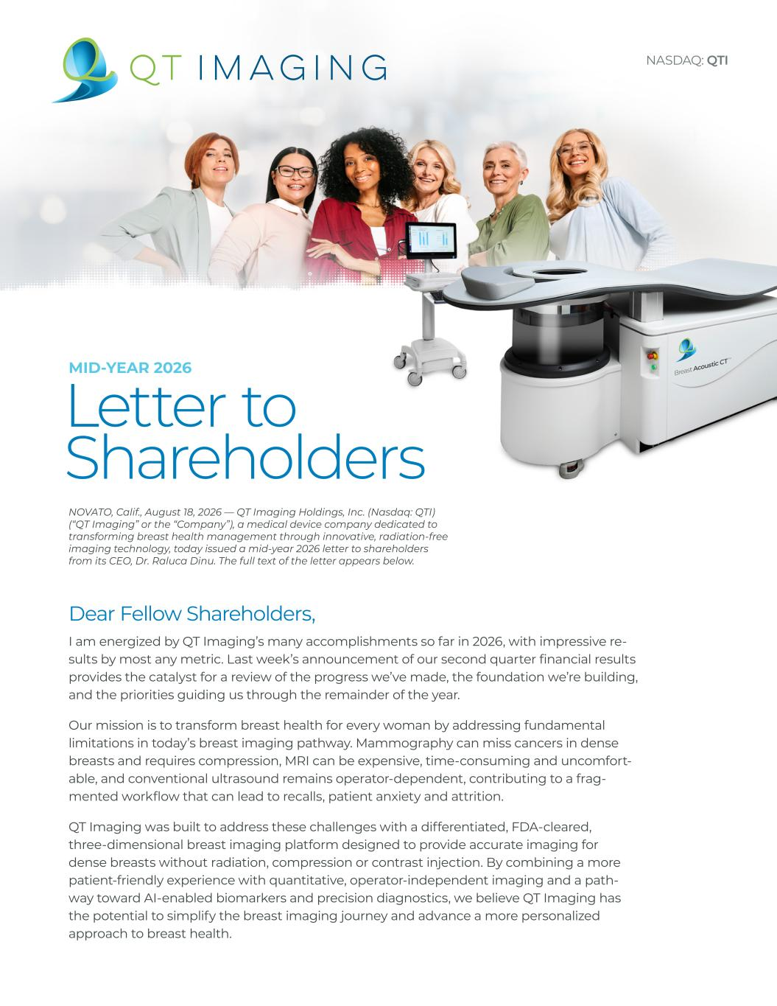

Letter to Shareholders MID-YEAR 2026 Dear Fellow Shareholders, I am energized by QT Imaging’s many accomplishments so far in 2026, with impressive re- sults by most any metric. Last week’s announcement of our second quarter financial results provides the catalyst for a review of the progress we’ve made, the foundation we’re building, and the priorities guiding us through the remainder of the year. Our mission is to transform breast health for every woman by addressing fundamental limitations in today’s breast imaging pathway. Mammography can miss cancers in dense breasts and requires compression, MRI can be expensive, time-consuming and uncomfort- able, and conventional ultrasound remains operator-dependent, contributing to a frag- mented workflow that can lead to recalls, patient anxiety and attrition. QT Imaging was built to address these challenges with a differentiated, FDA-cleared, three-dimensional breast imaging platform designed to provide accurate imaging for dense breasts without radiation, compression or contrast injection. By combining a more patient-friendly experience with quantitative, operator-independent imaging and a path- way toward AI-enabled biomarkers and precision diagnostics, we believe QT Imaging has the potential to simplify the breast imaging journey and advance a more personalized approach to breast health. NOVATO, Calif., August 18, 2026 — QT Imaging Holdings, Inc. (Nasdaq: QTI) (“QT Imaging” or the “Company”), a medical device company dedicated to transforming breast health management through innovative, radiation-free imaging technology, today issued a mid-year 2026 letter to shareholders from its CEO, Dr. Raluca Dinu. The full text of the letter appears below. NASDAQ: QTI

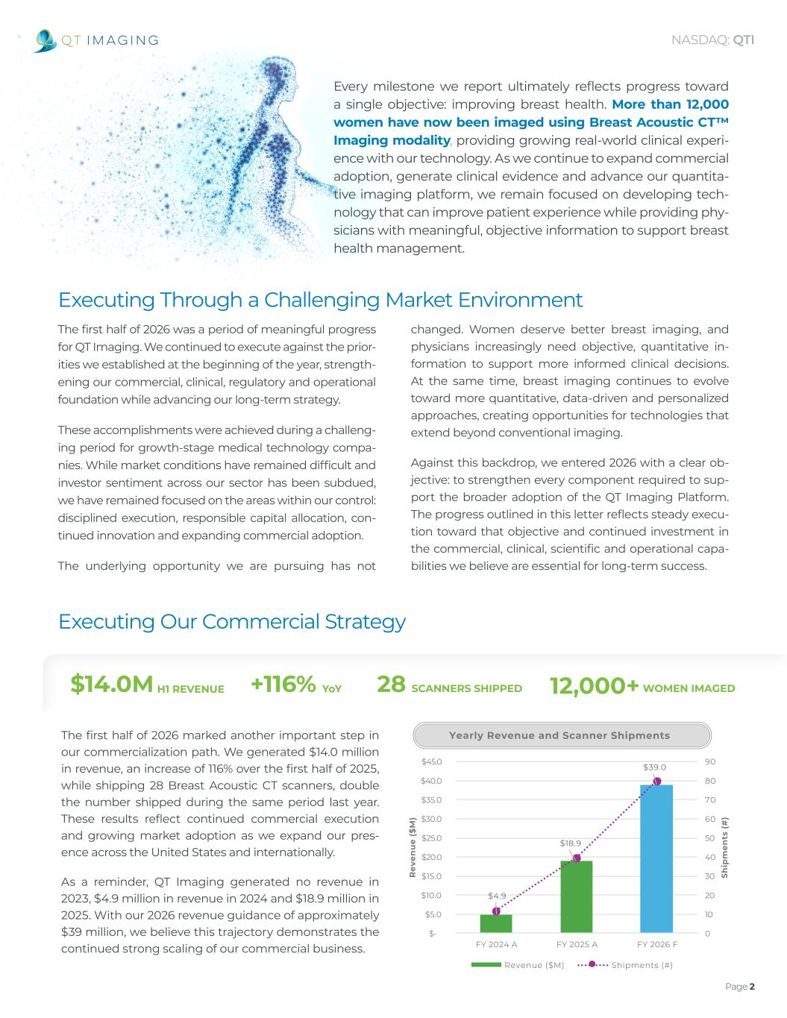
Page 2 NASDAQ: QTI The first half of 2026 was a period of meaningful progress for QT Imaging. We continued to execute against the prior- ities we established at the beginning of the year, strength- ening our commercial, clinical, regulatory and operational foundation while advancing our long-term strategy. These accomplishments were achieved during a challeng- ing period for growth-stage medical technology compa- nies. While market conditions have remained difficult and investor sentiment across our sector has been subdued, we have remained focused on the areas within our control: disciplined execution, responsible capital allocation, con- tinued innovation and expanding commercial adoption. The underlying opportunity we are pursuing has not changed. Women deserve better breast imaging, and physicians increasingly need objective, quantitative in- formation to support more informed clinical decisions. At the same time, breast imaging continues to evolve toward more quantitative, data-driven and personalized approaches, creating opportunities for technologies that extend beyond conventional imaging. Against this backdrop, we entered 2026 with a clear ob- jective: to strengthen every component required to sup- port the broader adoption of the QT Imaging Platform. The progress outlined in this letter reflects steady execu- tion toward that objective and continued investment in the commercial, clinical, scientific and operational capa- bilities we believe are essential for long-term success. Every milestone we report ultimately reflects progress toward a single objective: improving breast health. More than 12,000 women have now been imaged using Breast Acoustic CT™ Imaging modality, providing growing real-world clinical experi- ence with our technology. As we continue to expand commercial adoption, generate clinical evidence and advance our quantita- tive imaging platform, we remain focused on developing tech- nology that can improve patient experience while providing phy- sicians with meaningful, objective information to support breast health management. Executing Through a Challenging Market Environment Executing Our Commercial Strategy The first half of 2026 marked another important step in our commercialization path. We generated $14.0 million in revenue, an increase of 116% over the first half of 2025, while shipping 28 Breast Acoustic CT scanners, double the number shipped during the same period last year. These results reflect continued commercial execution and growing market adoption as we expand our pres- ence across the United States and internationally. As a reminder, QT Imaging generated no revenue in 2023, $4.9 million in revenue in 2024 and $18.9 million in 2025. With our 2026 revenue guidance of approximately $39 million, we believe this trajectory demonstrates the continued strong scaling of our commercial business. $4.9 $18.9 $39.0 0 10 20 30 40 50 60 70 80 90 $- $5.0 $10.0 $15.0 $20.0 $25.0 $30.0 $35.0 $40.0 $45.0 FY 2024 A FY 2025 A FY 2026 F Sh ip m en ts (# ) R ev en u e ($ M ) Yearly Revenue and Scanner Shipments Revenue ($M) Shipments (#) $14.0M H1 REVENUE 28 SCANNERS SHIPPED 12,000+ WOMEN IMAGED+116% YoY

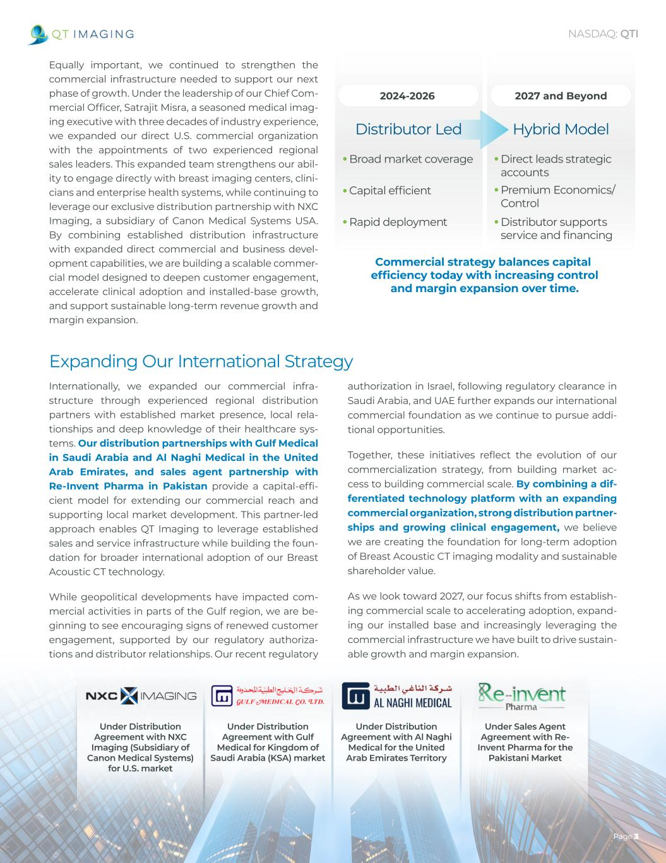
Page 3 NASDAQ: QTI Equally important, we continued to strengthen the commercial infrastructure needed to support our next phase of growth. Under the leadership of our Chief Com- mercial Officer, Satrajit Misra, a seasoned medical imag- ing executive with three decades of industry experience, we expanded our direct U.S. commercial organization with the appointments of two experienced regional sales leaders. This expanded team strengthens our abil- ity to engage directly with breast imaging centers, clini- cians and enterprise health systems, while continuing to leverage our exclusive distribution partnership with NXC Imaging, a subsidiary of Canon Medical Systems USA. By combining established distribution infrastructure with expanded direct commercial and business devel- opment capabilities, we are building a scalable commer- cial model designed to deepen customer engagement, accelerate clinical adoption and installed-base growth, and support sustainable long-term revenue growth and margin expansion. 2027 and Beyond2024-2026 Hybrid Model •Direct leads strategic accounts •Premium Economics/ Control •Distributor supports service and financing •Broad market coverage •Capital efficient •Rapid deployment Commercial strategy balances capital efficiency today with increasing control and margin expansion over time. Distributor Led Internationally, we expanded our commercial infra- structure through experienced regional distribution partners with established market presence, local rela- tionships and deep knowledge of their healthcare sys- tems. Our distribution partnerships with Gulf Medical in Saudi Arabia and Al Naghi Medical in the United Arab Emirates, and sales agent partnership with Re-Invent Pharma in Pakistan provide a capital-effi- cient model for extending our commercial reach and supporting local market development. This partner-led approach enables QT Imaging to leverage established sales and service infrastructure while building the foun- dation for broader international adoption of our Breast Acoustic CT technology. While geopolitical developments have impacted com- mercial activities in parts of the Gulf region, we are be- ginning to see encouraging signs of renewed customer engagement, supported by our regulatory authoriza- tions and distributor relationships. Our recent regulatory authorization in Israel, following regulatory clearance in Saudi Arabia, and UAE further expands our international commercial foundation as we continue to pursue addi- tional opportunities. Together, these initiatives reflect the evolution of our commercialization strategy, from building market ac- cess to building commercial scale. By combining a dif- ferentiated technology platform with an expanding commercial organization, strong distribution partner- ships and growing clinical engagement, we believe we are creating the foundation for long-term adoption of Breast Acoustic CT imaging modality and sustainable shareholder value. As we look toward 2027, our focus shifts from establish- ing commercial scale to accelerating adoption, expand- ing our installed base and increasingly leveraging the commercial infrastructure we have built to drive sustain- able growth and margin expansion. Expanding Our International Strategy Under Distribution Agreement with NXC Imaging (Subsidiary of Canon Medical Systems) for U.S. market Under Distribution Agreement with Gulf Medical for Kingdom of Saudi Arabia (KSA) market Under Distribution Agreement with Al Naghi Medical for the United Arab Emirates Territory Under Sales Agent Agreement with Re- Invent Pharma for the Pakistani Market

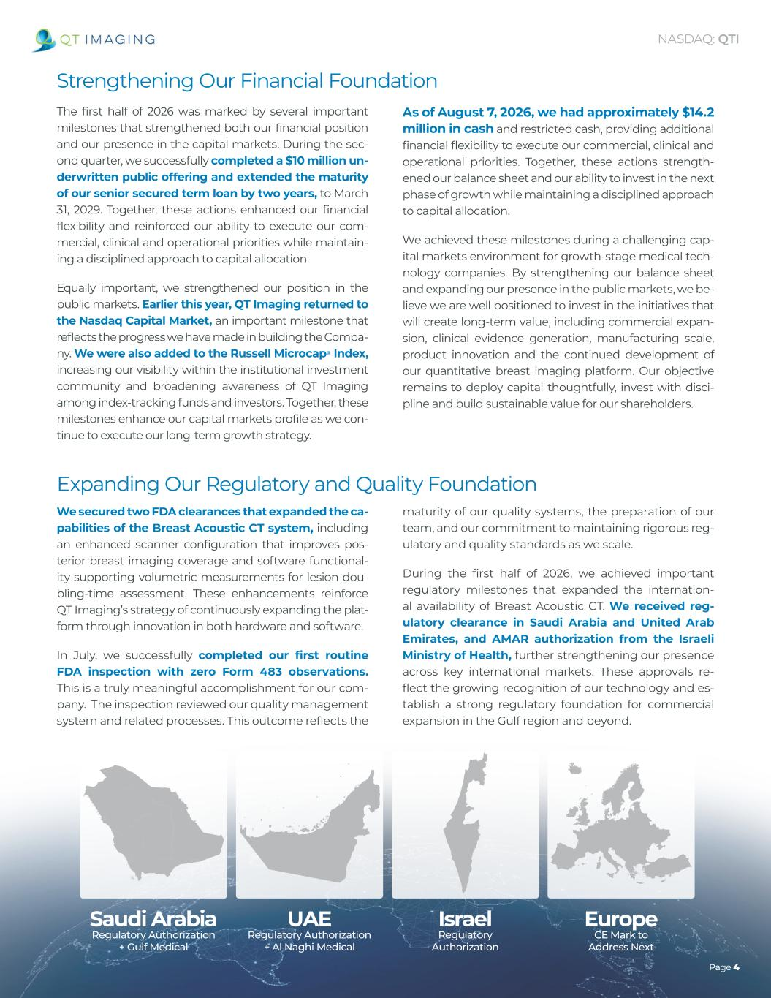
UAE Regulatory Authorization + Al Naghi Medical Israel Regulatory Authorization Saudi Arabia Regulatory Authorization + Gulf Medical Europe CE Mark to Address Next Page 4 NASDAQ: QTI Strengthening Our Financial Foundation The first half of 2026 was marked by several important milestones that strengthened both our financial position and our presence in the capital markets. During the sec- ond quarter, we successfully completed a $10 million un- derwritten public offering and extended the maturity of our senior secured term loan by two years, to March 31, 2029. Together, these actions enhanced our financial flexibility and reinforced our ability to execute our com- mercial, clinical and operational priorities while maintain- ing a disciplined approach to capital allocation. Equally important, we strengthened our position in the public markets. Earlier this year, QT Imaging returned to the Nasdaq Capital Market, an important milestone that reflects the progress we have made in building the Compa- ny. We were also added to the Russell Microcap® Index, increasing our visibility within the institutional investment community and broadening awareness of QT Imaging among index-tracking funds and investors. Together, these milestones enhance our capital markets profile as we con- tinue to execute our long-term growth strategy. As of August 7, 2026, we had approximately $14.2 million in cash and restricted cash, providing additional financial flexibility to execute our commercial, clinical and operational priorities. Together, these actions strength- ened our balance sheet and our ability to invest in the next phase of growth while maintaining a disciplined approach to capital allocation. We achieved these milestones during a challenging cap- ital markets environment for growth-stage medical tech- nology companies. By strengthening our balance sheet and expanding our presence in the public markets, we be- lieve we are well positioned to invest in the initiatives that will create long-term value, including commercial expan- sion, clinical evidence generation, manufacturing scale, product innovation and the continued development of our quantitative breast imaging platform. Our objective remains to deploy capital thoughtfully, invest with disci- pline and build sustainable value for our shareholders. We secured two FDA clearances that expanded the ca- pabilities of the Breast Acoustic CT system, including an enhanced scanner configuration that improves pos- terior breast imaging coverage and software functional- ity supporting volumetric measurements for lesion dou- bling-time assessment. These enhancements reinforce QT Imaging’s strategy of continuously expanding the plat- form through innovation in both hardware and software. In July, we successfully completed our first routine FDA inspection with zero Form 483 observations. This is a truly meaningful accomplishment for our com- pany. The inspection reviewed our quality management system and related processes. This outcome reflects the maturity of our quality systems, the preparation of our team, and our commitment to maintaining rigorous reg- ulatory and quality standards as we scale. During the first half of 2026, we achieved important regulatory milestones that expanded the internation- al availability of Breast Acoustic CT. We received reg- ulatory clearance in Saudi Arabia and United Arab Emirates, and AMAR authorization from the Israeli Ministry of Health, further strengthening our presence across key international markets. These approvals re- flect the growing recognition of our technology and es- tablish a strong regulatory foundation for commercial expansion in the Gulf region and beyond. Expanding Our Regulatory and Quality Foundation

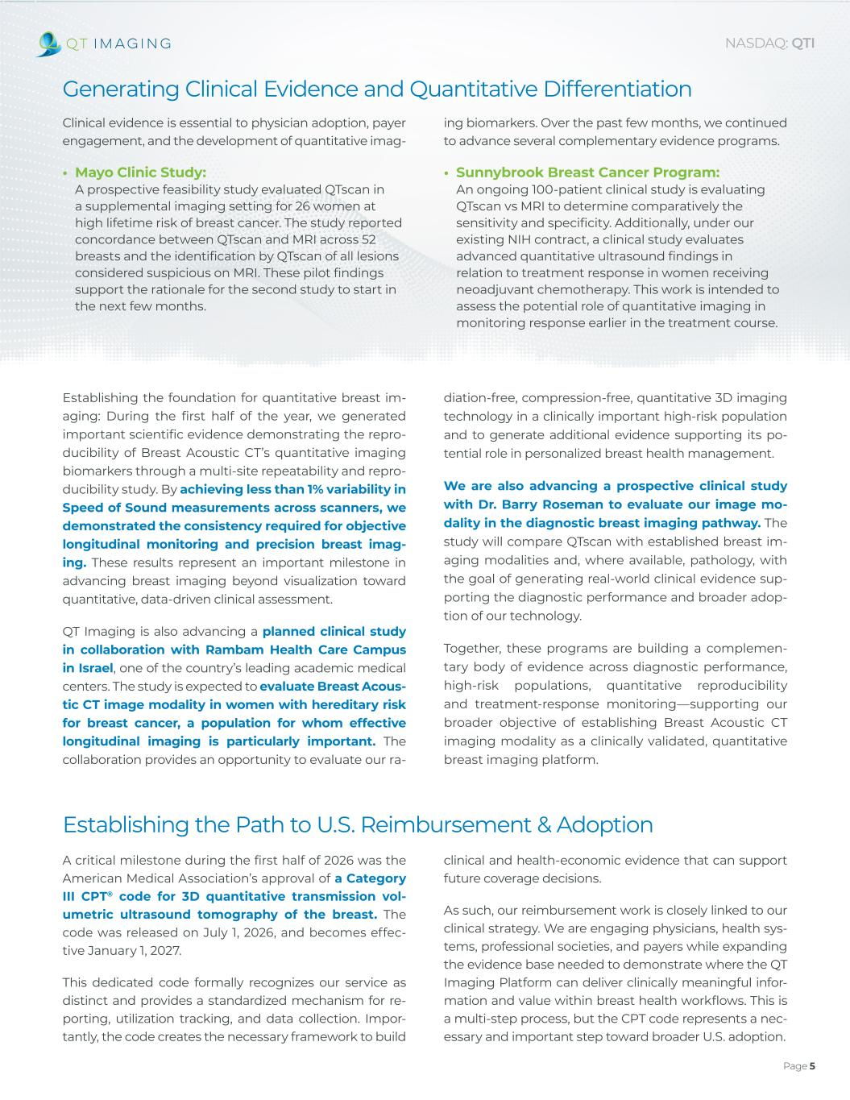
Page 5 NASDAQ: QTI Generating Clinical Evidence and Quantitative Differentiation Clinical evidence is essential to physician adoption, payer engagement, and the development of quantitative imag- diation-free, compression-free, quantitative 3D imaging technology in a clinically important high-risk population and to generate additional evidence supporting its po- tential role in personalized breast health management. We are also advancing a prospective clinical study with Dr. Barry Roseman to evaluate our image mo- dality in the diagnostic breast imaging pathway. The study will compare QTscan with established breast im- aging modalities and, where available, pathology, with the goal of generating real-world clinical evidence sup- porting the diagnostic performance and broader adop- tion of our technology. Together, these programs are building a complemen- tary body of evidence across diagnostic performance, high-risk populations, quantitative reproducibility and treatment-response monitoring—supporting our broader objective of establishing Breast Acoustic CT imaging modality as a clinically validated, quantitative breast imaging platform. Establishing the foundation for quantitative breast im- aging: During the first half of the year, we generated important scientific evidence demonstrating the repro- ducibility of Breast Acoustic CT’s quantitative imaging biomarkers through a multi-site repeatability and repro- ducibility study. By achieving less than 1% variability in Speed of Sound measurements across scanners, we demonstrated the consistency required for objective longitudinal monitoring and precision breast imag- ing. These results represent an important milestone in advancing breast imaging beyond visualization toward quantitative, data-driven clinical assessment. QT Imaging is also advancing a planned clinical study in collaboration with Rambam Health Care Campus in Israel, one of the country’s leading academic medical centers. The study is expected to evaluate Breast Acous- tic CT image modality in women with hereditary risk for breast cancer, a population for whom effective longitudinal imaging is particularly important. The collaboration provides an opportunity to evaluate our ra- • Sunnybrook Breast Cancer Program: An ongoing 100-patient clinical study is evaluating QTscan vs MRI to determine comparatively the sensitivity and specificity. Additionally, under our existing NIH contract, a clinical study evaluates advanced quantitative ultrasound findings in relation to treatment response in women receiving neoadjuvant chemotherapy. This work is intended to assess the potential role of quantitative imaging in monitoring response earlier in the treatment course. Establishing the Path to U.S. Reimbursement & Adoption A critical milestone during the first half of 2026 was the American Medical Association’s approval of a Category III CPT® code for 3D quantitative transmission vol- umetric ultrasound tomography of the breast. The code was released on July 1, 2026, and becomes effec- tive January 1, 2027. This dedicated code formally recognizes our service as distinct and provides a standardized mechanism for re- porting, utilization tracking, and data collection. Impor- tantly, the code creates the necessary framework to build clinical and health-economic evidence that can support future coverage decisions. As such, our reimbursement work is closely linked to our clinical strategy. We are engaging physicians, health sys- tems, professional societies, and payers while expanding the evidence base needed to demonstrate where the QT Imaging Platform can deliver clinically meaningful infor- mation and value within breast health workflows. This is a multi-step process, but the CPT code represents a nec- essary and important step toward broader U.S. adoption. ing biomarkers. Over the past few months, we continued to advance several complementary evidence programs. • Mayo Clinic Study: A prospective feasibility study evaluated QTscan in a supplemental imaging setting for 26 women at high lifetime risk of breast cancer. The study reported concordance between QTscan and MRI across 52 breasts and the identification by QTscan of all lesions considered suspicious on MRI. These pilot findings support the rationale for the second study to start in the next few months.

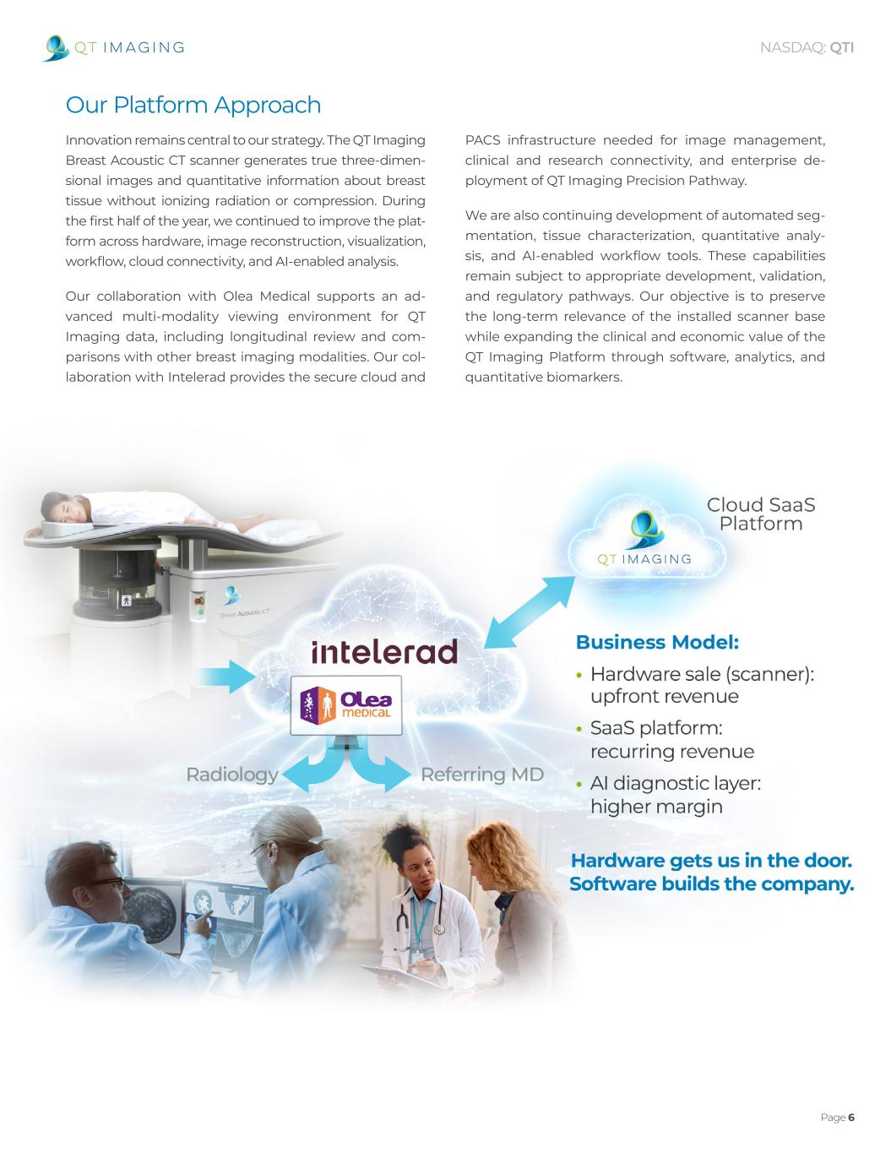
Page 6 NASDAQ: QTI Advancing the QT Imaging Platform Innovation remains central to our strategy. The QT Imaging Breast Acoustic CT scanner generates true three-dimen- sional images and quantitative information about breast tissue without ionizing radiation or compression. During the first half of the year, we continued to improve the plat- form across hardware, image reconstruction, visualization, workflow, cloud connectivity, and AI-enabled analysis. Our collaboration with Olea Medical supports an ad- vanced multi-modality viewing environment for QT Imaging data, including longitudinal review and com- parisons with other breast imaging modalities. Our col- laboration with Intelerad provides the secure cloud and PACS infrastructure needed for image management, clinical and research connectivity, and enterprise de- ployment of QT Imaging Precision Pathway. We are also continuing development of automated seg- mentation, tissue characterization, quantitative analy- sis, and AI-enabled workflow tools. These capabilities remain subject to appropriate development, validation, and regulatory pathways. Our objective is to preserve the long-term relevance of the installed scanner base while expanding the clinical and economic value of the QT Imaging Platform through software, analytics, and quantitative biomarkers. : I Our Platform Approach


NASDAQ: QTI Page 7 Strengthening Our Clinical and Scientific Leadership We continued to strengthen clinical expertise sup- porting the adoption of Breast Acoustic CT imaging modality through our Clinical Advisory Board. Dr. Mary W. Yamashita, Section Chief of Breast Imaging at USC’s Keck School of Medicine, brings deep exper- tise in breast imaging and clinical research and advises us on clinical interpretation standards, structured report- ing and physician training. Dr. Barry Roseman, a fellow- ship-trained surgical oncologist and breast surgeon, completed his surgical residency at UCSF and his sur- gical oncology fellowship at MD Anderson Cancer Cen- ter and brings more than 25 years of experience in breast cancer diagnosis and care. Dr. John Tentinger, a Mayo Clinic-trained, board-certified radiologist, founder of Innovative Radiology and an early adopter of Breast Mary W. Yamashita, MD USC KECK SCHOOL OF MEDICINE BREAST IMAGING Section Chief of Breast Imaging at USC’s Keck School of Medicine, bringing deep expertise in breast imaging and clinical research. Advises on clinical interpretation standards, structured reporting and physician training. Barry Roseman, MD, FACS UCSF / MD ANDERSON BREAST SURGICAL ONCOLOGY Fellowship-trained surgi- cal oncologist and breast surgeon. Completed his surgical residency at UCSF and surgical on- cology fellowship at MD Anderson, bringing 25+ years of experience in breast cancer diagnosis and care. John Tentinger, MD MAYO CLINIC-TRAINED CLINICAL ADOPTION / RADIOLOGY Board-certified radiolo- gist, founder of Innova- tive Radiology and an early adopter of Breast Acoustic CT, bringing hands-on experience integrating the technol- ogy into clinical practice. Julia Albright, PhD CHIEF SCIENCE OFFICER Brings more than three decades of leadership experience across med- ical imaging, healthcare technology, artificial intelligence and enter- prise software, helping align scientific strategy, product innovation and clinical programs. Acoustic CT scanner, brings hands-on experience inte- grating technology into clinical practice. Together, their complementary expertise across breast imaging, breast surgery and clinical practice is helping strengthen phy- sician education, clinical implementation and broader adoption of our technology. We also strengthened our scientific leadership with the appointment of Dr. Julia Albright as Chief Science Offi- cer. Dr. Albright brings more than three decades of lead- ership experience across medical imaging, healthcare technology, artificial intelligence and enterprise software. In this role, she is helping align our scientific strategy, product innovation, engineering and clinical programs as we advance the QT Imaging Platform.

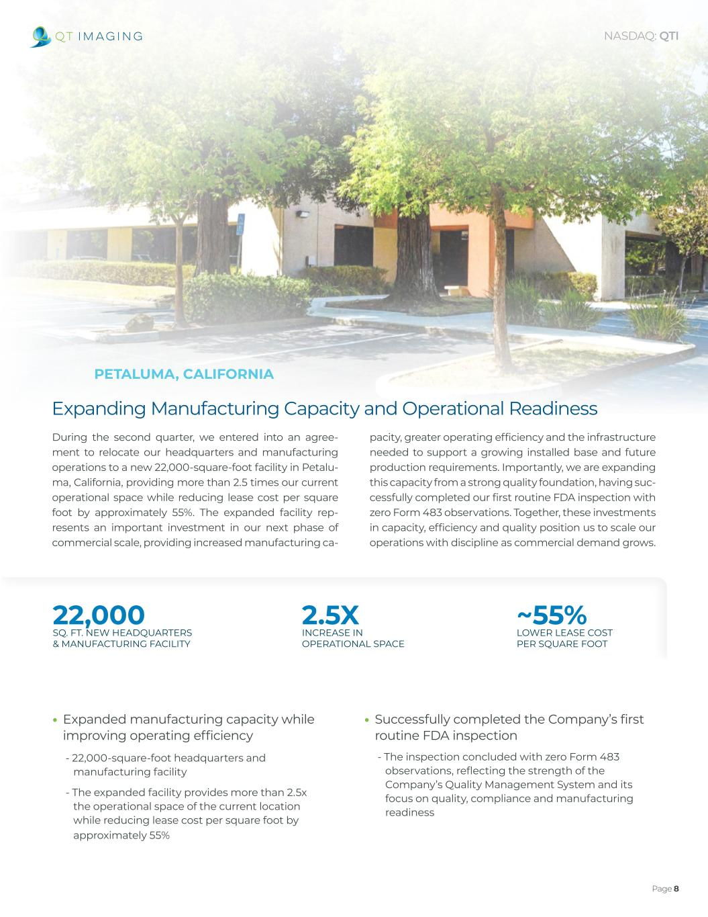
22,000 2.5X ~55% SQ. FT. NEW HEADQUARTERS & MANUFACTURING FACILITY INCREASE IN OPERATIONAL SPACE LOWER LEASE COST PER SQUARE FOOT Page 8 NASDAQ: QTI Expanding Manufacturing Capacity and Operational Readiness During the second quarter, we entered into an agree- ment to relocate our headquarters and manufacturing operations to a new 22,000-square-foot facility in Petalu- ma, California, providing more than 2.5 times our current operational space while reducing lease cost per square foot by approximately 55%. The expanded facility rep- resents an important investment in our next phase of commercial scale, providing increased manufacturing ca- pacity, greater operating efficiency and the infrastructure needed to support a growing installed base and future production requirements. Importantly, we are expanding this capacity from a strong quality foundation, having suc- cessfully completed our first routine FDA inspection with zero Form 483 observations. Together, these investments in capacity, efficiency and quality position us to scale our operations with discipline as commercial demand grows. • Expanded manufacturing capacity while improving operating efficiency - 22,000-square-foot headquarters and manufacturing facility - The expanded facility provides more than 2.5x the operational space of the current location while reducing lease cost per square foot by approximately 55% PETALUMA, CALIFORNIA • Successfully completed the Company’s first routine FDA inspection - The inspection concluded with zero Form 483 observations, reflecting the strength of the Company’s Quality Management System and its focus on quality, compliance and manufacturing readiness

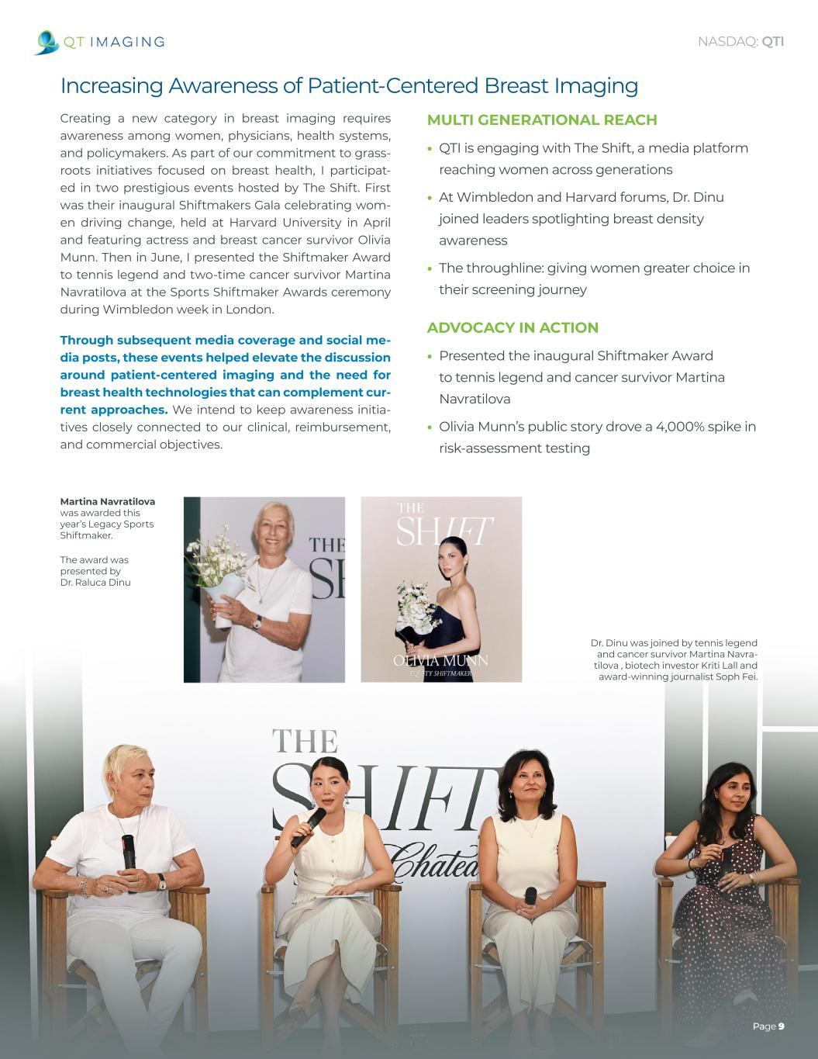
Dr. Dinu was joined by tennis legend and cancer survivor Martina Navra- tilova , biotech investor Kriti Lall and award-winning journalist Soph Fei. Martina Navratilova was awarded this year’s Legacy Sports Shiftmaker. The award was presented by Dr. Raluca Dinu Page 9 NASDAQ: QTI Increasing Awareness of Patient-Centered Breast Imaging Creating a new category in breast imaging requires awareness among women, physicians, health systems, and policymakers. As part of our commitment to grass- roots initiatives focused on breast health, I participat- ed in two prestigious events hosted by The Shift. First was their inaugural Shiftmakers Gala celebrating wom- en driving change, held at Harvard University in April and featuring actress and breast cancer survivor Olivia Munn. Then in June, I presented the Shiftmaker Award to tennis legend and two-time cancer survivor Martina Navratilova at the Sports Shiftmaker Awards ceremony during Wimbledon week in London. Through subsequent media coverage and social me- dia posts, these events helped elevate the discussion around patient-centered imaging and the need for breast health technologies that can complement cur- rent approaches. We intend to keep awareness initia- tives closely connected to our clinical, reimbursement, and commercial objectives. MULTI GENERATIONAL REACH • QTI is engaging with The Shift, a media platform reaching women across generations • At Wimbledon and Harvard forums, Dr. Dinu joined leaders spotlighting breast density awareness • The throughline: giving women greater choice in their screening journey ADVOCACY IN ACTION • Presented the inaugural Shiftmaker Award to tennis legend and cancer survivor Martina Navratilova • Olivia Munn’s public story drove a 4,000% spike in risk-assessment testing

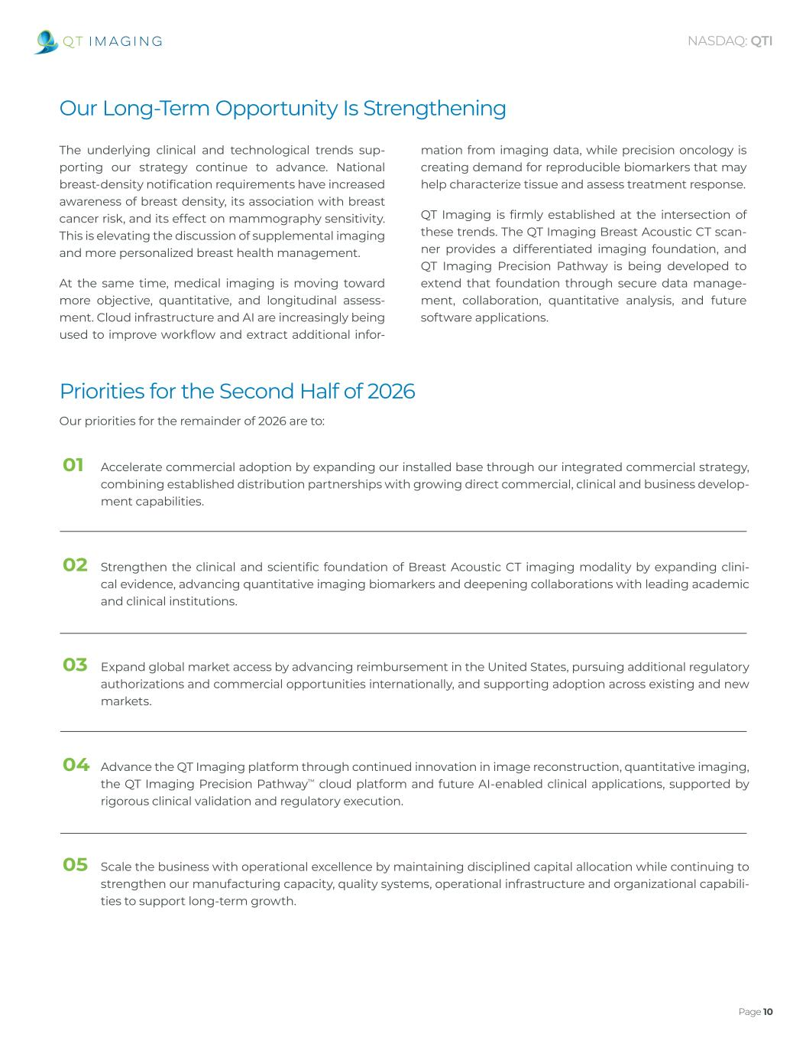
Page 10 NASDAQ: QTI 01 Accelerate commercial adoption by expanding our installed base through our integrated commercial strategy, combining established distribution partnerships with growing direct commercial, clinical and business develop- ment capabilities. 02 Strengthen the clinical and scientific foundation of Breast Acoustic CT imaging modality by expanding clini- cal evidence, advancing quantitative imaging biomarkers and deepening collaborations with leading academic and clinical institutions. 03 Expand global market access by advancing reimbursement in the United States, pursuing additional regulatory authorizations and commercial opportunities internationally, and supporting adoption across existing and new markets. 04 Advance the QT Imaging platform through continued innovation in image reconstruction, quantitative imaging, the QT Imaging Precision Pathway™ cloud platform and future AI-enabled clinical applications, supported by rigorous clinical validation and regulatory execution. 05 Scale the business with operational excellence by maintaining disciplined capital allocation while continuing to strengthen our manufacturing capacity, quality systems, operational infrastructure and organizational capabili- ties to support long-term growth. Priorities for the Second Half of 2026 Our priorities for the remainder of 2026 are to: Our Long-Term Opportunity Is Strengthening The underlying clinical and technological trends sup- porting our strategy continue to advance. National breast-density notification requirements have increased awareness of breast density, its association with breast cancer risk, and its effect on mammography sensitivity. This is elevating the discussion of supplemental imaging and more personalized breast health management. At the same time, medical imaging is moving toward more objective, quantitative, and longitudinal assess- ment. Cloud infrastructure and AI are increasingly being used to improve workflow and extract additional infor- mation from imaging data, while precision oncology is creating demand for reproducible biomarkers that may help characterize tissue and assess treatment response. QT Imaging is firmly established at the intersection of these trends. The QT Imaging Breast Acoustic CT scan- ner provides a differentiated imaging foundation, and QT Imaging Precision Pathway is being developed to extend that foundation through secure data manage- ment, collaboration, quantitative analysis, and future software applications.

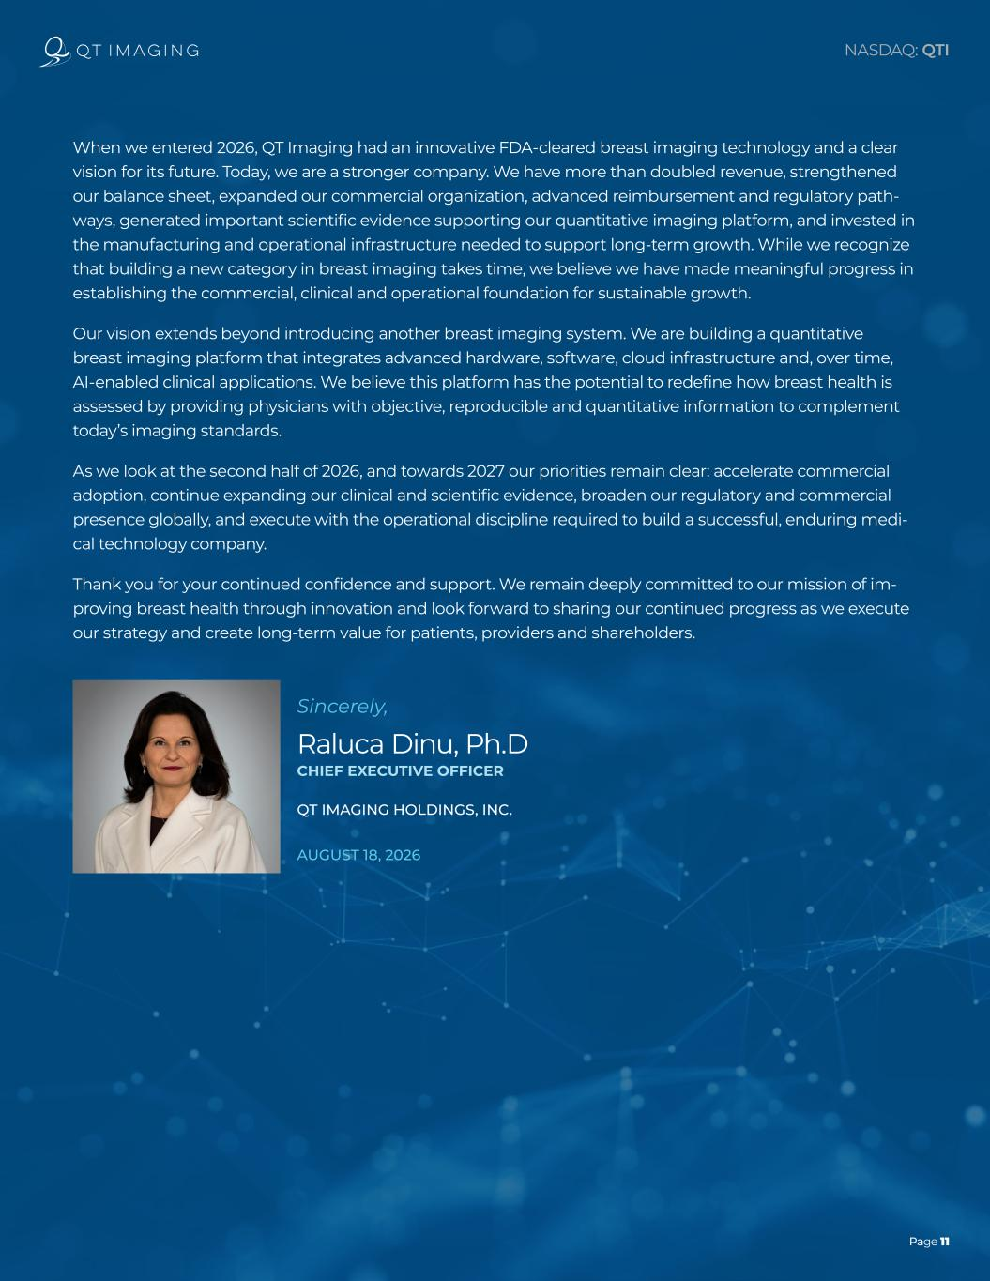
Page 11 NASDAQ: QTI When we entered 2026, QT Imaging had an innovative FDA-cleared breast imaging technology and a clear vision for its future. Today, we are a stronger company. We have more than doubled revenue, strengthened our balance sheet, expanded our commercial organization, advanced reimbursement and regulatory path- ways, generated important scientific evidence supporting our quantitative imaging platform, and invested in the manufacturing and operational infrastructure needed to support long-term growth. While we recognize that building a new category in breast imaging takes time, we believe we have made meaningful progress in establishing the commercial, clinical and operational foundation for sustainable growth. Our vision extends beyond introducing another breast imaging system. We are building a quantitative breast imaging platform that integrates advanced hardware, software, cloud infrastructure and, over time, AI-enabled clinical applications. We believe this platform has the potential to redefine how breast health is assessed by providing physicians with objective, reproducible and quantitative information to complement today’s imaging standards. As we look at the second half of 2026, and towards 2027 our priorities remain clear: accelerate commercial adoption, continue expanding our clinical and scientific evidence, broaden our regulatory and commercial presence globally, and execute with the operational discipline required to build a successful, enduring medi- cal technology company. Thank you for your continued confidence and support. We remain deeply committed to our mission of im- proving breast health through innovation and look forward to sharing our continued progress as we execute our strategy and create long-term value for patients, providers and shareholders. Sincerely, Raluca Dinu, Ph.D CHIEF EXECUTIVE OFFICER QT IMAGING HOLDINGS, INC. AUGUST 18, 2026

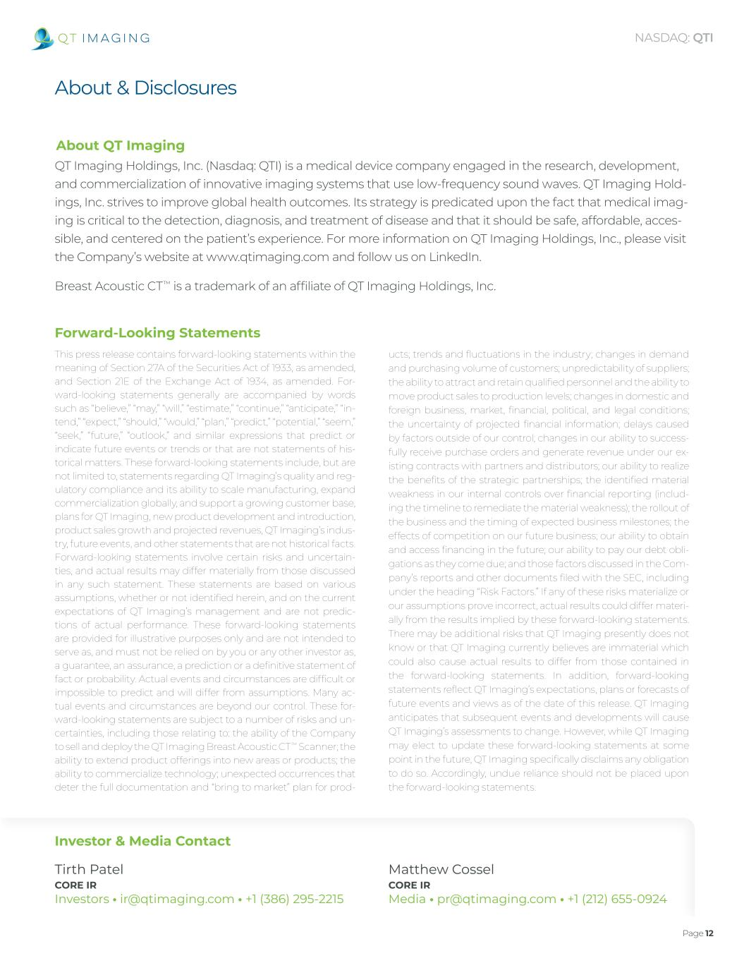
Page 12 NASDAQ: QTI About & Disclosures About QT Imaging Forward-Looking Statements Investor & Media Contact QT Imaging Holdings, Inc. (Nasdaq: QTI) is a medical device company engaged in the research, development, and commercialization of innovative imaging systems that use low-frequency sound waves. QT Imaging Hold- ings, Inc. strives to improve global health outcomes. Its strategy is predicated upon the fact that medical imag- ing is critical to the detection, diagnosis, and treatment of disease and that it should be safe, affordable, acces- sible, and centered on the patient’s experience. For more information on QT Imaging Holdings, Inc., please visit the Company’s website at www.qtimaging.com and follow us on LinkedIn. Breast Acoustic CT™ is a trademark of an affiliate of QT Imaging Holdings, Inc. This press release contains forward-looking statements within the meaning of Section 27A of the Securities Act of 1933, as amended, and Section 21E of the Exchange Act of 1934, as amended. For- ward-looking statements generally are accompanied by words such as “believe,” “may,” “will,” “estimate,” “continue,” “anticipate,” “in- tend,” “expect,” “should,” “would,” “plan,” “predict,” “potential,” “seem,” “seek,” “future,” “outlook,” and similar expressions that predict or indicate future events or trends or that are not statements of his- torical matters. These forward-looking statements include, but are not limited to, statements regarding QT Imaging’s quality and reg- ulatory compliance and its ability to scale manufacturing, expand commercialization globally, and support a growing customer base, plans for QT Imaging, new product development and introduction, product sales growth and projected revenues, QT Imaging’s indus- try, future events, and other statements that are not historical facts. Forward-looking statements involve certain risks and uncertain- ties, and actual results may differ materially from those discussed in any such statement. These statements are based on various assumptions, whether or not identified herein, and on the current expectations of QT Imaging’s management and are not predic- tions of actual performance. These forward-looking statements are provided for illustrative purposes only and are not intended to serve as, and must not be relied on by you or any other investor as, a guarantee, an assurance, a prediction or a definitive statement of fact or probability. Actual events and circumstances are difficult or impossible to predict and will differ from assumptions. Many ac- tual events and circumstances are beyond our control. These for- ward-looking statements are subject to a number of risks and un- certainties, including those relating to: the ability of the Company to sell and deploy the QT Imaging Breast Acoustic CT™ Scanner; the ability to extend product offerings into new areas or products; the ability to commercialize technology; unexpected occurrences that deter the full documentation and “bring to market” plan for prod- ucts; trends and fluctuations in the industry; changes in demand and purchasing volume of customers; unpredictability of suppliers; the ability to attract and retain qualified personnel and the ability to move product sales to production levels; changes in domestic and foreign business, market, financial, political, and legal conditions; the uncertainty of projected financial information; delays caused by factors outside of our control; changes in our ability to success- fully receive purchase orders and generate revenue under our ex- isting contracts with partners and distributors; our ability to realize the benefits of the strategic partnerships; the identified material weakness in our internal controls over financial reporting (includ- ing the timeline to remediate the material weakness); the rollout of the business and the timing of expected business milestones; the effects of competition on our future business; our ability to obtain and access financing in the future; our ability to pay our debt obli- gations as they come due; and those factors discussed in the Com- pany’s reports and other documents filed with the SEC, including under the heading “Risk Factors.” If any of these risks materialize or our assumptions prove incorrect, actual results could differ materi- ally from the results implied by these forward-looking statements. There may be additional risks that QT Imaging presently does not know or that QT Imaging currently believes are immaterial which could also cause actual results to differ from those contained in the forward-looking statements. In addition, forward-looking statements reflect QT Imaging’s expectations, plans or forecasts of future events and views as of the date of this release. QT Imaging anticipates that subsequent events and developments will cause QT Imaging’s assessments to change. However, while QT Imaging may elect to update these forward-looking statements at some point in the future, QT Imaging specifically disclaims any obligation to do so. Accordingly, undue reliance should not be placed upon the forward-looking statements. Tirth Patel CORE IR Investors • ir@qtimaging.com • +1 (386) 295-2215 Matthew Cossel CORE IR Media • pr@qtimaging.com • +1 (212) 655-0924

